Science 8
Unit E
Section 1
Self-Check Quiz

Answer all 5 questions in the spaces provided. Think carefully before typing your answers. If you need help, return to the lesson in the online course. Save your quiz when you are done.

Leave your answers in blue; it will be easier for you and your teacher to see them later.

Question 1

Explain why it is very important for humans to manage and protect our freshwater sources.

Type your answer here.

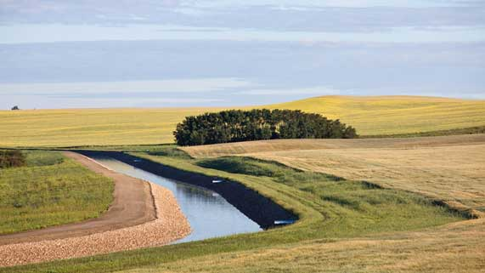
Question 2

Why are irrigation canal systems important for farmers in southern Alberta?
Type your answer here.


Question 3

Why is potable tap water not considered to be distilled water?

Type your answer here.

Question 4

Explain why it is important for people who have well water to get their water tested often.

Type your answer here.

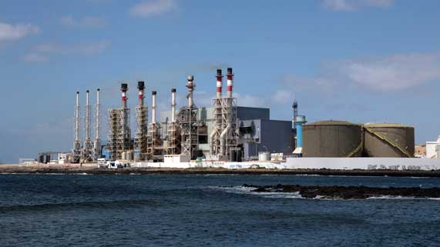
Question 5

Some Middle Eastern desert countries have lots of oil resources.
Explain why citizens of these countries use desalination of seawater to obtain fresh drinking water.

Type your answer here.

Congratulations! You have completed this self-check quiz.

Now it's time to carefully compare your answers to the suggested answers in the online course. When comparing, you should feel free to make changes to your answers or make extra notes.

Don't forget to save the quiz whenever you make changes.

Keep this quiz for study purposes. If you want more feedback, share it with your teacher.

