Science 8
Unit E
Lesson 4
Self-Check Quiz

Answer all 5 questions in the spaces provided. Think carefully before typing your answers. If you need help, return to the lesson in the online course. Save your quiz when you are done.

Leave your answers in blue; it will be easier for you and your teacher to see them later.

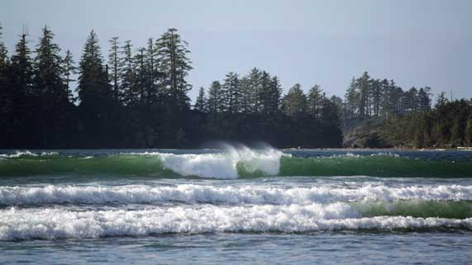
Question 1

Explain why experienced surfers on Vancouver Island say that best surfing happens during the winter.

Type your answer here.

Question 2

Describe how tsunami waves are different from large storm waves.
Type your answer here.

Question 3

Explain why low and high tide times can be predicted in advance, but the timing of crashing waves on the shore cannot be predicted.

Type your answer here.

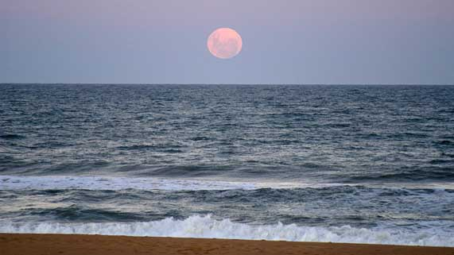
Question 4

You are visiting the ocean and see a full moon. The Sun is 180 degrees opposite to the Moon, which lights it up.
What would you expect to see at low tide that night?

Type your answer here.

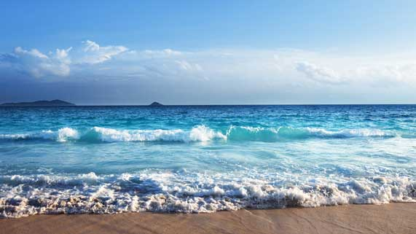
Question 5

Why do beaches still have waves on days with no wind?

Type your answer here.

Congratulations! You have completed this self-check quiz.

Now it's time to carefully compare your answers to the suggested answers in the online course. When comparing, you should feel free to make changes to your answers or make extra notes.

Don't forget to save the quiz whenever you make changes.

Keep this quiz for study purposes. If you want more feedback, share it with your teacher.

