Science 8
Unit E
Lesson 5
Self-Check Quiz

Answer all 5 questions in the spaces provided. Think carefully before typing your answers. If you need help, return to the lesson in the online course. Save your quiz when you are done.

Leave your answers in blue; it will be easier for you and your teacher to see them later.

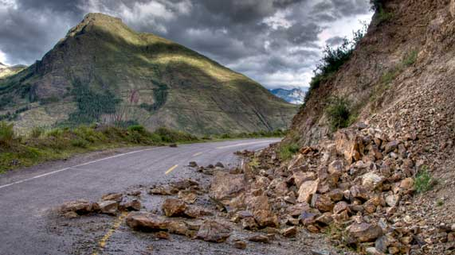
Question 1

Explain why landslides sometimes occur on hills or mountains after a heavy rainfall.
Type your answer here.

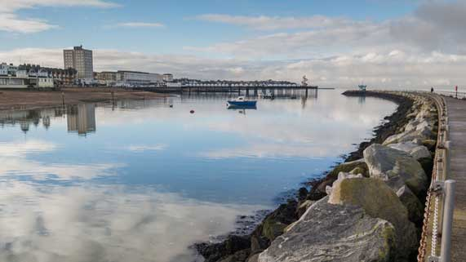
Question 2

Explain why people build retaining walls beside rivers in cities and towns.
Type your answer here.

Question 3

Why do meandering rivers not form high in the mountains?

Type your answer here.

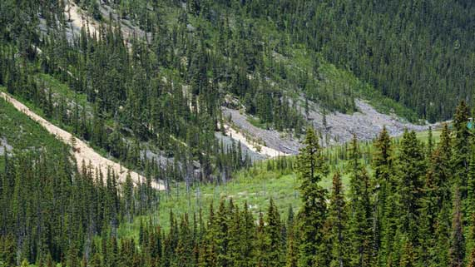
Question 4

Explain why trees on hillsides help prevent erosion.
Type your answer here.

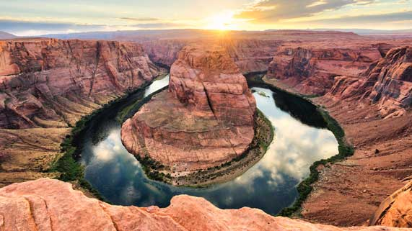
Question 5

Explain why canyons tend to form in soft, layered sedimentary rock instead of hard igneous or metamorphic rock.

Type your answer here.

Congratulations! You have completed this self-check quiz.

Now it's time to carefully compare your answers to the suggested answers in the online course. When comparing, you should feel free to make changes to your answers or make extra notes.

Don't forget to save the quiz whenever you make changes.

Keep this quiz for study purposes. If you want more feedback, share it with your teacher.

