Science 8
Unit E Lesson 6
Lesson Activity
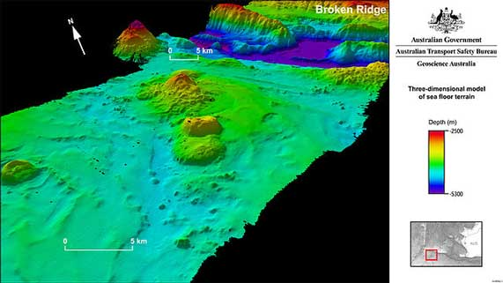
Mapping Ocean Basins

Sonar technology on boats measures how long it takes for a reflected sound wave to travel from the ocean floor back to the boat. Scientists have measured the speed of sound through water as 1500 metres per second.

The relationship between speed, distance, and time is:

speed = distance ÷ time

If we know the speed of a sound wave, and we know the amount of time that the sound wave travels back from the ocean floor to a boat, we can calculate the distance to the ocean floor by this relationship:

distance = speed x time

Instructions:

- The sonar data in this table was collected by a ship at 10 different locations on the ocean’s surface. The locations were equal distances apart. For each location, calculate the distance of the ship from the ocean floor. The speed of sound in water is 1500 metres per second.
Sonar Data

Location | 1 | 2 | 3 | 4 | 5 | 6 | 7 | 8 | 9 | 10
Time for reflected sound waves to travel to ship  (seconds) | 0.5 | 0.5 | 1 | 2 | 3 | 3 | 1.5 | 3 | 6 | 3
Distance of ship from ocean floor (ocean depth)
(metres)

- Use the sonar data to draw a side-view profile of the ocean floor, on the graph below. At each location, draw a dot showing the ocean depth below the surface.

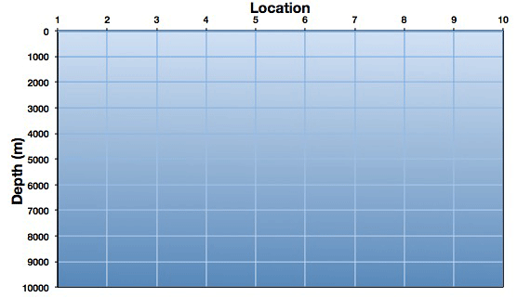
- Connect all the dots, from left to right.
- Examine your ocean basin profile. What ocean basin features do you observe at each location?

Questions:

Think about the following questions very carefully. Then, type or write your answers. When you have your answers, click the questions in the Moodle lesson for feedback.

- What ocean basin feature did sonar detect between locations 1 and 2?

- What ocean basin feature did sonar detect at location 7?

- What ocean basin feature did sonar detect at location 9?

