Science 8
Unit E
Lesson 6
Self-Check Quiz

Answer all 5 questions in the spaces provided. Think carefully before typing your answers. If you need help, return to the lesson in the online course. Save your quiz when you are done.

Leave your answers in blue; it will be easier for you and your teacher to see them later.

Question 1

A drop of water falls in the Athabasca River near the northern Alberta city of Fort McMurray. Where will the drop of water eventually end up?
Type your answer here.

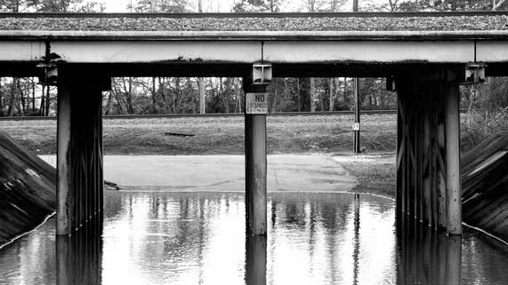
Question 2

In heavy rainstorms, why do road underpasses often flood?
Type your answer here.

Question 3

Explain why water in the Oldman River through Lethbridge eventually flows to Hudson Bay, while only 100 kilometres away, water in the Milk River eventually flows to the Gulf of Mexico.

Type your answer here.

Question 4

Why is offshore oil drilling so expensive?

Type your answer here.

Question 5

In a drainage basin, smaller rivers flow into bigger rivers, until a large river finally reaches the ocean. Why don’t most small rivers and streams flow directly into the ocean?

Type your answer here.

Congratulations! You have completed this self-check quiz.

Now it's time to carefully compare your answers to the suggested answers in the online course. When comparing, you should feel free to make changes to your answers or make extra notes.

Don't forget to save the quiz whenever you make changes.

Keep this quiz for study purposes. If you want more feedback, share it with your teacher.

