Science 8
Unit E
Lesson 7
Self-Check Quiz

Answer all 5 questions in the spaces provided. Think carefully before typing your answers. If you need help, return to the lesson in the online course. Save your quiz when you are done.

Leave your answers in blue; it will be easier for you and your teacher to see them later.

Question 1

Explain one piece of evidence showing that Alberta was once covered in a continental ice sheet.

Type your answer here.

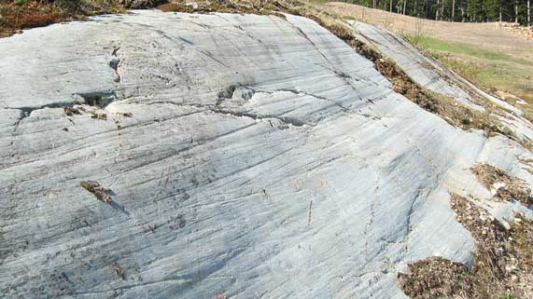
Question 2

Rocks in glacial mountain areas are often covered with long scratches called striations.
Why do glaciers cause striations in underlying rocks?
Type your answer here.

Question 3

Explain how retreating, disappearing glaciers due to climate change will affect the lives of Albertans.

Type your answer here.

Question 4

Explain how retreating, disappearing glaciers due to climate change will affect the lives of people who live in coastal communities.

Type your answer here.

Question 5

Both the Rocky Mountains in North America and the continent of Antarctica are made from rock. However, why do the Rocky Mountains contain many more eroded rock landscapes than Antarctica?

Type your answer here.

Congratulations! You have completed this self-check quiz.

Now it's time to carefully compare your answers to the suggested answers in the online course. When comparing, you should feel free to make changes to your answers or make extra notes.

Don't forget to save the quiz whenever you make changes.

Keep this quiz for study purposes. If you want more feedback, share it with your teacher.

