Science 8
Unit E
Lesson 8
Self-Check Quiz

Answer all 5 questions in the spaces provided. Think carefully before typing your answers. If you need help, return to the lesson in the online course. Save your quiz when you are done.

Leave your answers in blue; it will be easier for you and your teacher to see them later.

Question 1

Scotland is located on the Atlantic coast of Europe. The city of Edinburgh, Scotland is at approximately the same latitude as Fort McMurray, Alberta. The average January temperature in Edinburgh, Scotland is +3°C. The average January temperature in Fort McMurray AB is -17°C. Why is there such a large difference in the winter temperatures of these two northern cities?

Type your answer here.

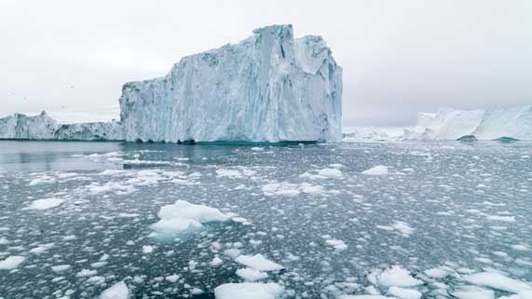
Question 2

Climate change is causing continental ice sheets in Greenland to melt. This adds fresh water into the North Atlantic Ocean. The Gulf Stream also runs through the North Atlantic Ocean.
What effect could melting ice sheets have on climate?
Type your answer here.

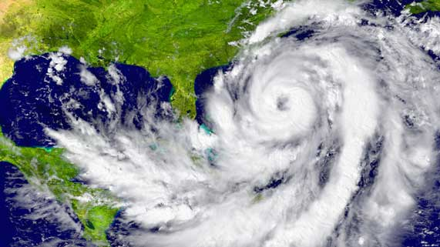
Question 3

Hurricanes, or tropical cyclones, form in the Atlantic Ocean in the summer and fall months.
Why do hurricanes not generally form during the winter months?

Type your answer here.

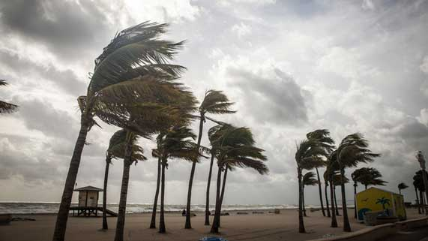
Question 4

Climate change can cause severe storms to occur more often.
Why are governments concerned about an increase in severe storms, due to climate change?

Type your answer here.

Question 5

On a winter afternoon, the temperature in Edmonton is -15°C, while the temperature in Calgary is +5°C. Why is there a large temperature difference between these two cities, that are only 300 km apart?

Type your answer here.

Congratulations! You have completed this self-check quiz.

Now it's time to carefully compare your answers to the suggested answers in the online course. When comparing, you should feel free to make changes to your answers or make extra notes.

Don't forget to save the quiz whenever you make changes.

Keep this quiz for study purposes. If you want more feedback, share it with your teacher.

