Science 8
Unit E
Section 2
Self-Check Quiz

Answer all 5 questions in the spaces provided. Think carefully before typing your answers. If you need help, return to the lesson in the online course. Save your quiz when you are done.

Leave your answers in blue; it will be easier for you and your teacher to see them later.

Question 1

Describe one similarity and one difference between hurricane-generated storm waves and tsunamis.

Type your answer here.

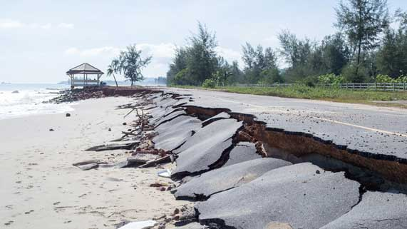
Question 2

Along a coastline, a road is broken and worn away.
What caused the road to collapse?
Type your answer here.

Question 3

The Bow River starts at Bow Glacier, in Alberta’s Rocky Mountains. After connecting with other rivers, it eventually drains into Hudson Bay, 1600 kilometers away. The Pacific Ocean is much closer to the Bow Glacier, only 500 kilometers away. Why does the Bow River drain into the distant Hudson Bay rather than the closer Pacific Ocean?

Type your answer here.

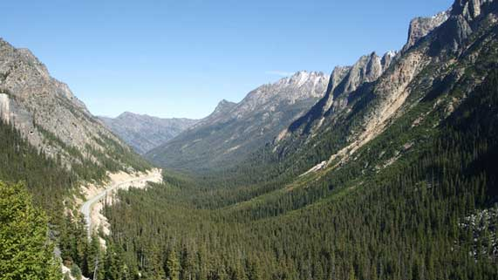
Question 4

A U-shaped mountain valley was once covered by a glacier.
Explain how the glacier created the valley’s shape.

Type your answer here.

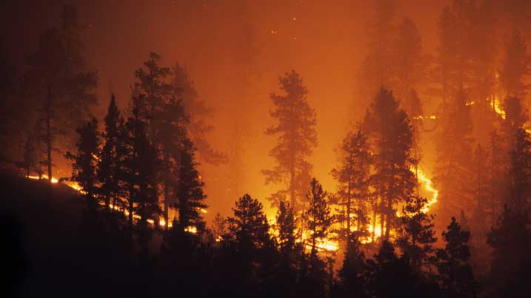
Question 5

Why do bad forest fire years in western Canada often happen at the same time as El Niño?
Type your answer here.

Congratulations! You have completed this self-check quiz.

Now it's time to carefully compare your answers to the suggested answers in the online course. When comparing, you should feel free to make changes to your answers or make extra notes.

Don't forget to save the quiz whenever you make changes.

Keep this quiz for study purposes. If you want more feedback, share it with your teacher.

