Science 8
Unit E
Lesson 9
Self-Check Quiz

Answer all 5 questions in the spaces provided. Think carefully before typing your answers. If you need help, return to the lesson in the online course. Save your quiz when you are done.

Leave your answers in blue; it will be easier for you and your teacher to see them later.

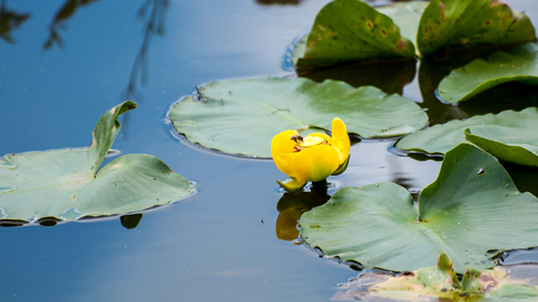
Question 1

Water lilies have large, flat, floating leaves.
How does this adaptation help water lilies?

Type your answer here.

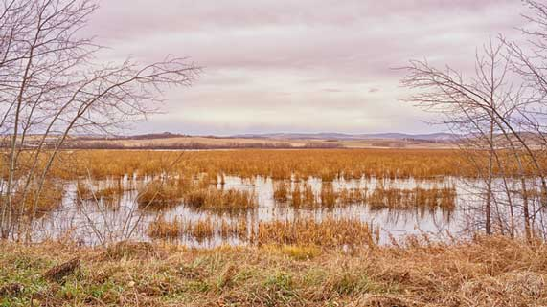
Question 2

Explain two reasons why wetlands are very important in Canada.

Type your answer here.

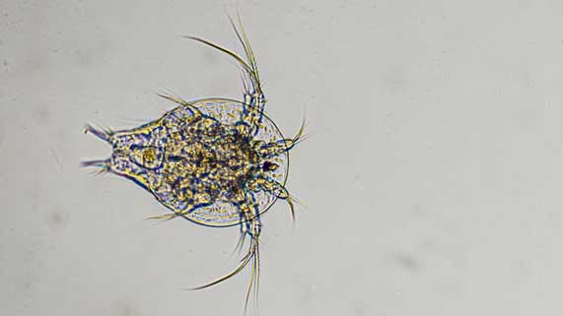
Question 3

What are plankton? Why are plankton important in aquatic ecosystems?

Type your answer here.

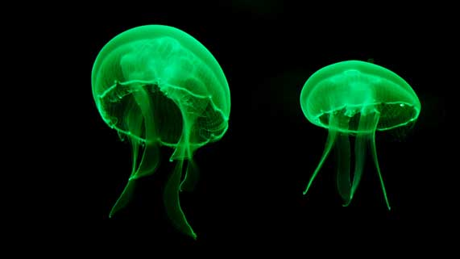
Question 4

Some deep ocean organisms produce light in their bodies. Jellyfish are an example of a bioluminescent organism.
What are some benefits for deep ocean organisms with this bioluminescence adaptation?

Type your answer here.

Question 5

Describe one similarity and one difference between a mangrove estuary habitat and a freshwater wetlands habitat.

Type your answer here.

Congratulations! You have completed this self-check quiz.

Now it's time to carefully compare your answers to the suggested answers in the online course. When comparing, you should feel free to make changes to your answers or make extra notes.

Don't forget to save the quiz whenever you make changes.

Keep this quiz for study purposes. If you want more feedback, share it with your teacher.

