Science 8
Unit E
Lesson 10
Self-Check Quiz

Answer all 5 questions in the spaces provided. Think carefully before typing your answers. If you need help, return to the lesson in the online course. Save your quiz when you are done.

Leave your answers in blue; it will be easier for you and your teacher to see them later.

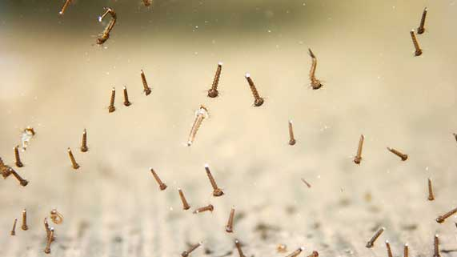
Question 1

Mosquitoes lay eggs in standing water such as puddles.
After a dry winter and spring in southern Alberta, a researcher observed that the frog population in a town decreased. What is the best explanation for this observation?

Type your answer here.

Question 2

Climate change is causing the average temperature of oceans to increase. Less oxygen is able to dissolve in warmer water. How could lower dissolved oxygen levels in oceans change the populations of species such as fish?

Type your answer here.

Question 3

In 1990, no zebra mussels were present in Ontario’s Rideau River. By 2000, the zebra mussel population had exploded. Why did the zebra mussel population increase so quickly?

Type your answer here.

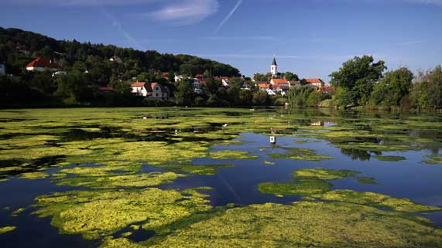
Question 4

Due to fertilizer runoff, the algae population increases on a lake’s surface.
What would you expect to happen to populations of underwater plants at the bottom of the lake?

Type your answer here.

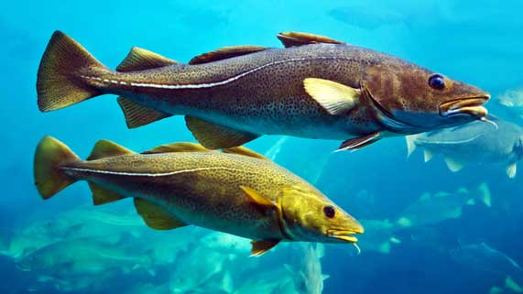
Question 5

In 1992, the Canadian government made a law to ban cod fishing off the coast of Newfoundland, because fish populations collapsed. As of 2016, this law is still in effect, even though cod populations have recovered about 10% from their lowest levels.
Is the cod fishery collapse a short term or a long term population change? Explain your answer.

Type your answer here.

Congratulations! You have completed this self-check quiz.

Now it's time to carefully compare your answers to the suggested answers in the online course. When comparing, you should feel free to make changes to your answers or make extra notes.

Don't forget to save the quiz whenever you make changes.

Keep this quiz for study purposes. If you want more feedback, share it with your teacher.

