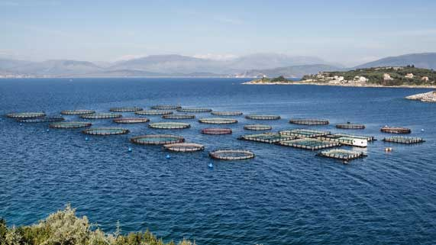
Science 8
Unit E Lesson 11
Lesson Activity
Fish Farms

As wild ocean fish populations in the ocean decrease, people are turning to fish farming instead of open sea fishing, to obtain fish for human consumption.

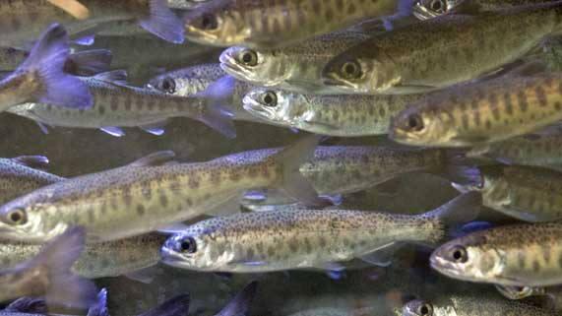
Some fish farms raise fish in enclosed cages in the ocean. This is a controversial practice because some people are concerned about how fish farming affects water quality for wild fish species.

In this activity, you will learn more about the controversy over fish farming. You will collect information on both sides of the issue.

Instructions:

- Construct a table with two columns. You can do this on a sheet of paper or type on the table provided below.
- Title the columns “Advantages of Fish Farming” and “Disadvantages of Fish Farming”.
- Watch these videos. As you watch the videos, listen for examples of advantages and disadvantages to fish farming. Pause the video when you hear an example and summarize the example in the correct column of your table.

Video Research:

This video explains the development of fish farming and recent innovations to fix its disadvantages.
Fish farming in geodesic domes

Watch this video to learn more about some advantages of fish farming.
Salmon fishing

This video shows the world’s largest fish farm in the open ocean.
World’s largest fish farm

This video explains some of the risks and rewards of salmon farming.
Risks and rewards of salmon farming

This video explores the controversy about farming salmon in natural salmon habitat.
Problem with farmed salmon

Fish farming can even be found on the prairies.
Prairie fish farm

Fish Farms

Advantages of Fish Farming | Disadvantages of Fish Farming

Sharing:

Congratulations on completing this activity! The subject of fish farming is interesting – consider sharing your list of advantages and disadvantages with your teacher and fellow students in the online course Sharing Forum. You can also put your opinion in your post if you like – are you for or against fish farming?

