Science 8
Unit E
Lesson 11
Self-Check Quiz

Answer all 5 questions in the spaces provided. Think carefully before typing your answers. If you need help, return to the lesson in the online course. Save your quiz when you are done.

Leave your answers in blue; it will be easier for you and your teacher to see them later.

Question 1

The water is tested in a freshwater pond. Compared to a year ago, the water has a more acidic pH, and lower levels of dissolved oxygen. What change would you expect to see to the species in the pond?

Type your answer here.

Question 2

During a hike, you walk past a wetland. The wetland is filled with bulrushes. You can hear frogs croaking and insects buzzing. You see a duck and ducklings swimming in the water. What can you conclude about the water quality in the wetland and why?

Type your answer here.

Question 3

A river ecosystem contains a large number of living things. Is it safe to drink the river water? Why or why not?

Type your answer here.

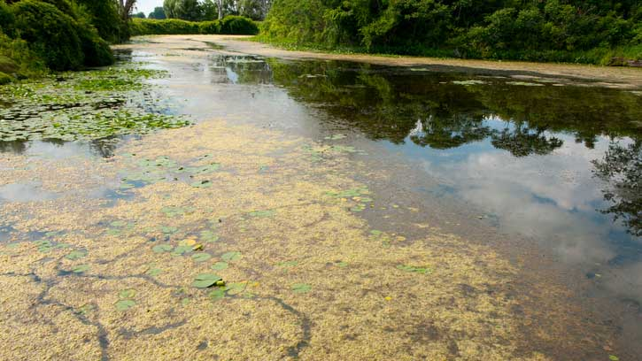
Question 4

A riverbank is completely covered with green slimy scum.
What can you conclude about the water quality and the organisms in the river?

Type your answer here.

Question 5

The water in a lake was tested five years and today. The water testing results are shown below.

Water Test | Five Years Ago | Today
Dissolved Oxygen | 5 | 10
pH | 5.3 (slightly acidic) | 6.8 (neutral)
Percentage of surface covered in green algae | 30 | 2
Describe how the water quality in the pond changed over five years.

Type your answer here.

Congratulations! You have completed this self-check quiz.

Now it's time to carefully compare your answers to the suggested answers in the online course. When comparing, you should feel free to make changes to your answers or make extra notes.

Don't forget to save the quiz whenever you make changes.

Keep this quiz for study purposes. If you want more feedback, share it with your teacher.

