Science 8
Unit E
Section 3
Self-Check Quiz

Answer all 5 questions in the spaces provided. Think carefully before typing your answers. If you need help, return to the lesson in the online course. Save your quiz when you are done.

Leave your answers in blue; it will be easier for you and your teacher to see them later.

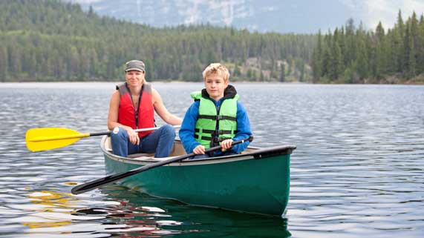
Question 1

A family goes boating on a lake for the day. They bring a lunch in plastic sandwich bags and eat it on the boat.
Why is it important for the family to take their lunch garbage home, instead of throwing it overboard into the lake?

Type your answer here.

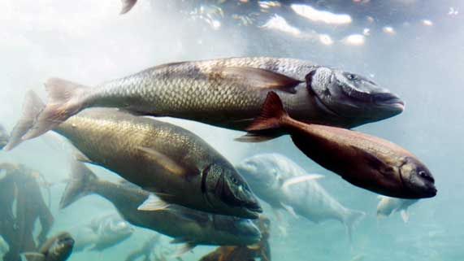
Question 2

Fish have the adaptation of gills. Gills are slits on the side of a fish’s face. When a fish opens its mouth and takes in water, its gills absorb oxygen and release carbon dioxide.
Why are gills a necessary adaptation for fish?
Type your answer here.

Question 3

The bottom of the ocean is very dark and cold. What are some adaptations that help deep ocean organisms survive in a cold, dark habitat?

Type your answer here.

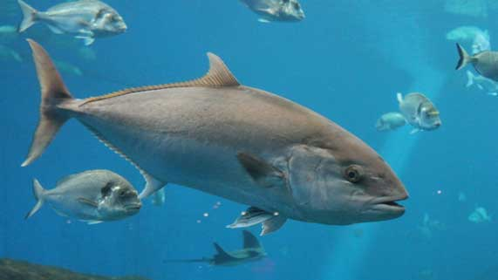
Question 4

Many people enjoy eating tuna, which is a group of large saltwater fish. Several species of tuna have recently become endangered, which means they are at risk of becoming extinct.

What is a likely explanation for the recent decrease in tuna populations?

Type your answer here.

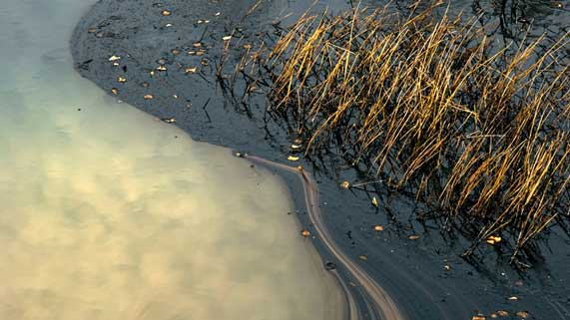
Question 5

A tanker ship leaks oil into the ocean.
How would an oil spill affect populations of aquatic organisms in the area? Would there be a short or a long-term change to populations?
Type your answer here.

Congratulations! You have completed this self-check quiz.

Now it's time to carefully compare your answers to the suggested answers in the online course. When comparing, you should feel free to make changes to your answers or make extra notes.

Don't forget to save the quiz whenever you make changes.

Keep this quiz for study purposes. If you want more feedback, share it with your teacher.

