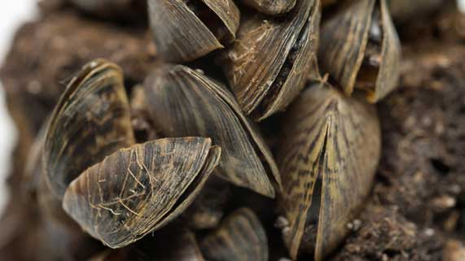
Science 8
Unit E, Section 3
Project
Aquatic Invasive Species Action Plan

You are required to submit the following project to your teacher for marks. Very carefully, read the project and how to do it. Be sure to read the requirements and rubric, they explain the expectations for this project and how it will be marked.

Situation

Invasive species are an increasing problem in both salt and freshwater aquatic environments in Canada. Invasive species are not native to an ecosystem. Invasive species are introduced from other parts of the world. Without natural predators, invasive species tend to reproduce quickly and threaten the well-being of other species.

Government and environmental groups are taking action to reduce the negative impact of invasive species on natural aquatic habitats in Canada.

Project Task

Research an aquatic invasive species. Create an action plan that contains suggestions of how to reduce the harmful effects of the invasive species on Canadian aquatic ecosystems.

Before you begin your research and action plan, ask yourself these questions:

- What adaptations does the invasive species have? (Review Lesson E9)
- How does the invasive species affect the population of other species? (Review Lesson E10)
- How does the invasive species affect water quality? (Review Lesson E11)
- What can be done to stop the spread of the invasive species?
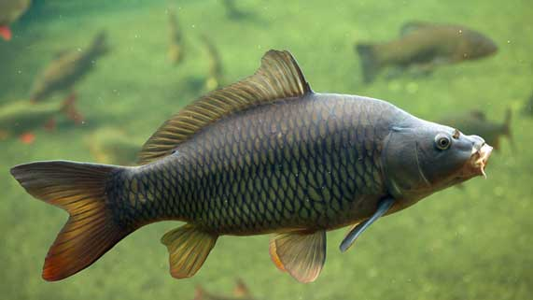
Method

- Choose an aquatic invasive species in Canada. You may choose from the following species:

- European Green Crab (Carcinus maenas)
- Sea Lamprey (Petromyzon marinus)
- Oyster Thief (Codium fragile)
- Grass Carp (Ctenopharyngodon idella)
- New Zealand Mud Snail (Potamopyrgus antipodarum)
- Chinese Mitten Crab (Eriocheir sinensis)
- Eurasian Water Milfoil (Myriophyllum spicatum)
- Check with your teacher if you wish to research a different aquatic invasive species

- Research your chosen aquatic invasive species. Sources of information include the following:

- Reference books
- News articles in newspapers, magazines, or other publications
- Websites
- YouTube videos
- Interviews with adults who work in fishing or environmental protection industries

- Construct a table to collect information. The categories that you must research are indicated on the sample table below.

The table must contain information summarized in your own words. Beside each piece of supporting information, list the source of the information. For example, insert the URL of any websites, book titles and authors, newspaper names and dates of publication or names of people interviewed as your sources.

You must submit the research table with your action plan.

- Create and communicate an action plan to reduce the harmful effects of your chosen invasive species. Here are some ideas from which you can choose:

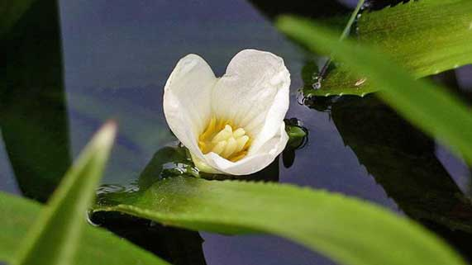
- Write an information brochure.
- Write a report.
- Screencast or video a presentation.
- Build a website.
- Draw a poster containing written information.
- Record a podcast.
- Use some other creative idea, but check with your teacher first!

Requirements

You must communicate clearly the following information in your action plan.

- Describe the invasive species, its adaptations, and its habitat in Canada.
- Describe how the invasive species affects other native species populations. Which other native species are affected?
- Outline an action plan describing how people can prevent the spread of the invasive species.

Aquatic Invasive Species Action Plan
Category | Information | Source of Information
Description of the invasive species

- What is its appearance? What size is it?
- What part of the world did it come from?
- How was it introduced to Canada?
- Include a photo or drawing.
Adaptations of the invasive species

- What adaptations help the invasive species survive?
Description of invasive species habitat in Canada

- Does it live in fresh or salt water?
- What other native species live in the habitat
Effect of invasive species on other populations

- What does the invasive species eat?
- What feeds on the invasive species?
- How does the invasive species affect other populations?
Effect of invasive species on water quality

- How does the invasive species affect water quality?
Stopping the invasive species

- What can be done to stop this invasive species?

Rubric

A rubric explains how your project will be evaluated. It explains clearly all the aspects you must include in your project. Read it very carefully before you start your work.

Aquatic Invasive Species Action Plan
24 marks

CRITERIA | PERFORMANCE
CRITERIA |  | NOT OK | OK | GOOD | EXCELLENT
CRITERIA | Not Submitted  0 marks | Does not  meet criteria  1 mark | Minimally  meets criteria  2 marks | Fully  meets criteria  3 marks | Exceeds  criteria  4 marks
Research table completed | Not  Submitted | Research table is not completed; it lacks details and sources of information. | Research table is somewhat completed; some details and sources of information are confusing or lacking. | Research table and sources of information are completed; some supporting details and examples.are provided. | Research table and sources of information are completed; several supporting details and examples are provided.
Description of species and its adaptations | Not  Submitted | No description of species and adaptations. | Description of species and adaptations is too brief and lacks detail. | Full basic description of species and adaptations provided. | Full description of species and adaptations provided with great detail.
Description of invasive species habitat in Canada | Not  Submitted | No habitat described. | Habitat described only briefly. | Habitat described, including food sources and living space. | Habitat described in great detail, including how well it meets needs of the invasive species.
Effect of invasive species on other populations | Not  Submitted | No description of how the invasive species affects other populations. | Description of how invasive species affects other populations is too brief and lacks detail. | Full basic description of how invasive species affects other populations. | Full detailed description of how invasive species affects and changes other populations.
Description of an invasive species action plan | Not  Submitted | No action plan described. | Action plan very briefly described. | Basic action plan described. | Very detailed action plan described.
Communication | Not  Submitted | Research and action plan not communicated clearly; details lacking. | Research and action plan partly communicated; some details lacking or confusing. | Research and action plan communicated, but descriptions brief. | Research and action plan communicated with great detail and clarity.

Submitting Your Work

If you do this project as pencil drawing(s) on another piece of paper, you will have to scan your work to submit it.

If you have prepared any other electronic images or documents for this project, you will need to submit them. The same goes for any Internet location where your work is located, you will need to submit the URL so your teacher can view your work.

When you are ready to submit your completed project, return to the Unit E Section 2 Project page in your online course and click the “Add submission” button at the bottom of the page and follow the directions.

Note that when you submit anything to your teacher, PLEASE INCLUDE YOUR NAME IN THE DOCUMENT TITLE. For example, you might title it something like this:

UnitE_Section3_Project_Jenny_Smith.doc

