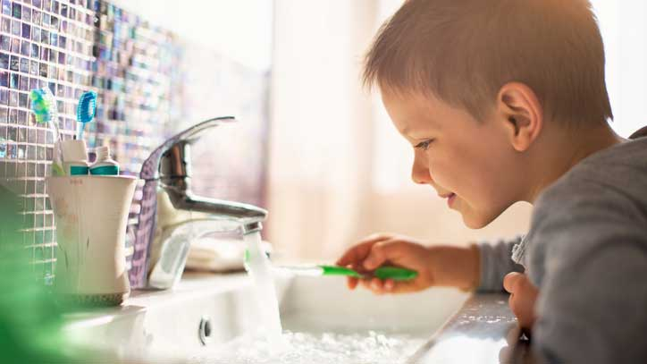
Science 8
Unit B Lesson 13
Try It!
Daily Water Use

Try this simple activity to track how you and your family directly use water during an ordinary day.

Materials:

- Water tracking chart
- Pen or pencil

Instructions:

Carry the water tracking chart with you for one entire day. Under the column “Water Use”, write down each purpose for which your family directly uses water. Under the column “Number of Times”, make a checkmark for each time you use water in that particular way.

Observations Table:

Water Tracking Chart

Water Use | Number of Times

Questions:

Think about the following questions very carefully. Then, type or write your answers. After you have your answers, click the questions in the online course for feedback.

- How many different ways did you and your family use water in a day?

- List some ways that you and your family could directly use less water everyday.

