Science 8
Unit E
Lesson 12
Self-Check Quiz

Answer all 5 questions in the spaces provided. Think carefully before typing your answers. If you need help, return to the lesson in the online course. Save your quiz when you are done.

Leave your answers in blue; it will be easier for you and your teacher to see them later.

Question 1

Why should people wash their cars in a car wash, instead of at home on the street?

Type your answer here.

Question 2

This chart shows how much water it requires to produce certain kinds of food.

Food (1 kg) | Water to Produce (L)
Beef | 15 000
Chicken | 4 000
Rice | 2 500
Potatoes | 300
Tomato | 200

What kind of diet would reduce a person’s water footprint?

Type your answer here.

Question 3

Earth’s human population has increased from 4 billion people in 1974 to 7 billion people in 2012. What effect does human population increase have on world fresh water supplies?

Type your answer here.

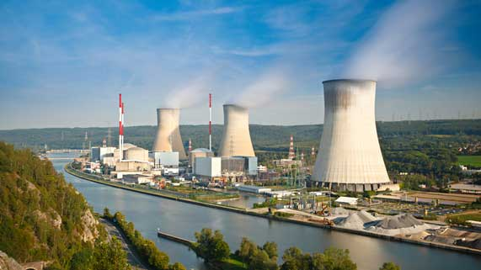
Question 4

Nuclear reactions in power plants generate large amounts of heat. This heat is used to turn water into steam. The steam spins a turbine to generate electricity.
How do nuclear power plants impact nearby water systems?

Type your answer here.

Question 5

Why should you take harmful household chemicals to a hazardous waste disposal station instead of pouring them down the drain?

Type your answer here.

Congratulations! You have completed this self-check quiz.

Now it's time to carefully compare your answers to the suggested answers in the online course. When comparing, you should feel free to make changes to your answers or make extra notes.

Don't forget to save the quiz whenever you make changes.

Keep this quiz for study purposes. If you want more feedback, share it with your teacher.

