Science 8
Unit E
Section 4
Self-Check Quiz

Answer all 5 questions in the spaces provided. Think carefully before typing your answers. If you need help, return to the lesson in the online course. Save your quiz when you are done.

Leave your answers in blue; it will be easier for you and your teacher to see them later.

Question 1

Your friend says that he has a very low water footprint because he takes short showers. How could you explain to your friend that his water footprint is higher than he thinks?

Type your answer here.

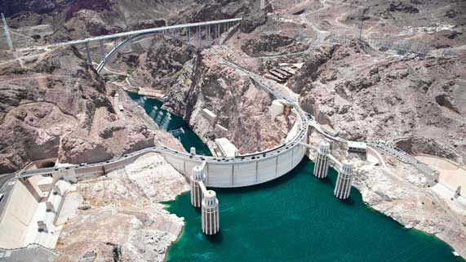
Question 2

Building dams on rivers can be controversial. What is a benefit of building dams? What is a disadvantage of building dams?
Type your answer here.

Question 3

List two industries in Alberta that use water. Explain why these industries need water.

Type your answer here.

Question 4

Why do people in developed countries like Canada and the United States use so much more water than people in developing nations?

Type your answer here.

Question 5

Why should river water upstream from towns and cities be tested and monitored frequently?

Type your answer here.

Congratulations! You have completed this self-check quiz.

Now it's time to carefully compare your answers to the suggested answers in the online course. When comparing, you should feel free to make changes to your answers or make extra notes.

Don't forget to save the quiz whenever you make changes.

Keep this quiz for study purposes. If you want more feedback, share it with your teacher.

