
Science 8
Unit E
Project
Water Problem News Report

You are required to submit this project to your teacher. Very carefully, read the project and how to do it. Be sure to read the requirements and rubric, they explain the expectations for this project and how it will be marked.

Situation

Water problems disturb the natural functioning of fresh and saltwater systems. Water problems can threaten water quality, aquatic ecosystems, and human safety. Many water problems are caused by human activity, such as climate change and contamination.

An environmental protection group wants to create news reports to inform the public about different water problems. They want people to understand why it is important to take action to fix water problems.

Project Task

Create a news report that clearly explains one water problem, how the water problem affects ecosystems and people, and what people and governments can do to help solve the water problem.

Before you begin your news report, ask yourself these questions:

- What water problem do I want to research?
- How am I going to find more information about my chosen water problem?

Method

- Choose a specific water problem. You learned about several water problems in Unit E, including the ones listed below. Choose one of the listed water problems, or choose a different water problem. Check with your teacher once you have chosen a water problem.

Possible water problem choices:
- Algal blooms
- Glaciers melting
- Rising sea levels
- Tailings ponds
- Thermal pollution
- Various kinds of water contamination

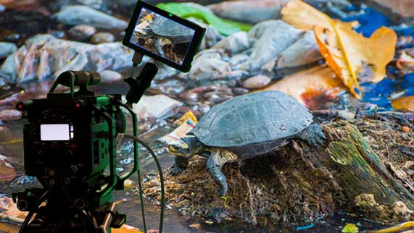
- Research your chosen water problem. Sources of information include the following:

- Unit E lessons
- Reference books
- News articles in newspapers and magazines or other publications
- Websites
- YouTube videos
- Interviews with adults who work in industries related to the water problem

- Construct a table to collect information. The table must contain information summarized in your own words. Beside each piece of supporting information, list the source of the information. For example, insert the URL of any websites, book titles and authors, newspaper names and dates of publication or names of people interviewed as your sources.

You must submit the research table with your news report.

Information about Water Problem | Source of Information

- Choose the way you would like to communicate your news report. Here are some ideas from which you can choose:


- Write a newspaper or magazine article
- Write a news press release
- Record a radio newscast
- Build a news website
- Video a news broadcast
- Write a series of social media updates
- Use some other creative idea, but check with your teacher first!
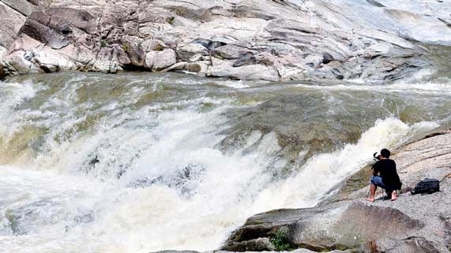
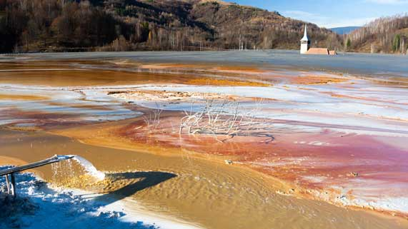
Requirements

You must communicate clearly the following information in your news report.

- Describe the water problem.

- What type of water source does the problem affect?
- Where is the water problem located on Earth?
- What negative changes are happening to the water source?
- What causes the water problem?
- How do humans make the water problem worse?

- Describe how the water problem affects ecosystems.

- What other organisms are affected by the change to the water system?
- How are populations of different species affected by the water problem?

- Explain how the water problem affects humans and human water use.

- Explain what can humans do to fix the water problem.

- How is the water problem monitored?
- What can people personally do to solve the water problem?
- What can governments do to solve the water problem?

Rubric

This project is worth 28 marks. This rubric explains how your work will be marked. It also explains all the things you need to include. Read it very carefully before starting your work.

Water Problem News Report
28 marks

CRITERIA | PERFORMANCE
CRITERIA |  | NOT OK | OK | GOOD | EXCELLENT
CRITERIA | Not Submitted  0 marks | Does not  meet criteria  1 mark | Minimally  meets criteria  2 marks | Fully  meets criteria  3 marks | Exceeds  criteria  4 marks
Research table completed | Not Submitted | Research table is not completed; it lacks details and sources of information. | Research table is somewhat completed; some details and sources of information are confusing or lacking. | Research table and sources of information are completed; some supporting details and examples are provided. | Research table and sources of information are completed; several supporting details and examples are provided.
Description of water problem, with reference to its causes | Not Submitted | No description of water problem or its causes; details are lacking. | Description of water problem and its causes is too brief and lacks detail. | Full basic description of water problem and its causes provided with some supporting details. | Full description of water problem and its causes provided with many supporting details
Description of the water problem’s effects on ecosystems | Not Submitted | No description of water problem’s effects on ecosystems; details are lacking. | Description of water problem’s effects on ecosystems is too brief and lacks detail. | Full basic description of water problem’s effects on ecosystems provided with some supporting details. | Full description of water problem’s effects on ecosystems provided with many supporting details.
Explanation of the water problem’s effects on humans and human water use | Not Submitted | No explanation of water problem’s effects on humans; details are lacking. | Explanation of water problem’s effects on humans is too brief and lacks detail. | Full basic explanation of water problem’s effects on humans provided with some supporting details. | Full description of water problem’s effects on humans provided with many supporting details.
Explanation of how the water problem can be monitored and solved | Not Submitted | No explanation of how water problem can be monitored and solved; details are lacking. | Explanation of how water problem can be monitored and solved is too brief and lacks detail. | Full basic explanation of how water problem can be monitored and solved provided with some supporting details. | Full description of how water problem can be monitored and solved provided with many supporting details.
Creativity | Not Submitted | News report is very simple and lacks imagination. | News report is simple but shows some imagination. | News report has some interesting features and shows some imagination. | News report has several interesting features and shows much imagination.
Communication | Not Submitted | News report communicates inadequately; details are lacking. | News report communicates partially; some details are confusing or lacking. | News report communicates somewhat effectively with some details. | News report communicates clearly with much detail.

Submitting Your Work
- If you do this project as pencil drawing(s) on another piece of paper, you will have to scan your work to submit it.
- If you have prepared any other electronic images or documents for this project, you will need to submit them. The same goes for any Internet location where your work is located, you will need to submit the URL so your teacher or marker can view your work.

When you are ready to submit your completed assessment, click the "Add submission" button at the bottom of the Moodle page and follow the directions. If you would like to view a tutorial on how to submit your assignment, click here.

Note that when you submit anything to your teacher, PLEASE INCLUDE YOUR NAME IN THE DOCUMENT TITLE. For example, you might title it something like this:

unitE_project_Jenny_Smith.doc

