**Name:** …………………………….

**55 marks**

**Social Studies 10-2: Unit Six Critical Challenge**

In this three part activity, you will review the main concepts in this unit. In part two you will look at three sources and analyze their perspective. Finally in part three, you will complete a writing assignment similar to that found on the Social Studies 30-2 Provincial Diploma Exam.

**PART ONE 6 marks**

Using a mind-mapping programme or on the mind-map below, take notes regarding the main issues regarding global economic development and sustainable prosperity and some possible solutions. Include “Environmental Issues” in the centre with major issues possible solutions. You may also list these issues and solutions in note form.   
*(Marks: 1 mark for each issue/solution, 1 mark for quality of presentation)*   
  
Suggested mindmapping sites:

* <http://popplet.com/>
* <https://cacoo.com/> (recommended)
* <http://www.mindmeister.com/> (available as a Google App)

SAMPLE

**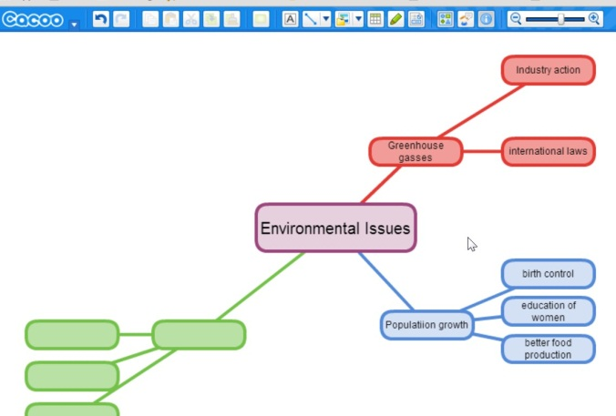**

ENVIRONMENTAL ISSUES MINDMAP

**PART TWO 24 marks**

|  |
| --- |
| **SOURCE 1**  **m4_061_breakingbank_toon**  *Cartoon by Clay Bennett, Christian Science Monitor* |
| **SOURCE 2** The Alberta Forest Usage Survey studied the values Albertans hold towards their forests. It revealed that 84% of 3000 respondents agreed that ‘Access and use of forests should be based first on preserving and protecting the environment and sustaining wildlife habitat at the expense of sustained economic benefits and jobs.’  *Source: Alberta Wilderness Association, May 2006*  [*http://news.albertawilderness.ca/NR2006/NR060509/NR060509.htm*](http://news.albertawilderness.ca/NR2006/NR060509/NR060509.htm) |
| **SOURCE 3**   * Alberta’s forest sector generates annual revenues of almost $8.4 billion. * The forest sector provides nearly 54,000 jobs for Albertans (24,195 from the primary sector and 29,490 from the secondary sector). This generates $1.6 billion in household income. * Another 15,000 jobs are directly related to the forest products industry through supplier and services providers. * Alberta’s forests are a sustainable, renewable natural resource * Forestry is a primary industry in 50 communities in Alberta. 12 communities are dependent on the forestry industry.   ***Source****: Extract from**Alberta Forest Products*[*https://www.albertaforestproducts.ca/industry/facts\_figures.aspx*](https://www.albertaforestproducts.ca/industry/facts_figures.aspx) |

**Source One**

1. **Whose** **perspective** is represented in this source? (1 mark)
2. What is the **main idea** presented by the source? (1 mark)
3. What **reasons and examples from the source** support this position? (3 marks)
4. To what extent do you share this perspective? Explain, using at least one specific example to support your position (3 marks)

**Source Two**

1. **Whose** **perspective** is represented in this source? (1 mark)
2. What is the **main idea** presented by the source? (1 mark)
3. What **reasons and examples from the source** support this position? (2 marks)
4. To what extent do you share this perspective? Explain, using at least one specific example to support your position (3 marks)

**Source Three**

1. **Whose** **perspective** is represented in this source? (1 mark)
2. What is the **main idea** presented by the source? (1 mark)
3. What **reasons and examples from the source** support this position? (2 marks)
4. To what extent do you share this perspective? Explain, using at least one specific example to support your position (**3** marks)

**Part Three: RESPONSE 25 marks**

**Using the ideas you explored in Part Two**, write a response in which you

* MCj04113060000[1]**interpret** each source to identify what the source tells you about globalization and sustainable prosperity
* **explain** your position on globalization and sustainable prosperity

Be sure to **support** your interpretations and position by referring to details in the sources, and your understanding of social studies

**Reminders for Writing  
• Remember** that you must answer both questions.

• **Plan** your response.

• **Organize** your response to address the assignment effectively.

• **Refer** to the sources on as you write your response.

• **Correct** errors that you find in your writing.

Paragraph One (Explain the perspective in the first source)

< >

Paragraph Three (Explain the perspective in the second source)

< >

Paragraph Four (Explain the perspective in the third source)

< >

Paragraph Four (Explain your position on globalization and sustainable prosperity)

< >

Your assignment will be graded according to the following scoring criteria:

|  |  |  |  |
| --- | --- | --- | --- |
| **Markers are reminded that students are working under examination conditions, have completed first draft compositions, and are responsible for three writing assignments.** | | | |
|  | **Interpretation of Sources (10 marks)** | **Defense of Position (10 marks)** | **Communication (5 marks)** |
| **Excellent**  **E** | Interpretations are **insightful and comprehensive.** Evidence is **specific and accurate** and errors, if present, do not detract from the response. The student demonstrates a **confident and perceptive understanding** of applicable social studies knowledge. Mark=9-10 | The defense of position is based on one or more **convincing, logical** arguments. Evidence is **specific and accurate** and errors, if present, do not detract from the response. The student demonstrates a **confident and perceptive understanding** of applicable social studies knowledge. Mark=9-10 | The writing is **fluent and effectively organized**. Vocabulary is **precise and effective**. The writing demonstrates **confident control.** The occurrence of error is rare.  Mark=5 |
| **Proficient**  **Pf** | Interpretations are **specific and accurate** but may not address all sources. Evidence is **relevant and appropriate** but may contain some **minor factual errors**. The student demonstrates a **clear understanding** of applicable social studies knowledge. Mark=7-8 | The defense of position is based on one or more **sound arguments**. Evidence is **appropriate, but may contain some factual errors.** The student demonstrates a **clear understanding** of applicable social studies knowledge. Mark=7-8 | The writing is **clearly organized**. Vocabulary is **accurate and appropriate**. The writing frequently demonstrates **effective control**. The occurrence of error is infrequent.  Mark=4 |
| **Satisfactory**  **S** | Interpretations are **valid but general** and **may contain minor misconceptions**. Evidence is **relevant, but general**, may be **incompletely developed,** and/or contains **minor errors**. The student demonstrates an **acceptable understanding** of applicable social studies knowledge.  Mark=5-6 | The defense of position is based on one or more **adequate** arguments. Evidence is **relevant, but general and/or incompletely developed**. The evidence **may contain errors**. The student demonstrates an **acceptable understanding** of applicable social studies knowledge**.**  Mark=5-6 | The writing generally clear and functionally organized. Vocabulary is generally accurate, but not specific. The writing demonstrates basic control. Errors do not seriously interfere with communication.  Mark=3 |
| **Limited**  **L** | Interpretations are **overgeneralized** and may contain **substantial misconceptions**. Evidence is **superficial, irrelevant or may contain significant errors**. The student demonstrates a **confused yet discernable understanding** of applicable social studies knowledge.  Mark=3-4 | The defense of position is based on **simple assertions and/or questionable logic** rather than on supportive arguments. Evidence is **superficial and may not always be relevant**. The evidence **may contain significant errors**. The student demonstrates a **limited understanding** of applicable social studies knowledge. Mark=3-4 | The writing is **uneven and incomplete** but is **discernibly organized**. Vocabulary is **imprecise and/or inappropriate.** The writing demonstrates **faltering control**. Errors hinder communication. Mark=2 |
| **Poor**  **P** | Interpretations are **mistaken or irrelevant.** Evidence, if present, is **incomplete and/or marginally relevant** and frequently contains **significant errors**. The student demonstrates a **negligible understanding** of applicable social studies knowledge. Mark=1-2 | The defense of position taken is **difficult to determine and/or little or no attempt is made to defend it**. Evidence, if present, is **incomplete and/or marginally relevant**. Significant errors in content are frequent. The student demonstrates a **minimal understanding** of applicable social studies knowledge. Mark=1-2 | The writing is **unclear and disorganized.** Vocabulary is **ineffective and frequently incorrect**. A **lack of control** is demonstrated. Errors impede communication.  Mark=1 |
| **Zero**  **0** | Zero is assigned to a response that fails to meet the minimum requirements of the Poor category. A zero may be assigned in one or more categories. | | |