**Assignment Submission**

**To submit a file(s), complete the following steps:**

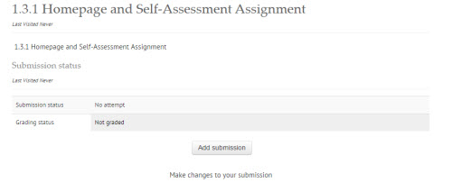

* Click “*Add submission*”.

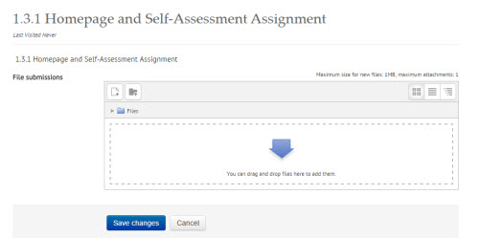

**Drag and Drop**

* Drag and drop the file(s) into the File submission area.

**Add file icon**

* **Or** click the “Add icon” to add your assignment
* Click “*Save changes*”.
* A *Submission status* page will appear.
* 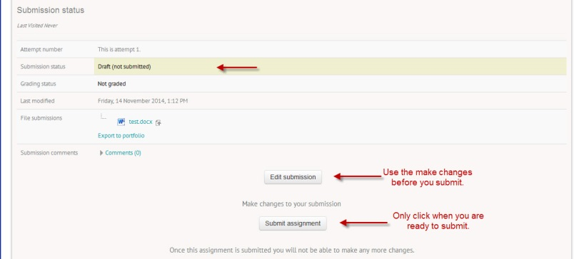**Note** that your assignment is in DRAFT form.
* You can click the “*Edit submission”* and make changes, and “*Save changes”* multiple times until you feel your assignment is ready to be submitted.
* Click “*Submit assignment*”.
* 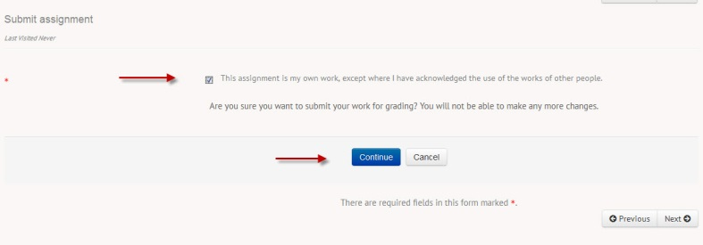Next, check the box to state this is your own work and that you are ready to submit.
* Click “*Continue”*.

Your Assignment is now submitted for marking. Continue your course work by clicking the **NEXT** button.