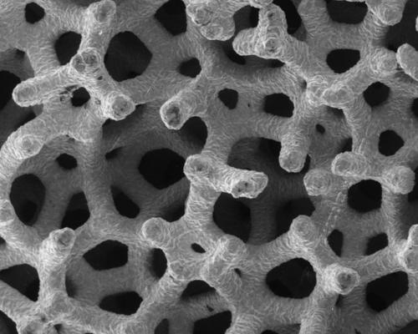

 A Great Potential for Alleviating Human Suffering

         Scientists, researchers, inventors, and lay people have always tried to make the Earth a better place for people to live. They have done this because throughout time people have demanded a safer place for themselves and their children. These demands for improvement have lead to some of the greatest inventions and advancements of all time such as computers, electricity, and medicine. Without these improvements, the Earth would be a very different place. However, making these improvements was not easy; there were many tough obstacles to overcome. Today, stem cells, the next major improvement, are having a hard time being accepted by all people. There many controversies-ethical, legal, religious, and moral-surrounding stem cell research. Stem cell research will continue despite the concerns surrounding it because stem cells could save thousands of lives, the benefits outweigh the risks, and new methods of acquiring stem cells are becoming available.

        Stem cells will provide a real cure for many previously incurable conditions. This is possible because stem cells are able to divide and form any type of cell in the body. Since they can form any type of cell, they have a big potential for usage in medicine (Cray). For example, if a person had a damaged spinal cord, and was paralyzed, it would be possible to use stem cells to re-grow the spinal cord cells outside the body and then place the new spinal cells into a person’s damaged spine to re-grow the spinal cells and cure the paralysis (Stem Cell Basics). This person’s life would be forever changed for the better. The previously incurable paralysis would have been cured. Spinal cords are just the beginning; stem cells have the possibility to cure many other ailments such as strokes, burns, heart disease, and many other life threatening problems (Stem Cell Basics). People will demand stem cell research progress because it would be unthinkable to allow people to suffer from debilitating diseases while there is a cure available.

         Many people have ethical, moral, and religious concerns about the method of acquiring embryonic stem cells. They believe that the risk of destroying a three-day-old human embryo does not outweigh the benefit of saving a suffering person. The embryos that are used are acquired from in vitro fertilization clinics, where over 400,000 unused and unwanted embryos are currently frozen. Many of these embryos are discarded annually, along with future stem cells (Cray). Many scientists feel that these unused embryos should be used, with consent, to develop stem cells. Embryonic stem cells are needed because currently they have the most potential to form any type of tissue (Stem Cell Basics). However, because human embryos are destroyed in the process, many people are apprehensive and feel that it is wrong to use embryos (Lee). Embryonic stem cells are taken when the embryo is only three days old. It is a small clump of cells with no feelings, consciousness, thoughts, or heartbeat; it can only be seen with a microscope. There are concerns and apprehensions that three day old cells have the potential to be human life (Kinsley). However, there are many religious groups which do not condemn embryonic stem cell research because it has the ability to alleviate human suffering. For example, Judaism allows for embryos left over from in vitro fertilization to be used in stem cell research (Eisenberg). Embryonic stem cells have the greatest possibility to form different types of cells and are therefore very important in the use of curing previously incurable diseases (Stem Cell Basics). The benefits of healing a suffering human being far outweigh the loss of three cells.

        The final reason why stem cell research will continue is that new methods of acquiring stem cells are becoming available. Scientists have already found other methods of procuring stem cells. New research has found that many adult organs contain stem cells which form new cells. However, this is not a simple solution; it is harder to make the adult stem cells change into the desired cell (Stem Cell Basics). Another type of stem cell discovered is umbilical-cord cells. These stem cells come from the umbilical-cord and do not require the destruction of an embryo (Cray). However both of these methods are not perfect and do not generally produce all of the desired cells. This year a technique for reverting an adult mouse cell back to its embryonic state was discovered. This by far is most promising because embryonic stem cells can be used without the loss of an embryo (Walsh). The discovery of new techniques for acquiring stem cells will push stem cell research further and continue to help stop much human suffering.

        The true genius and the ultimate failure of the human race is that it always demands more. Since their beginnings, humans have always demanded a better life and less suffering. Stem cell research is something that mankind has demanded for a long time: a way to cure many debilitating diseases. Stem cell research will continue because it is what humanity craves, a way to save lives, something in which the benefits outweigh the risks, and something that will continue to get better. In summary, stem cell research will continue because people will want to save the ones they love.

Works Cited

Cray, Dan; Gibbs, Nancy; Park, Alice. “Stem Cells. The Hope and the Hype.”     Time. 7 August 2006: 40-46.

Eisenberg, Daniel, M.D. “Is the destruction of preexisting pre-embryos permitted for stem cell research?” [Aish.com](http://Aish.com). 11 Nov. 2001. [Aish.com](http://Aish.com). 23 Nov. 2007. <[www.aish.com...](http://www.aish.com/.../Is_Stem_Cell_Research_Ethical)$.asp>.

Kinsley, Michael. “The False Controversy of Stem Cells.” Time. 31 May 2004:88.

Lee, Thomas F. "Stem Cells." Encyclopedia Americana. 2007. Grolier Online. 4 Nov. 2007 <[ea.grolier.com...](http://ea.grolier.com/.../article?)

“Stem Cell Basics.” Stem Cell Information. The National Institute of Health. 4 Nov. 2007. <[stemcells.nih.gov...](http://stemcells.nih.gov/.../defaultpage.asp)>.

Walsh, Bryan. “Stem Cells: Japan Gets Ahead of the Curve.” Time. 14 Jun. 2007:67-68.

Retrieved from: <https://campus.digication.com/English9/Student_Research_Paper_Example>