**Unit 1**

**Early Canada**

Name: < >

Date: < >

**Chapter 4, Lesson 1: Venn Diagram Activity**

Instructions for this activity are below.

Do **one** of the following:

• Print and complete the **Venn Diagram Template**.

• Complete the **Characteristics of the English and French Fur Trade** chart on the following page.

Venn Diagram Template

• If you are using the printable template to complete the **Venn Diagram**, print the page containing the template at the **end of this document**.

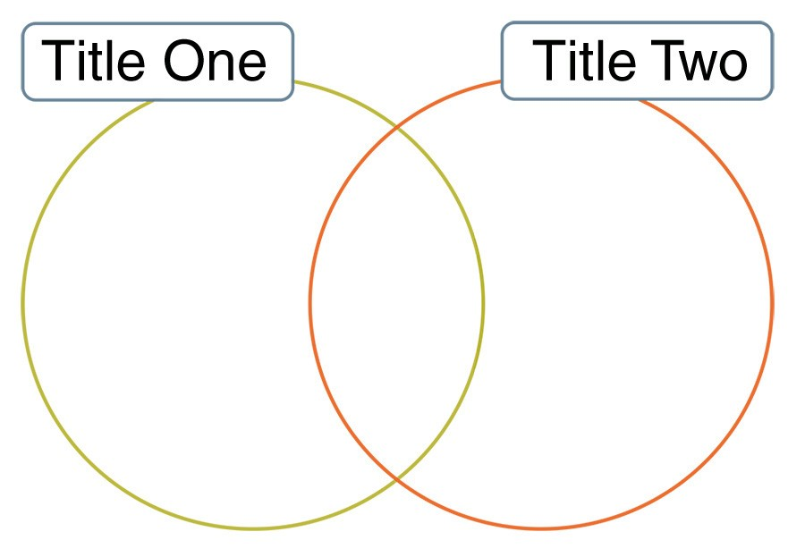

○ In the first title space, write *Characteristics of the*

*French Fur Trade*.

○ In the second title space, write *Characteristics of the*

*English Fur Trade*.

○ The overlapping space will be where you enter information that is the *Same*.

Proceed to the next page if you are completing the chart instead of the Venn Diagram.

Characteristics of the English and French Fur Trade Chart

Complete the following chart. Type your responses between the blue brackets provided.

|  |  |  |
| --- | --- | --- |
| **Characteristics of the French**  **Fur Trade** | **Same** | **Characteristics of the English Fur Trade** |
| < > | < > | < > |

**2**

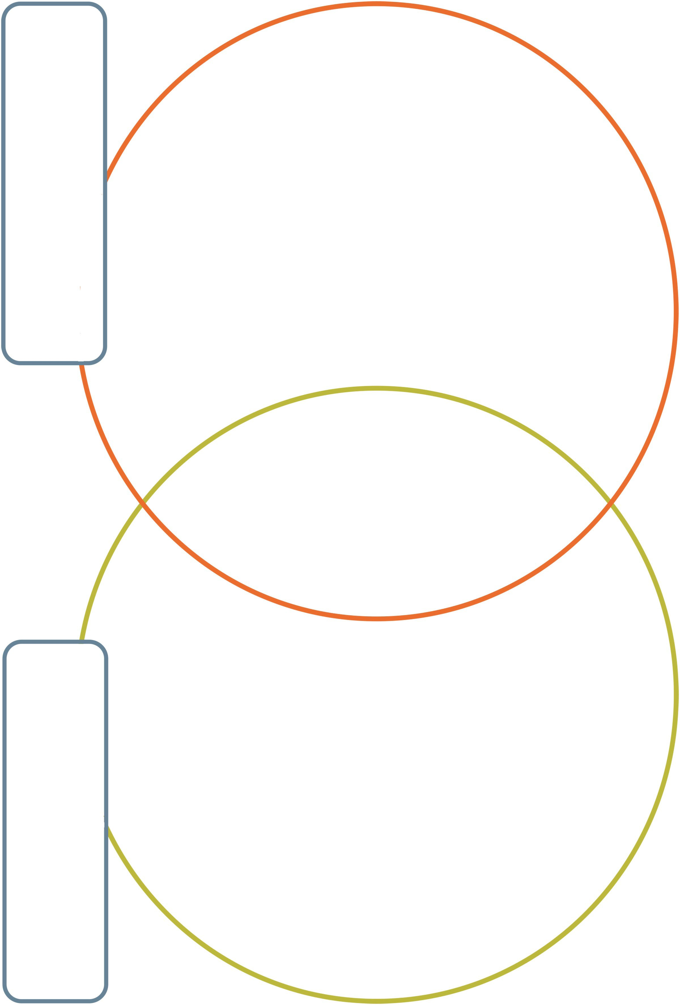

**3**