Unit 4 Name: < >
After Confederation – Part 2 Date: < >

Chapter 11, Lesson 2 Activity

A Pluralistic Society

Complete the following chart. Type your responses between the blue brackets provided.

Group | Why did they come? | Was this a push factor or a pull factor?
Barr Colonists | < > | < >
Hutterites | < > | < >
British Home Children | < > | < >

Answer the following questions. Type your responses between the blue brackets provided.

- What are two ways Francophones left their mark in Western Canada?

< >

- In what ways did Canadien missionaries and Francophone businesses contribute to the development of communities in the West?

< >

- Why is the community of St. Boniface an important community?

< >

4. What did Canadiens do to boost the population of Francophones in the West?
< >

- Look at the chart on page 260 in Voices and Visions: A Story of Canada. This chart shows the ethnic origins of Canadians. Which group grew the most? Was Canada successful in its goal of attracting immigrants?

< >

- Compare the following two pictures of ploughing a field. In the boxes below the pictures describe two similarities and two differences in the pictures.

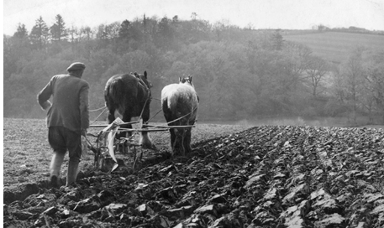 | 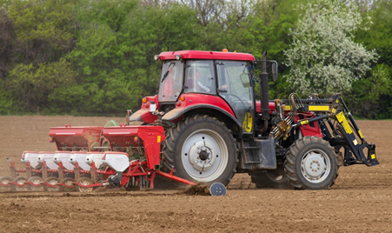

Similarities | Differences
< > | < >

