**Social Studies 30-2** 

**1.13 Assignment: Discovering the Influence of Ideology**

[Here is a link to the instruction video also found on the assignment download page](https://adlc.wistia.com/medias/76gel0xlq5)

Issue Question: *Should identity be the foundation of ideology?*

Big Ideas

*Explore factors that may influence individual and collective beliefs and values.*

*The extent to which personal identity should be shaped by ideologies.*

 This is a 3-part assignment.

In this assignment, you will explore the influence of ideology on identity by examining the extent to which the beliefs, values, and actions of certain famous personalities reflect their ideologies.

***ideology*:** a theory or concept about the way in which society should be organized; a system of thought that includes beliefs and values that can be seen through actions

Typically, an ideology is the creation of a group (political, cultural, or economic) for the purpose of spreading or keeping its perspective on reality among themselves and others.

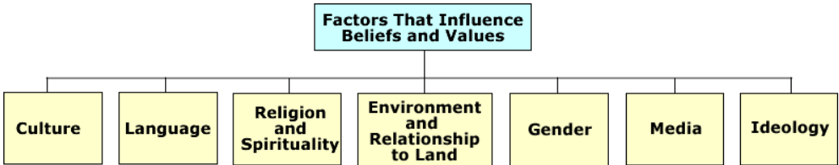

Ideologies are ways of seeing the world that include **characteristics** (interpretations of history, beliefs about human nature, beliefs about the structure of society, visions for the future)

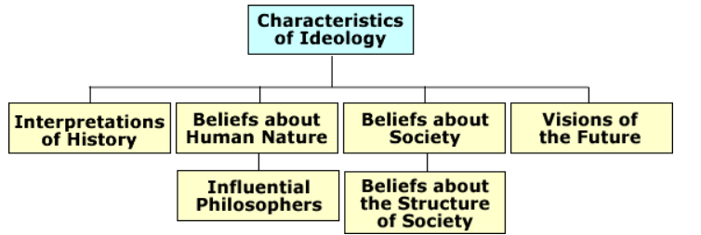

and **themes** (nation, class, relationship to land, environment, religion).

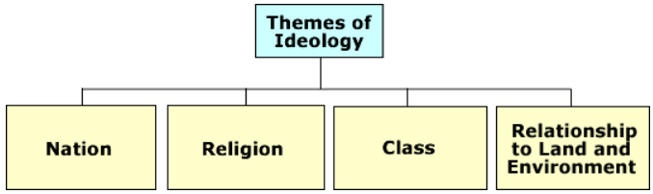

Understanding the identity of a person or group through their beliefs, values, and actions can lead to understanding their ideology: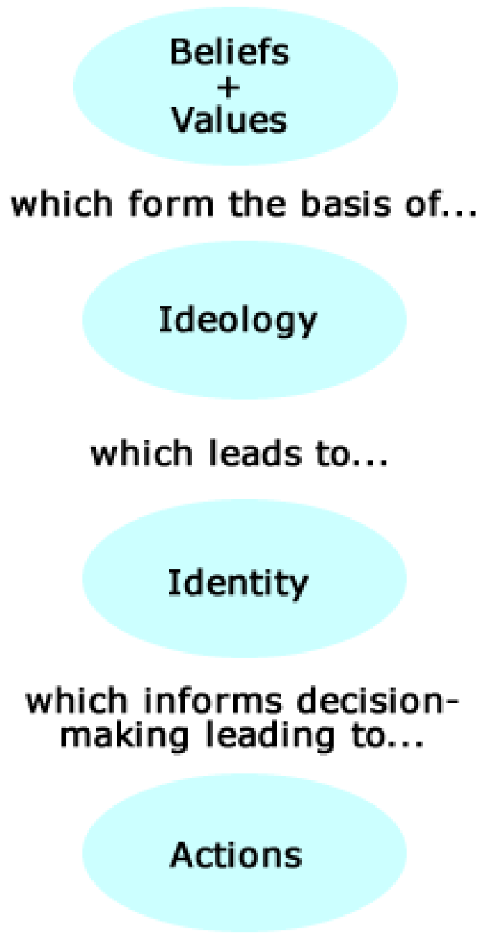

* Do our actions reveal our beliefs and values?
* What factors influence our beliefs and values?
* Along with actions, what do beliefs and values reveal about the identity of a person or group?

**Note:** You will need access to research sources using internet searches to complete this assignment. Utilize a search engine such as “Google Search” to help you access the information you require to complete the assignment. Narrow your search parameters by typing the name of your famous person then a “comma” and biography. Example: *Mother Theresa, biography*. You may want to review “How to Conduct Research on the Internet” and “How to Cite References” attached to this assignment. If you do not have access to Internet resources, complete your research using library sources.

 **Part One** 

**Examining the Beliefs, Values, and Actions of Some Famous People**

Research a famous person who has influenced your life in the following chart. Research at least two sites on the Internet for this person to complete the following chart.

Total /5

 Part One Research 

The following example of Mother Theresa is done as an example for you. 1 mark per box which is 5 marks. * Remember to include the URL for your research site.

|  |  |  |  |  |
| --- | --- | --- | --- | --- |
| **Famous People** | **What do his or her actions reveal about his or her beliefs and values? What do he/she believe or value?** | **What factors influenced his or her beliefs and values?** | **In addition to actions, what do his or her beliefs and values reveal about his or her identity?** | **Factors that have influenced the person’s actions. Use factors from the textbook readings pages 10-20.** |
| **Example:**  **Mother Theresa**  **Possible answers include:** | Believed in religion, humanity  Valued serving children and the poor  Committed to helping the poorest of the poor; love and respect for humanity | In her early years she was fascinated by stories of the lives of missionaries  Often went on religious  pilgrimages at a young age  Had a religious calling to live among the poor | Devotion to serving God  Selfless and committed | Committed to serving humanity  Religion |

 Part One Research 

1 mark per box which is 5 marks. * Remember to include the URL for your research site.

|  |  |  |  |  |
| --- | --- | --- | --- | --- |
| **Famous Person** | **What do his or her actions reveal about his or her beliefs and values? What do he/she believe or value?** | **What factors influenced his or her beliefs and values?** | **In addition to actions, what do his or her beliefs and values reveal about his or her identity?** | **Factors that have influenced the person’s actions. Use factors from the textbook readings pages 10-20. readings.** |
| Use your own words. |  |  |  |  |
| Copy the URLs (website addresses) that you used to research. (Remember that you are to use at least **two** sites.) | | | | |

/5

 Part Two Self Inventory 

Conduct a self inventory of your Factors that Influence Beliefs and Values and record them on the chart below. You will need to reference this chart in your written response.

There are 7 marks for the chart but you must complete all of the entries.

|  |  |
| --- | --- |
| Factors that Influence Beliefs and Values | Your personal example |
| Culture |  |
| Language |  |
| Religion and Spirituality |  |
| Gender |  |
| Media |  |
| Ideology |  |
| Relationships to the Land |  |

/7

 Part Three Written Response 

Create a written response that explains how both you and the famous person you researched were influenced by the Factors That Influence Beliefs and Values. Relate these factors to your Ideological worldview.

**/15 marks** *based on the Rubric found at end of assignment







 Part Three Written Response 

 **Response Outline**

**Outline for Response:**

* Name the person and the **factor** that had the largest impact on the person’s identity.
* Write a brief description of the person’s life.
* What factors influenced them the most?
* What factors influenced the person’s actions? Link them to the factor you chose.
* What do his or her actions reveal about his or her beliefs and values? State the person’s beliefs and values.
* In addition to actions, what do his or her beliefs and values reveal about his or her identity?
* What factor(s) have influenced you the most?
* How have your actions been influenced by your factors of belief and values?
* How has this shaped your worldviews?

**Suggestions for Success:**

* Avoid biography-type summaries of the person’s life.
* Make this response a large paragraph of 7–10 sentences.
* Avoid including too many factors; focus on 1–3.
* Make sure you use factors from unit one course material.

How to cite references tutorial video [here](https://adlc.wistia.com/medias/swn14i9qs7).

How to cite references tutorial [here](https://moodle.adlc.ca/mod/page/view.php?id=10701652).

<Write your response here.>

# **Rubric for Position Paragraph(s)**

|  |  |  |
| --- | --- | --- |
| **Scoring Criteria:**  **Position Paragraph(s)** | **Explanations and Support**  **10 marks**  When marking ***Explanations and Support***, markers should consider the   * quality of explanations * selection and quality of support | **Communication**  **5 marks**  When marking ***Communication***, markers should consider   * organization and coherence * vocabulary (specificity and accuracy) * sentence construction (clarity and completeness) * grammar and mechanics (consistency of tense, punctuation, spelling, and capitalization) |
| **Excellent**  **E** | Explanations are thorough and comprehensive, revealing a perceptive understanding. Support is specific and accurate. Errors, if present, do not detract from the response. 10 | The writing is fluent and effectively organized. Vocabulary is precise and effective. The writing demonstrates confident control of sentence construction, grammar, and mechanics. The occurrence of errors is rare.  5 |
| **Proficient**  **Pf** | Explanations are appropriate and purposeful, revealing a clear understanding. Support is relevant and appropriate but may contain some minor errors. 8 | The writing is clearly organized. Vocabulary is accurate and appropriate. The writing frequently demonstrates effective control of sentence construction, grammar, and mechanics. The occurrence of errors is infrequent. 4 |
| **Satisfactory**  **S** | Explanations are general and straightforward, revealing an acceptable understanding. Support is relevant but general, may be incompletely developed, and/or contains errors. 6 | The writing is generally clear and functionally organized. Vocabulary is generally accurate but not specific. The writing demonstrates basic control of sentence construction, grammar, and mechanics. Errors do not seriously interfere with communication. 3 |
| **Limited**  **L** | Explanations are overgeneralized and/or redundant, revealing a confused, though discernable, understanding. Support is superficial, may not always be relevant, and contains significant errors. 4 | The writing is uneven and incomplete but is discernibly organized. Vocabulary is imprecise and/or inappropriate. The writing demonstrates faltering control of sentence construction, grammar, and mechanics. Errors hinder communication. 2 |
| **Poor**  **P** | Explanations are tangential or minimal, revealing a negligible understanding. Support, if present, is incomplete, may be marginally relevant, and contains significant and/or frequent errors. 2 | The writing is unclear and disorganized. Vocabulary is ineffective and frequently incorrect. The writing demonstrates lack of control of sentence construction, grammar, and mechanics. Errors impede communication.  1 |
| **Total: /15** | | |
| **Areas of Strength** |  | |
| **Areas to Improve** |  | |
| **Totals** | **Charts: /12 Paragraph: /15 Total: /27**  Once your assignment is graded, always review the comments and the feedback file. You will be expected to use those comments and feedback in your next assignment. | |

**Example One 12/15**

A person’s identity reflects their ideology in so many ways. Many factors play a role in shaping their identity such as their culture, religion, their gender, or even the media. Nelson Mandela was an important man and throughout his life he did a lot of very influential work that shaped South Africa and even made a difference worldwide. Throughout his life he worked to fight against racism in a way that not many people use to resolve conflict. He worked with the ANCYL to help make a difference in the way decisions were made politically and to break the barriers on racism and inequality. This shaped his identity in so many ways. His work has showed us that he values his people and strongly believes in equality of everyone. You could say that Nelson’s identity is based around equality and that he is a global citizen because he wants equality for everyone no matter what their race or background is. This also relates to his ideology because he and many others believe that equality is essential in the world.

My own belief about the importance of my relationship to the land and environment are very strong influences on my actions. I have been going out into the wilds for many years of my life and have been taught to respect nature and to see the beauty of it. I strongly believe that it must be protected. When I go out into the wild I experience a strong spiritual connection. Combined with this I feel it is important to be free to make individual choices so my personal ideology is more individualism but I do think that there much be some concern for the collective actions as well because we are very interconnected. As a result I believe that society should allow all people to have freedom of choice I also except that society is interconnected so individualism must sometimes be restricted by collective ideas because there should be some protection for the common good. Therefore I do accept the need for hunting law. I have become very involved with conservation efforts and the need to educate people who want to experience the natural world. So therefore your beliefs and values are critical in a person’s identity and their identity. **(This is good, but I’d like to see you relate specific factors of beliefs and values, such as culture, a bit more to specific actions that he took as a result of his ideology. Remember to use specific reference ot characteristics of ideology that Mandela displayed. Eg. Beliefs about the structure of society and beliefs about society. 12/15)**

**Example Two 8/15**

Angelina Jolie is a great actress and has many winning awards. However not only that, she is part of many organizations that help people around the world. Such as the UNHCR, women rights, and child immigration and education. Media, Gender, and Religion have all shaped Angelina’s identity and ideology. (please explain and give examples for each.) Her beliefs and values are obviously helpful to many people. She has adopted children, and works hard on spreading awareness for women rights. These actions have shaped her as a great person and her identity really gives us clear message of who she is and what she believes in.

Because I have many of the same types of influences on my beliefs and values as Angelina she has been a strong influence for me. I think that women can be strong leaders for good in this world. Someday I hope to work on this issue as well.

(Your response needs to center around the factors from the readings. Link the actions of your person as well as yourself to the factors list. In addition you should link your beliefs and actions to your world view.)