**Social Studies 30-2**

**Unit 2.12 A The Chart**

**Critical Challenge: Balancing Individualism, Collectivism and the Common Good**

[Here is a link to the instruction video also found on the assignment download page](https://adlc.wistia.com/medias/rjfrfput8o)

**Issue Question:** *Should identity be the foundation of ideology?*

**Big Ideas**

|  |  |
| --- | --- |
|  | * *Examine the relationship between individualism and common good in contemporary societies.* * *Appreciate various perspectives regarding identity and ideology.* |
|  | * *This is a two-part assignment.* |

**Contents**

Instructions 2

Part One Canadian Values 2

# **Instructions**

In this assignment, you will assess the degree to which individualism, collectivism, or a combination of the two, best promotes the common good.

**Do individualism and collectivism both contribute to the common good?**

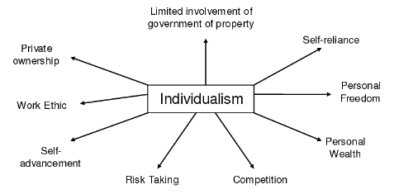 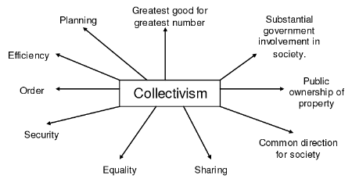

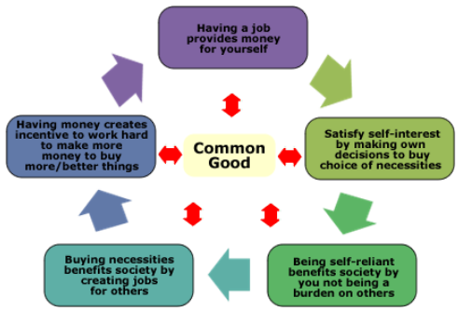



# **Part One Canadian Values**

**The Relationships of Individualism, Collectivism, and the Common Good**

In the following chart, provide a description of Canada’s actions under the ideologies of collectivism and individualism. Evaluate Canada as an example of either an individualist or collectivist society.

**\***You should review ***Unit 2.3 Values of Individualism and Liberalism***, ***Unit 2.6 Values of Collectivism***, and ***Unit 2.10 Individualism, Collectivism, and the Common Good*** before you complete the chart.

Define this terms in your own words.

**Total /6**

|  |  |  |  |
| --- | --- | --- | --- |
| **Key Values** | | **Define each term in your own words** | **Canada’s actions or an example in your own words** |
| **Values of Collectivism**  **Textbook pages 81-88**  **/3 Marks** | **Economic:** Public Property, Economic Equality |  |  |
| **Social:** Cooperation, Collective Responsibility, Adherence to Collective Norms |  |  |
| **Values of Individualism**  **Textbook pages 49-58**  **/3 Marks** | **Political:** Rule of Law, Individual Rights and Freedoms |  |  |
| **Economic:** Economic Freedom, Self-Interest, Competition, Private Property |  |  |
| **Social:** Individual Freedoms |  |  |

**Social Studies 30-2**



**2.12 B Form the Outline**

[Here is a link to the instruction video also found on the assignment download page](https://adlc.wistia.com/medias/4dboqhs3w1)

**Issue Question:** *Should society address its needs predominantly through collective or individualistic approaches?*

**Big Ideas**

|  |  |
| --- | --- |
|  | * *Examine the relationship between individualism and common good in contemporary societies* * *Appreciate various perspectives regarding identity and ideology.* |
|  | * *This is a one-part assignment.* |

**Contents**

Getting Started 5

Part One Outline 6

Total /6 10

Teacher Feedback 10

# **Getting Started**

Choose **one** of these current interests to center your position paper around.

Environmentalism First Nations Interests Metis or Inuit Interests Immigration Oil/fossil fuel Gender Identity

Legalization of Marijuana Quebec Sovereignty Gun Control

Internationalism Globalization Homelessness

Veterans Care Fertility Healthcare Coverage Senior Citizen Care

Fishing and Hunting Language Preservation LGBTQ Interests

Terrorism/National Security

|  |  |  |
| --- | --- | --- |
| **Citizen One** | **Citizen Two** | **Citizen Three** |
| https://lh3.googleusercontent.com/aJZe7gPqidAXipcQ_A6mPKXwLNfcekOjLme4WkSvkX0Ms2tJZ25BPQdlJL-GhShWdBNMo_oYHbyQJ4tRPkb9PkmvYbRd-r-jxg_XbgaNw77ELgwXv4J_O2qp-6Bdwn2WsNhslCc3KOrGzzZ9iw | https://lh5.googleusercontent.com/gGmXD1kmSWTpO_S_LqMJwvipMyICYNCW7f1AoD1AYqHa611szqFetKxE_HGVl3MKt9XOAygqfYGHNsNC48jTaluU4mV-qt37uoPdqbhhWPCTOJYY_Gfy_eZy8HiUn_89CZiDt15exQbwY6I01Q | https://lh3.googleusercontent.com/px5Xx3auJvH-WhgoaX14ZRpFzy-5guMyizDTKCEDhR8T7cVbU0hax08kDr20pTCrSfGygtNyuB6tX3uEZEuO32cA_4gMo925FuK1Q0IhBGSTAoPp6gjc7SBDE1PadoymH8Cu0Vo21SRZmHoNNw |
| I believe in pluralism.  As a group we can recognize individual and collective principles to achieve the needs of the common good. Pluralism allows us to balance our individual judgments, and relate them as a collective union for the common good. | When people live by their own will and intelligence they can achieve success. Individuals who are allowed to pursue prosperity and happiness are best suited to satisfy their own interests. The common good is best achieved if each person is a responsible citizen. As individuals profit from their efforts, their success is a benefit to the common good. | Prosperity and happiness are best achieved when people work together toward common goals in a collectivist approach. Each person is responsible for the goals of society. The common good of society is achieved when everyone works together to achieve that goal. Individual goals should be given less emphasis than those of society. |

* **Explore** the issue of how Canadians approach a current interest
* **Analyze** different perspectives on the issue
  + **Do not simply restate the individual citizens’ points of view from the prompt. You must identify different ideological perspectives on the issue.**
* **Explain and defend** your position on the question.
* **Support** your point of view using your understanding of social studies.
* **Use terminology** from the chart 2.12A to support.

# **Part One Outline**

**This outline is formative**. You will receive feedback on your ideas and support before completing assignment 2.12 C

**Total /6** What is the topic from the above list? I choose ____________.

**Paragraph 1 Exploration and Analysis**

|  |
| --- |
| Write about the complexity of your chosen interest in society. Why is it important? Why is this interest so complex? (2-3 points) You may use point form. |

|  |
| --- |
| What ideologies (beliefs and values) can you bring in to show the complexity of your interest? Can you put this issue on the spectrum?  (2-3 points) You may use point form. |

|  |  |  |
| --- | --- | --- |
| How does your interest link to the values of collectivism and individualism? Relate your interest to both approaches to show complexity. 2-3 points. | Which principles of liberalism can you apply to your interest? (What freedoms are protected or taken away?)   |  | | --- | | Liberalism includes: Private property, rights & freedoms, rule of law, competition, economic freedom and self-interest, cooperation, collective responsibility, adherence to norms, economic equality, public property |   Explain in 3-4 points |

**Thesis Statement**

Use the information from your outline tocompose a thesis statement regarding the complexity and perspectives on the issue you chose.

Remember, your thesis should present a position either for or against the issue you have chosen.

|  |
| --- |
| 1 sentence |

**Paragraph 2: Perspective on the Issue**

Suggestions for success:

* Do not skip this paragraph
* Make it 7-10 sentences
* Use course terminology
* Close with a thesis around the fact there is multiple perspectives on the matter.

|  |
| --- |
| How might a ***collectivist*** argue for or against your issue?   * a belief in the value of the collective, or group, above the individual * That is, the group is more important than the individual. * By addressing the needs of the collective good rather than individual needs, the common good is taken care of.   Provide examples to support this perspective. Include a current event, or a country and ideologies. **Apply terminology from 2.12 A**. 5-7 points. |

**Paragraph 3: Perspective on the Issue**

|  |
| --- |
| How might an ***individualist*** argue for or against your issue?   * a belief in the value of the individual above the group * That is, the individual is more important than the group. * By addressing the needs of the all individuals, the common good is taken care of at the same time. * Provide examples to support this perspective. Include a current event, or a country and ideologies. **Apply terminology from 2.12 A**. 5-7 points. |

**Paragraph 4: Perspective on the Issue:**

 Suggestions for success:

* Do not skip this paragraph
* Make it 5-7 sentences each
* Use course terminology
* **Do not simply copy down the citizen prompts. That is called *cribbing* and gets you no marks.**

|  |
| --- |
| How might the ***common good*** be argued for or against your issue? (please go to the glossary to make your you can define the term)  Provide examples to support this perspective. Include a current event, or a country and ideologies. **Apply terminology from 2.12 A**. 5-7 points. |

**Paragraph: 5 Your Position**

Suggestions for success:

* Do not skip this paragraph
* Make it 6-10 sentences
* Use course terminology
* Pick a position

|  |
| --- |
| Pick for or against the interest you’ve chosen. Explain why you are for or against this interest. Use **supportive examples** and **terminology** to support your position. Include a current event, or a country and ideologies. **Apply terminology from 2.12 A**. 6-10 points. |

**Submit this to your teacher in 2.12 B. Wait for feedback. Apply the feedback you receive to 2.12 C**

# **Total /6**

# **Teacher Feedback**