**Social Studies 30-2**

**Unit 2.12 A The Chart**

**Critical Challenge: Balancing Individualism, Collectivism and the Common Good**

[Here is a link to the instruction video also found on the assignment download page](https://adlc.wistia.com/medias/rjfrfput8o)

**Issue Question:** *Should identity be the foundation of ideology?*

**Big Ideas**

|  |  |
| --- | --- |
|  | * *Examine the relationship between individualism and common good in contemporary societies.* * *Appreciate various perspectives regarding identity and ideology.* |
|  | * *This is a two-part assignment.* |

**Contents**

Instructions 2

Part One Canadian Values 3

# **Instructions**

In this assignment, you will assess the degree to which individualism, collectivism, or a combination of the two, best promotes the common good.

**Do individualism and collectivism both contribute to the common good?**

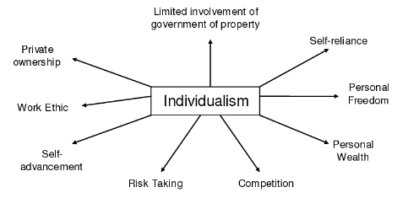 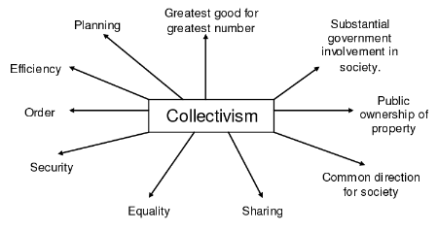

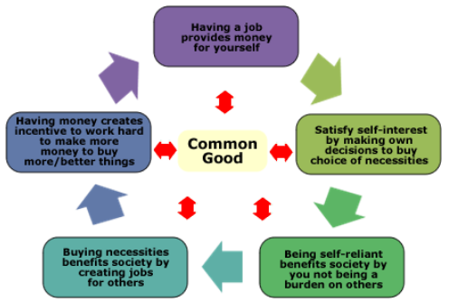



# **Part One Canadian Values**

**The Relationships of Individualism, Collectivism, and the Common Good**

In the following chart, provide a description of Canada’s actions under the ideologies of collectivism and individualism. Evaluate Canada as an example of either an individualist or collectivist society.

**\***You should review ***Unit 2.3 Values of Individualism and Liberalism***, ***Unit 2.6 Values of Collectivism***, and ***Unit 2.10 Individualism, Collectivism, and the Common Good*** before you complete the chart.

**Total /6**

|  |  |  |  |
| --- | --- | --- | --- |
| **Key Values** | | **Define each term in your own words** | **Canada’s actions or an example in your own words** |
| **Values of Collectivism**  **Textbook pages 81-88**  **/3 Marks** | **Economic:** Public Property, Economic Equality | **1.**  **2.** | **1.**  **2.** |
| **Social:** Cooperation, Collective Responsibility, Adherence to Collective Norms | **1.**  **2.**  **3.** | **1.**  **2.**  **3.** |
| **Values of Individualism**  **Textbook pages 49-58**  **/3 Marks** | **Political:** Rule of Law, Individual Rights and Freedoms | **1.**  **2.** | **1.**  **2.** |
| **Economic:** Economic Freedom, Self-Interest, Competition, Private Property | **1.**  **2.**  **3.**  **4.** | **1.**  **2.**  **3.**  **4.** |
| **Social:** Individual Freedoms | **1.** | 1. |