**Social Studies 30-2**

**Unit 2.12 C Critical Challenge: Balancing Individualism, Collectivism and the Common Good**

[Here is a link to the instruction video also found on the assignment download page](https://adlc.wistia.com/medias/7fwuz8ld60).

**Issue Question:** *Should identity be the foundation of ideology?*

**Big Ideas**

|  |  |
| --- | --- |
|  | * *Examine the relationship between individualism and common good in contemporary societies* * *Appreciate various perspectives regarding identity and ideology.* |
|  | * *This is a two-part assignment.* |

**Contents**

Introduction 2

Part Two Written Response 4

Suggestions for Success 4

Your Written Response 6

Suggestions for Success 7

Rubric: Exploring an Issue and Defending a Position 8

Student Exemplars 9

# **Introduction**

In this assignment, you will assess the degree to which individualism, collectivism, or a combination of the two, best promotes the common good.

**Do individualism and collectivism both contribute to the common good?**

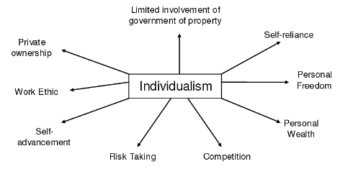 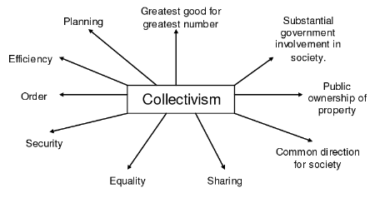

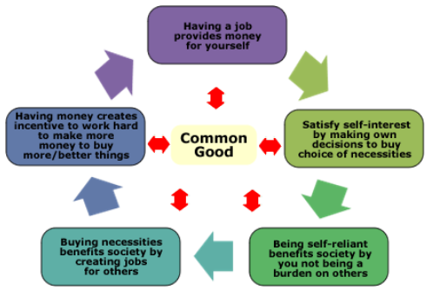



/**1 Mark**

|  |
| --- |
| **Based on part A chart information, place an X where you think Canada belongs on the following spectrum:**      __________________________________________________________ |

**/3 Marks**

|  |  |  |
| --- | --- | --- |
| **Citizen One** | **Citizen Two** | **Citizen Three** |
|  |  |  |
| I believe in pluralism. As a group we can recognize individual and collective principles to achieve the needs of the common good. Pluralism, allows us to balance our individual judgments, and relate them as a collective union for the common good. | When people live by their own will and intelligence they can achieve success. Individuals who are allowed to pursue prosperity and happiness are best suited to achieve satisfy their own interests. If each person is a responsible citizen then common good is best achieved. As individuals profit from their efforts, their success is a benefit to the common good. | Prosperity and happiness are best achieved when people work together toward common goals in a collectivist approach. Each person is responsible for the goals of society. The common good of society is achieved when everyone works together to achieve that goal. Individual goals should be given less emphasis than the goals of society receive. |
| **Place each of these citizens (1, 2, 3) on the correct position on the following spectrum.**    **Collective**  **Centre**  **Individualism**  **Left Wing** **Right Wing**  __________ ___________ ___________ | | |

# **Part Two Written Response**

Those who promote either individualism or collectivism have differing perspectives on how to uphold best the common good. Some thinkers believe that individualism contributes to the common good while extreme collectivism may be harmful to the common good; such as, totalitarian governments that ignore human rights and freedoms.

Other thinkers, suggest that collectivism contributes to the common good, while extreme individualism may actually be harmful to the common good; such as, lows in the economy characterized by excessive unemployment.



## **Suggestions for Success**

* **Review your understandings of ideological perspectives.** Think about everything you have learned in this course:

1. What are the **main reasons** you support your ideological perspective on the issue?
2. What information will help you **defend** your position?
3. What **specific examples** can be used to support your position?  Evidence can be theoretical, historical, contemporary, or current.

* Avoid re-stating the citizens’ statements. Discuss ideological perspectives that people might use to address the issue.
* Make sure that you state your own perspective. Avoid simply saying that you agree with a certain citizen. Make your position your own.
* Your response should have a minimum of 3 paragraphs.

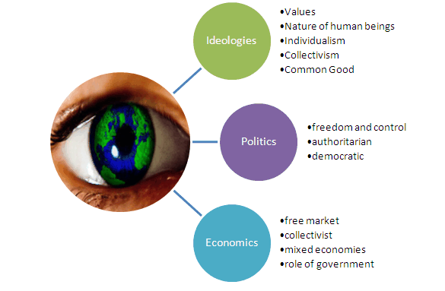

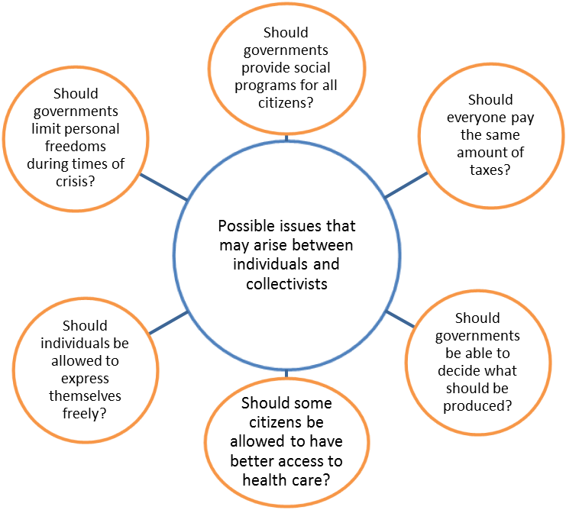

# **Your Written Response**

**Should society address its needs predominantly through collective or individualistic approaches?**

In this assignment, you will write a paragraph exploring the degree to which individualism, collectivism, or a combination of the two, best promotes the common good. You will use the feedback provided on your 2.12B Outline to help you with your response.

**Total /20** *Based on the Rubric found at the end of the assignment.

Choose **one** of these current interests to center your position paper around.

Environmentalism

First Nations Interests

Metis or Inuit Interests

Immigration

Oil/fossil fuel

Gender Identity

Legalization of Marijuana

Quebec Sovereignty

Gun Control

Internationalism

Globalization

Homelessness

Veterans Care

Fertility Healthcare Coverage

Senior Citizen Care

Fishing and Hunting Interests

Language Preservation

LGBTQ Interests

Terrorism/National Security

|  |  |  |
| --- | --- | --- |
| **Citizen One** | **Citizen Two** | **Citizen Three** |
| https://lh3.googleusercontent.com/aJZe7gPqidAXipcQ_A6mPKXwLNfcekOjLme4WkSvkX0Ms2tJZ25BPQdlJL-GhShWdBNMo_oYHbyQJ4tRPkb9PkmvYbRd-r-jxg_XbgaNw77ELgwXv4J_O2qp-6Bdwn2WsNhslCc3KOrGzzZ9iw | https://lh5.googleusercontent.com/gGmXD1kmSWTpO_S_LqMJwvipMyICYNCW7f1AoD1AYqHa611szqFetKxE_HGVl3MKt9XOAygqfYGHNsNC48jTaluU4mV-qt37uoPdqbhhWPCTOJYY_Gfy_eZy8HiUn_89CZiDt15exQbwY6I01Q | https://lh3.googleusercontent.com/px5Xx3auJvH-WhgoaX14ZRpFzy-5guMyizDTKCEDhR8T7cVbU0hax08kDr20pTCrSfGygtNyuB6tX3uEZEuO32cA_4gMo925FuK1Q0IhBGSTAoPp6gjc7SBDE1PadoymH8Cu0Vo21SRZmHoNNw |
| I believe in pluralism.  As a group we can recognize individual and collective principles to achieve the needs of the common good. Pluralism allows us to balance our individual judgments, and relate them as a collective union for the common good. | When people live by their own will and intelligence, they can achieve success. Individuals who are allowed to pursue prosperity and happiness are best suited to satisfy their own interests. The common good is best achieved if each person is a responsible citizen. As individuals profit from their efforts, their success is a benefit to the common good. | Prosperity and happiness are best achieved when people work together toward common goals in a collectivist approach. Each person is responsible for the goals of society. The common good of society is achieved when everyone works together to achieve that goal. Individual goals should be given less emphasis than those of society. |

## **Suggestions for Success**

* **Review the example responses found below the rubric.**
* **Explore** the issue of how Canadians approach a current interest
* **Analyze** different perspectives on the issue
  + **Do not simply restate the individual citizens’ points of view from the prompt. You must identify different ideological perspectives on the issue.**
* **Explain and defend** your position on the question.
* **Support** your point of view using your understanding of social studies.
* **Use terminology** from the chart 2.12A to support.

<Write your response here.>

# 

# **Rubric: Exploring an Issue and Defending a Position**

|  |  |  |  |
| --- | --- | --- | --- |
| **Focus** | **Exploration and Analysis**  **8 marks** | **Defence of Position**  **8 marks** | **Communication**  **4 marks** |
| * Quality of the exploration of the issue(s) * Quality of analysis of various points of view on the issue(s) * Understanding of the assigned task | * Quality of argument(s) selected to support the position taken * Quality of evidence selected to support the position taken * Understanding of the assigned task | * Organization and logic * Contribution of stylistic choices to the creation of voice * Vocabulary, sentence construction, grammar, and mechanics |
| **Excellent**  **E** | Exploration of the issue(s) is insightful and complete. Analysis is thoughtful and thorough, and misconceptions, if present, do not detract from the response. There is a confident and perceptive understanding of various points of view and the assigned task. 8 | The defence of position is based on one or more convincing, logical arguments. Evidence is specific and accurate, and errors, if present, do not take away from the response. There is a confident and perceptive understanding of appropriate social knowledge and the assigned task. 8 | The writing is fluent and effectively organized. Voice is convincing and engaging. Vocabulary is precise. The writing shows a confident control of sentence construction, grammar, and mechanics. Errors, if present, are unimportant. 4 |
| **Proficient**  **Pf** | Exploration of the issue(s) is specific and accurate. Analysis is appropriate and purposeful but may contain minor misunderstandings. There is a clear understanding of various points of view and the assigned task. 6.4 | The defence of position is based one or more sound arguments. Evidence is appropriate but may contain some minor factual errors. There is a clear understanding of appropriate social knowledge and the assigned task. 6.4 | The writing is straightforward and clearly organized. Voice is distinct. Vocabulary is specific. The writing shows effective control of sentence construction, grammar, and mechanics. Errors do not detract from communication. 3.2 |
| **Satisfactory**  **S** | Exploration of the issue(s) is valid but general and may contain misunderstandings. Analysis is general and straightforward. There is an acceptable understanding of various points of view and the assigned task. 4.8 | The defence of position is based one or more acceptable arguments. Evidence is relevant but general and/or incompletely developed. The evidence may contain errors. There is an acceptable understanding of appropriate social knowledge and the assigned task. 4.8 | The writing is generally clear and functionally organized. Voice and vocabulary are adequate. The writing shows basic control of sentence construction, grammar, and mechanics. Errors do not seriously interfere with communication. 2.4 |
| **Limited**  **L** | Exploration of the issue(s) is vague and may contain large errors. Analysis is limited and overgeneralized or repetitive but somewhat visible. There is a minimal understanding of various points of view and the assigned task. 3.2 | The defence of position is based on oversimplified arguments and/or questionable logic. Evidence is superficial, may not always be relevant, and may contain large errors. There is a confused, yet visible, understanding of appropriate social knowledge and the assigned task. 3.2 | The writing is uneven and incomplete but is somewhat organized. Voice is inappropriate and/or unconvincing. Vocabulary is imprecise and/or inappropriate. The writing shows uncertain control of sentence construction, grammar, and mechanics. Errors reduce communication. 1.6 |
| **Poor**  **P** | Exploration of the issue(s) is wrong or unrelated. Analysis is minimal and/or tangential. There is a minimal understanding of various points of view and the assigned task. 1.6 | The defence of position is hard to understand, and/or little to no attempt is made to defend it. Evidence, if present, is incomplete and/or barely appropriate with frequent large errors. There is minimal understanding of appropriate social knowledge and the assigned task. 1.6 | The writing is unclear and disorganized. Voice is unsuitable and/or ineffective. Vocabulary is ineffective and frequently incorrect. The writing shows lack of control of sentence construction, grammar, and mechanics. Errors hurt communication. .8 |
| **TOTAL: /20** | | | |
| **Areas of Strength** |  | | |
| **Areas to Improve** |  | | |
| **Totals** | **Spectrum: /4 Written Response: /20 Total: /24**  Once your assignment is graded, always review the comments and the feedback file. You will be expected to use those comments and feedback in your next assignment. | | |

# **Student Exemplars**

**Example One 14/20 Prior to adding issues to the assignment**

The common good isn’t necessarily the “goal” for everyone, because it sparks the question of “what is the common good?”, which no one can really answer, because “the common good” isn’t the same for everyone. The definition of “the common good” is “The benefit or interests of all.” For some, the common good might be government controlled security for all citizens, government controlled trade, and everyone has access to the same public healthcare, no matter how rich or poor. And then there’s other people who think the common good would be limited government-controlled trade, healthcare and security. However there’s also other possibilities of what the common good is for different people and not everyone agrees with that, so it’s not really a “common good”, for starters. **(Make sure your thesis is in your first paragraph – do YOU think there should be individualism only, collectivism only, or a combination of the 2?)**

In Canada, the people tend to be more collective in their point of views, in my own life experiences, especially in places like Vancouver. In regards to collectivism, Canadians contribute a lot, by doing things like obeying the law, fighting for “equal rights”, wanting more government control on certain things, etc. So, from the collectivism point of view, Canadians contribute a lot to the common good. Individualists also contribute to the common good, if they believe in that, by also fighting for equal rights, wanting less government control on certain things like trade, property rights, etc. And by wanting more freedom in general. However, on both sides there is good and bad, just like anything else.

The way someone thinks, mostly depends on where they live and the people they’re surrounded by, so there are some places in Canada that are more likely to be collectivists and others that are more likely to be individualists. For example, some people in Vancouver think that since it is a problem for some disabled people to open the round doorknobs, that it should be mandatory to put in door handles on all houses. That isn’t happening everywhere in Canada. Maybe it’s because in Vancouver they have more disabled people or the people there are just much more collectivists, but either way, it’s dependant upon where someone lives, to a degree.

At the end of the day, everyone wants the same thing; safety, freedom, food and equality, in general. And whether someone is a collectivist or an individualist, by living, working, being kind, helping others, etc. They are contributing to making the world a better place, which is most likely in everyone’s idea of “the common good”. 14/20 **This type of essay will also be on your midterm, final and diploma exam. It is called a “written response #3”. One of the main things you have to do is explore different perspectives, which you have done in a general way**

**Example Two 90-100% (After to adding issues to the assignment)**

Canadians should value both individualism and collectivism in order to contribute to the common good because there are benefits to all through both ideologies.  With individualism we have human rights and with collectivism we have social securities and rule of law**[AP1]** .  Some people believe that collectivism helps our society with social programs such as welfare and employment insurance which contributes to the common good of Canadians.  The relevance to today’s society is how we manage such things such as privacy or security as technology drives our society forward in time. Pluralism in society should be the main goal because we need to protect individual rights and freedoms of our citizens while we help the sick, needy and downtrodden.

Citizen one believes that prosperity and happiness can be achieved through cooperation to achieve a common goal for the common good.  This is undoubtedly true with the example of the United Farmers Co-op; the farming community becomes successful by sharing resources. Citizen one also believes each individual is responsible for the goals of the community, and that individual goals should be given less priority than the goals of society. I agree with citizen one because as a society we share many collective interests. An example of a collective interest is our environmental policies and our effort to reduce our ecological footprint by recycling, reducing our energy consumption. I believe these are important issues.  This can be achieved by subtle changes such as using cleaner fuel sources or carpooling. An example of collective responsibility is the Occupational Health and Safety Acts and Regulations. As a worker in Canada we all share the collective responsibility to work safe and keep ourselves and those around us safe, and protecting our environment harm while we work.

Citizen two recognizes that it takes individual and collective principles to achieve the needs of the common good; programs such as United Farmers Co-op which help the common good by pooling resources.  Pluralism allows society to balance individual judgement and relate them as a collective union for the common good. I agree with citizen two’s perspective because this allows Canada to protect the cultures within Canada.  Canada has many cultures such as our Native and Francaphone cultures or our Sikh and Hindu cultures or the Ukranian culture and many others. While being able to protect the multicultural or individual interests Canada still provides basic social securities to all with collective programs such as health care or employment insurance.  Some good examples of Canada’s collective ideology is how we protect our multiculturalism. Other good examples are Canada view on Christian education and our Health care and social securities programs.  We collectively pay taxes to float programs that take care of our sick and handicap citizens. I believe in these programs and I am happy to pay into them.

Citizen three believes that prosperity and happiness is accomplished when people live by their own will and intelligence. I disagree because of scandals such as the F-35 scandal where Stephen Harper was found in contempt of parliament for refusing to share details on the procurement of the F-35’s which implicates personal gain.  This did nothing for the common good except strengthen the peoples distrust in the leaders of our country. Citizen three also believes that each person is responsible, but I don’t agree with this because we have cases such as the Canadian Senate expenses scandal of 2012 where a long list of members of parliament were found to be guilty of falsely expensing travel and housing expenses. This did not benefit the common good and built on the mistrust of our leaders.  Citizen three believes that common good is achieved when individuals have the ability to serve their own interest and as individuals profit their success benefits the common good. On page 79 of Understanding Ideologies it talks about the disparity of incomes and how there is not much economic equality in Canada and our share the wealth program is income tax. Sure there might be income tax but that is under scrutiny because of the loopholes that are now proposed to be changed.  According to a CBC article in April 2017 there is over 6000 top earning Canadians not paying income tax due to loopholes. This doesn’t benefit the common good. I don’t agree with the view of citizen 3 because the removal of government regulations gives too much freedom to the corporations which allows them to exploit the people. It also means that the government is too easily swayed through lobbying. Lobbying for programs such as teperary foreign worker program which 80% of the jobs could be filled by unemployeed Canadians according to a study from the Auditor General Micheal Ferguson in May of 2017. This exploits the people by reducing wages and leaving many unemployeed.  Too much individualism leads to an unstable economy with economic highs and lows.

As a group we should strive for pluralism because we can recognize the individual’s rights and freedoms while maintaining a society with social securities.  I believe this is a fundamental telltale of a thriving society. I believe in pluralism. As a functioning society we can respect and protect each-others cultures while we tend to our sick and needy.  Canada has protected the French culture, the native culture and many other cultures and allowed them to flourish within Canadian borders which I believe is important to a healthy society. Canada through taxation has maintained social security programs such as Canadian Pension Plan, Employment Insurance and Health care benefits which demonstrates our efforts as a society that exercises pluralism.

**[AP1]Great application of terms in an impactful statement.**

**50-60%** (**Prior to adding issues to the assignment)**

Individualism and collectivism both contribute to the common good, they approach how they get there differently, and for example, individualist Tommy Douglas is one person that had a great impact on the Canadian collective good when talking about the Universal Health Care. Red Cross is a member of collectivism, it is a large organization that depends on volunteers (individualism) but collectively they have a huge impact in saving many, many loves in Canada and also around the entire world. Both the Red Cross and Tommy Douglas can help in many different ways. These ways being, Goodwill, it is a group or organization that works together for larger results like Red Cross also Tommy Douglas has been donating volunteering.

      Some points of view from the citizens that are being affected by these two groups really show how much they are influencing the community; Red Cross got this comment "I also plan to volunteer for the Red Cross to give back what they gave to me."-Linda Parker, this is showing that the amount Red Cross has done for people they want to be giving back by volunteering. One from Tommy Douglas is, “Courage, my friends; 'tis not too late to build a better world.”-Tommy Douglas, he is inferring here that he is all about changing the Canadian way of living and possibly change how some of the world lives but while making all these changes to be humble and have courage. My view on all of this is that I think Canada is better off with the individualism because even though having a big organization like Red Cross that helps many people I think when you create something as big as health care and get lots of people on your side as volunteers you will be better off.  **(You have some very good points here – but you are actually supposed to explain the views of the “citizens” interviewed at the beginning of this assignment.**