**Social Studies 30-2**

**4.14 Assignment: Rejecting Liberalism and Competing Ideologies Create Conflict**

[Here is a link to the instruction video also found on the assignment download page.](https://adlc.wistia.com/medias/b16gjqbtxf)

**Issue Question:** *Is resistance to liberalism justified?*

**Big Ideas**

|  |  |
| --- | --- |
|  | * *analyze ideological systems that rejected liberalism* * *Evaluate the extent to which resistance to liberalism is justified* * *Examine how ideological conflict shaped international relations* |
|  | * *This is a two-part assignment.* |

**Contents**

Instructions 3

Background 3

Part One Assessing Effects on International Relations 4

Research 6

Part 2: Response Outline 9

Suggested Format 9

Suggestions for Success 10

Part Two Written Response 10

Rubric for Position Paragraph(s) 11

Student Exemplars 12

# **Instructions**

1. In the first part of the assignment, you will use a **chart** to research and organize material from various sources.
2. The second part of the assignment requires you to write a **paragraph** to discuss the impact of these Cold War events on 20th century international relations.

# **Background**

In this assignment, you will assess the impact of some Cold War events and the factors that shaped international relations of the 20th century (1900s).

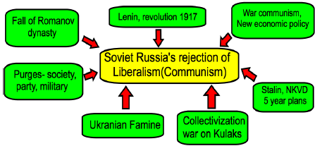

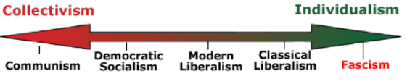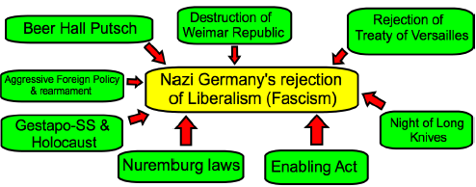

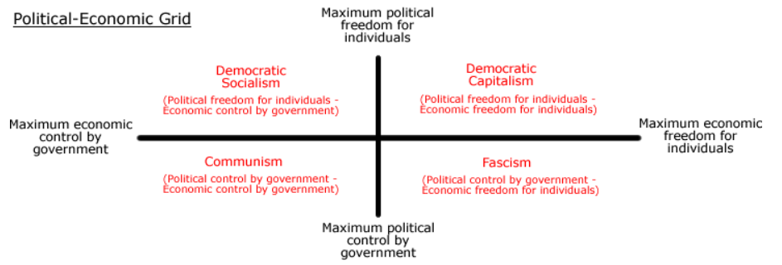

# **Part One Assessing Effects on International Relations**

**Assess the Effects of the Cold War on International Relations**

Research to determine how various foreign policy motives and methods shaped international relations during the Cold War.

|  |  |
| --- | --- |
|  | **The Cold War Motives**  **(Read the section about the Cold War in Unit 3)** |
|  | * Security * Peace * Prestige * Prosperity * Promoting or Defending Ideologies |

**Cold War Strategies (Textbook pages 196-206) Please see videos throughout Unit 4 online to support the readings on the Cold War.**

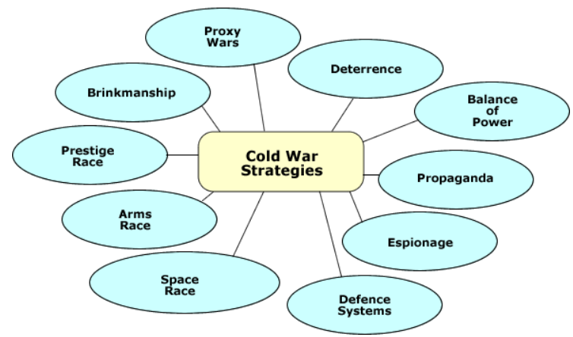

Use the following Cold War events to assess their impact on 20th century international relations.

* Vietnam War 1959-1975
* Berlin Wall 1961-1989
* Cuban Missile Crisis 1962
* Soviet War in Afghanistan 1978–1992

To research these motives and methods, you may use various sources:

* the Unit 4 Cold War pages of this course
* your textbook, *Understandings of Ideology*, pages 196-206
* the Internet

## **Research**

To help guide your research and organize your material, fill out the following chart for each event as follows:

* In point form, describe your supporting evidence for **motives** and/or **methods** as well as the **effect** on international relations.

|  |  |  |
| --- | --- | --- |
| **Event** | **Motives and/or Methods** | **Supporting Evidence in your own words**  8 marks (2 marks each) |
| **Korean War**  **1950-1953**  **See videos in the online course on this event on page 4.12.** | * Expansionism-I want to see the term in your explanation. * Containment- I want to see the term in your explanation. * Brinkmanship- I want to see the term in your explanation. * Promoting and defending Against Ideologies- I want to see the term in your explanation. * Balance of Power- I want to see the term in your explanation. | North Korea was seeking to expand its ideology and reunite north and south  United States wanted to contain communist expansion, China wanted to protect its ally and promote communism  United Nations involvement risked the losing its communist involvement in the United Nations  United Nations seemed like it was promoting western ideology China and North Korea were promoting a strong centralized ideology  Tensions were increased between China and western countries, the border between North and South Korea is heavily guarded and tension in Korea is very high |

Use the following chart on foreign policy motives and methods to determine how they shaped international relations during the Cold War.

**Total /8 marks**

|  |  |  |
| --- | --- | --- |
| **Event** | **Motives and/or Methods** | **Supporting Evidence**  **In your own words**  /8 marks (2 marks each) |
| **Vietnam War**  **1959-1975**  **See videos in the online course on this event on page 4.12.** | * Expansionism- I want to see the term in your explanation. * Containment- I want to see the term in your explanation. * Brinkmanship- I want to see the term in your explanation. * Promoting and defending Against Ideologies- I want to see the term in your explanation. * Balance of Power- I want to see the term in your explanation. |  |
| **Berlin Wall**  **1961-1981**  **See videos in the online course on this event on page 4.12.** | * Expansionism- I want to see the term in your explanation. * Containment- I want to see the term in your explanation. * Brinkmanship- I want to see the term in your explanation. * Promoting and defending Against Ideologies- I want to see the term in your explanation. * Balance of Power- I want to see the term in your explanation. |  |
| **Cuban Missile Crisis**  **1962**  **See videos in the online course on this event on page 4.12.** | * Expansionism- I want to see the term in your explanation. * Containment- I want to see the term in your explanation. * Brinkmanship- I want to see the term in your explanation. * Promoting and defending Against Ideologies- I want to see the term in your explanation. * Balance of Power- I want to see the term in your explanation. |  |
| **Soviet War in Afghanistan**  **1979–1989**  **See videos in the online course on this event on page 4.12.** | * Expansionism- I want to see the term in your explanation. * Containment- I want to see the term in your explanation. * Brinkmanship- I want to see the term in your explanation. * Promoting and defending Against Ideologies- I want to see the term in your explanation. * Balance of Power- I want to see the term in your explanation. |  |

# **Part 2: Response Outline**

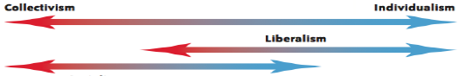

## **Suggested Format**

Introduction (3–5 sentences)

* Give a brief introduction of the basis for the Cold War. What was it about? Who was involved?
* Answer the following yes or no question as your thesis: Were principles of liberalism violated during the events of the Cold War?

Body 1 (5–7 sentences)

* Name the event.
* Give a brief description of the event.
* When and how were rights and freedoms violated?
* Be specific as to which principles of liberalism were violated.

Body 2 (5–7 sentences)

* Name the event.
* Give a brief description of the event.
* When and how were rights and freedoms violated?
* Be specific as to which principles of liberalism were violated.

Body 3 (5–7 sentences)

* Name the event.
* Give a brief description of the event.
* When and how were rights and freedoms violated?
* Be specific as to which principles of liberalism were violated.

Conclusion (3–5 sentences)

* Summarize the violations in each event (be specific).
* Did the Cold War events violate liberalism?
* Was the Cold War justified?
* Any conclusive statements to add?
* Will the future avoid this kind of event?

## **Suggestions for Success**

* Avoid only summaries of the Cold War.
* Make this response a large paragraph of 20-25 sentences.
* Avoid including too many Cold War events.
* Make sure you include specific principles of liberalism violated.
* Use Cold War terms from methods and motives in your response.
* Watch videos on these events in your online course on page 4.12.

# **Part Two Written Response**

**How did Cold War events demonstrate a rejection of liberalism? What specific rights and freedoms were violated with the each event in your response?**

Using the information from the chart, explore both the motives and strategies employed by Super Powers in the Cold War to shape world events.

**Your written response should** explain how these events contributed to increased tension between the countries involved and explore the conditions which contributed to rejecting liberalism. Show how they rejected liberalism.

**Total /15**  *Based on the Position Paragraph rubric found at the end of the assignment

<Write your response here.>

# 

# **Rubric for Position Paragraph(s)**

|  |  |  |
| --- | --- | --- |
| **Scoring Criteria:**  **Position Paragraph** | **Explanations and Support  10 marks**  When marking ***Explanations and Support***, markers should consider the   * quality of explanations * selection and quality of support | **Communication  5 marks**  When marking ***Communication***, markers should consider   * organization and coherence * vocabulary (specificity and accuracy) * sentence construction (clarity and completeness) * grammar and mechanics (consistency of   tense, punctuation, spelling, and capitalization) |
| **Excellent**  **E** | Explanations are thorough and comprehensive, revealing a perceptive understanding. Support is specific and accurate. Errors, if present, do not detract from the response.  10 | The writing is fluent and effectively organized. Vocabulary is precise and effective. The writing demonstrates confident control of sentence construction, grammar, and mechanics. The occurrence of errors is rare.  5 |
| **Proficient**  **Pf** | Explanations are appropriate and purposeful, revealing a clear understanding. Support is relevant and appropriate but may contain some minor errors.  8 | The writing is clearly organized. Vocabulary is accurate and appropriate. The writing frequently demonstrates effective control of sentence construction, grammar, and mechanics. The occurrence of errors is infrequent. 4 |
| **Satisfactory**  **S** | Explanations are general and straightforward, revealing an acceptable understanding. Support is relevant but general, may be incompletely developed, and/or contains errors. 6 | The writing is generally clear and functionally organized. Vocabulary is generally accurate but not specific. The writing demonstrates basic control of sentence construction, grammar, and mechanics. Errors do not seriously interfere with communication. 3 |
| **Limited**  **L** | Explanations are overgeneralized and/or redundant, revealing a confused, though discernable, understanding. Support is superficial, may not always be relevant, and contains significant errors.  4 | The writing is uneven and incomplete but is discernibly organized. Vocabulary is imprecise and/or inappropriate. The writing demonstrates faltering control of sentence construction, grammar, and mechanics. Errors hinder communication. 2 |
| **Poor**  **P** | Explanations are tangential or minimal revealing, a negligible understanding. Support, if present, is incomplete, may be marginally relevant, and contains significant and/or frequent errors. 2 | The writing is unclear and disorganized. Vocabulary is ineffective and frequently incorrect. The writing demonstrates lack of control of sentence construction, grammar, and mechanics. Errors impede communication.  1 |
| **Total:**  **/15** | | |
| **Areas of Strength** |  | |
| **Areas to Improve** |  | |
| **Totals** | **Part 1—Chart: /8 Part 2-Written Response: /15 Total: /23**  Once your assignment is graded, always review the comments and the feedback file. You will be expected to use those comments and feedback in your next assignment. | |

# **Student Exemplars**

**60-70%**

Liberalism values the freedom of the individual. The Cold War was party a product of two opposite competing ideologies: a democratic ideology and a communist ideology. A democratic ideology corresponds to a higher degree with the ideology of liberalism compared to communism where collectivism is prioritized above the freedom of the individual.

In that sense, a rejection of liberalism was I believe more to do with the actions of communist Soviet Union than democratic United States. After WWII had ended and a common enemy was defeated, the U.S and the Soviet Union’s fundamental differences in ideology started a competition without direct conflict. Stalin was right in his 1927 prediction in which he said “there will emerge two center of world significance: a socialist center, drawing to itself the countries that incline towards socialism, and a capitalist center, drawing to itself the countries that incline towards capitalism.” The U.S and the Soviet Union were these two centers, and a Cold War between them resulted. Both countries knew that a direct conflict would result in mutual assured destruction because of each country’s possession of nuclear weapons. **(Yes or no the Cold War rejected principles of liberalism?)** ADLC

Therefore, they competed in different forms such as an arms race, propaganda, prestige race, proxy wars, espionage and more. One of the earliest significant events of the Cold War was the Vietnam War. Vietnam was divided in two, the south and the north. After the defeat of the French in Vietnam, there were supposed to be free elections. The U.S feared that the Soviet Union and communist China supported north would win the free elections and Vietnam would become a communist country. The U.S supported the south in a proxy war between them and the north backed by the Soviet Union along with China. This war resulted in over a million Vietnamese deaths and 58000 deaths of U.S soldiers with the U.S eventually withdrawing and Vietnam becoming a communist country. Ultimately Vietnam rejected a system of capitalism and embraced communism effectively rejecting liberalism. **(In this event can you list specific events that rejected principles of liberalism or specific rights and freedoms?)**

The Cuban missile crisis and the Soviet Union invasion of Afghanistan are also events that demonstrate dismissal of liberalism. Beginning with the overthrowing of a U.S supported democratic government in Cuba by Fidel Castro, the U.S became very concerned with Cuba. Maybe not so much a rejection of liberalism, but the U.S did make countless efforts to remove Castro from power and effectively interfered in Cuban affairs. Cuba’s pursuit of a communist system invited the Soviet Union’s friendship which resulted in Soviet missiles being positioned in Cuba. This brinkmanship almost resulted in a direct conflict between the U.S and the USSR. **(In this event can you list specific events that rejected principles of liberalism or specific rights and freedoms?)**

The Afghan war was another proxy war fought between the U.S and the Soviet Union. The USSR invaded Afghanistan and set up a Soviet Union loyalist leader that would lead the country into a communist system. The U.S funded and aided opposition groups such as the Mujahedeen and eventually the Soviet Union retreated and left Afghanistan. A big reason for the rejection of communism rather than liberalism by many of the Afghan people was because communism was not compatible with many of their beliefs and religion. **(In this event can you list specific events that rejected principles of liberalism or specific rights and freedoms?)**

The Berlin wall was in my opinion one of the clearest demonstrations of rejecting liberalism. East Germany with the support of the USSR, constructed a wall that divided Germany in order to set a barrier between capitalism and communism and to prevent people from leaving the East side. Because the U.S and allies supported West Germany, it was becoming wealthy and developed and many people on the East wanted to leave. When the walls eventually came down in 1989, it in many ways symbolized the weakening or defeat of communism. **(In this event can you list specific events that rejected principles of liberalism or specific rights and freedoms?)**

Throughout this period of the Cold War, the Soviet Union made very vigorous efforts as did the U.S to spread and defend their ideologies. These events throughout the Cold War clearly show how the Soviet Union tried very hard to spread their ideology of communism in defiance of liberalism**. (Conclude regarding all the rights and freedoms violated during this time period. Was it justified?)**