**Social Studies 30-2**

**4.22 Critical Challenge: Challenging Liberalism with Alternative Thought**

[Here is a link to the instruction video also found on the assignment download page.](https://adlc.wistia.com/medias/ui9cfgbteg)

**Issue Question:** *Is resistance to liberalism justified?*

**Big Ideas**

|  |  |
| --- | --- |
|  | * *Appreciate how citizens and citizenship are impacted by the promotion of ideological principles.* * *Appreciate that individuals and groups may adhere to various ideologies.* * *Examine the extent to which modern liberalism is challenged by alternative ideas.* |
|  | * *This is a three-part assignment.* |

**Contents**

Introduction 2

Background 2

Strategies for Success 4

Source One Planning 5

Source One Paragraph 7

Source Two Planning 8

Source Two Paragraph 10

Source Three Planning 11

Source Three Paragraph 12

Rubric and Marks 13

Student Exemplars 14

# **Introduction**

1. You will analyze **three** source images to determine the main idea in each image.
2. For **each source**, you will explain what the source communicates about challenges to liberalism and whether the challenges are justified.

# **Background**

In the following assignment you will clearly communicate your interpretation of three sources with links to liberalism, identify the perspective communicated in each source, and communicate your thoughts on liberalism.

Source analysis is a very important skill for understanding perspectives in social studies. As both a social studies student and active citizen, you need to have strong interpretive skills. In addition, you will find this type of written response on both the mid-term and final exam for this course. This assignment is designed for you to learn and practice these skills and the written response format used on exams, which require you to interpret and demonstrate an understanding of the perspectives presented in sources.

Keep in mind that sources are designed to present the author or artist’s perspectives on an issue. It is very important to have the skills to analyze the perspective presented in a source. This might be very different from your perspective, but you need to be able to understand and explain the perspective found in a source.

Carefully examine all of the sources that follow, and identify the perspectives related to the issue of Alternatives to Modern Liberalism.

The diagram below is a review of liberal values. If necessary, go to **Unit 2.3 Values of Individualism and Liberalism** in your course to review each value.

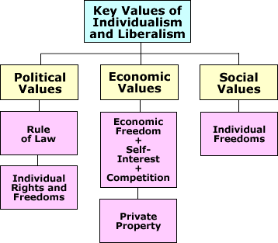

**Ideological challenges to liberal ideology** may come from Aboriginal perspectives, religious perspectives, environmentalist perspectives, and extremist perspectives.

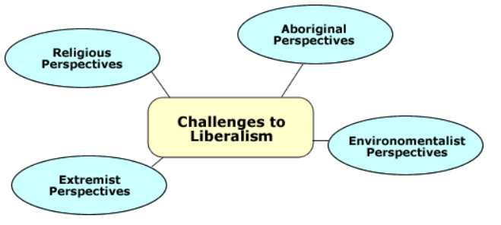

You will examine perspectives that offer alternatives to modern liberalism and determine the extent to which these perspectives offer viable alternatives to the values of liberalism. This assignment is designed to assess your skills in working with and understanding sources that present a variety of perspectives.

# **Strategies for Success**

* Review the tutorial links found on the assignment page resource box. They will add to your skills for this type of assignment.
  + How to Analyze a Political Cartoon
  + How to Read a Picture
  + How to Detect Bias and Propaganda
  + How to Read Critically
* Read pages 245-263 in your textbook, *Understanding of Ideologies*.
* Read pages 55-62 in your green reader, **4.19 Challenging Liberalism with Alternative Thought**.
* View the [tutorial](https://moodle.adlc.ca/mod/page/view.php?id=24529007) on how to analyze political cartoons.
* View the[tutorial](https://moodle.adlc.ca/mod/page/view.php?id=24529009) on how to view a picture.

Remember to consider these in your answer.

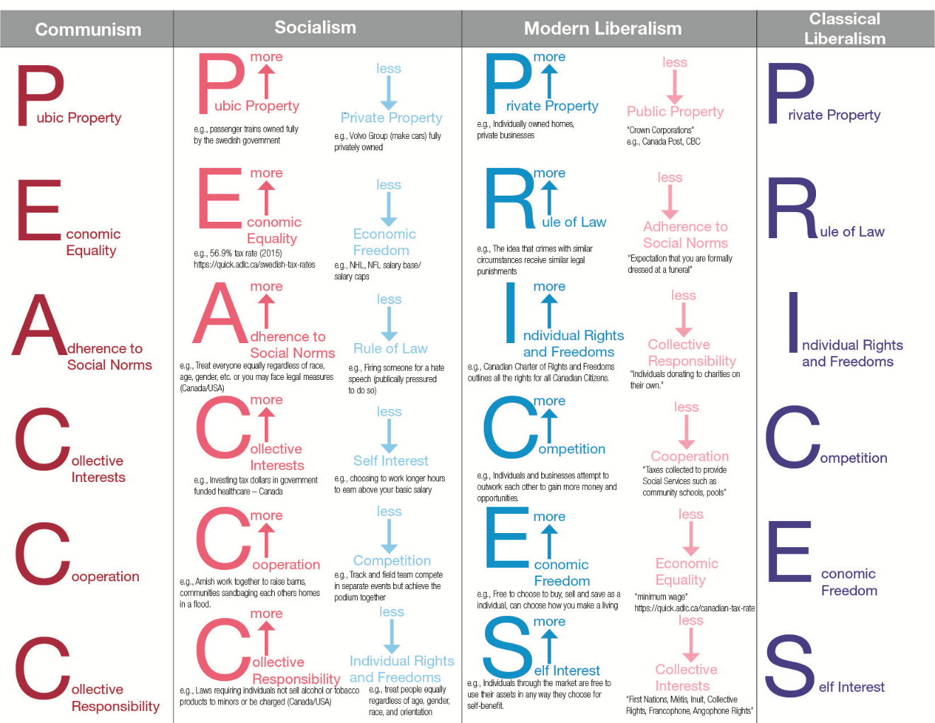

# 

# **Source One Planning Total /20**

**Source 1**

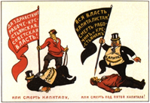

Soviet propaganda poster: “Death to Capitalism or Death under the Heel of Capitalism!”

Poster Courtesy SovietPosters.com

(The man in the black suit with a top hat represents capitalism; the man with the red shirt is a communist.)

|  |  |  |
| --- | --- | --- |
| **Question** | **Answer** | **Details from the source that support** |
| Who is the source about? |  |  |
| What is the source addressing? |  |  |
| When did it occur? |  |  |
| Where did it occur? |  |  |
| Why was the source created? |  |  |

After you have examined the source, you should be able to demonstrate both your understanding of the source and its link to ideology.

|  |  |  |
| --- | --- | --- |
| **Question** | **Answer** | **Details from the source that support** |
| What is the challenge to liberalism? (Refer to online reading Unit 4) |  |  |
| Is the resistance to liberalism in this source justified? |  |  |

## 

## 

## **Source One Paragraph**

Some people embrace the values of liberalism while other people challenge the values of liberalism in favor of alternative thought.

**What does this source communicate to you about the challenges to liberalism?** **AND Is each group’s resistance to liberalism justified?**

Use the chart above to write a paragraph that is 4–7 sentences long.

* Who is the source about?
* How do you know?
* What is happening in the source? What details support this?
* When did this occur? How do you know?
* What details prove that? Why was this source created? Any insight why? What is the challenge to liberalism? (Use the readings to discuss this) Is the resistance justified? Why or why not?

<Write your response here.>

# 

# **Source Two Planning**

**Total /20**

**Source 2**

[https://ethiopiagordonrdn.weebly.com/primary-documents.html](https://www.google.com/url?q=https://ethiopiagordonrdn.weebly.com/primary-documents.html&sa=D&source=hangouts&ust=1589475596545000&usg=AFQjCNFNBkwS2mT5fr7acrgNaq9uicaARA)

 Event

In 1935, the Italian army invaded Abyssinia (modern Ethiopia). When Abyssinians appealed to the League of Nations for help, the League condemned the attack and ordered members to impose economic sanction on Italy.

**Appeal to the League of Nations from Emperor Haile Selassie I of Ethiopia- June 1936**

At a time when my people are threatened with extermination, when the support of the League may ward off the final blow… I ask the fifty-two nations, who have given the Ethiopian people a promise to help them in their resistance to the aggressor, what are they willing to do for Ethiopia? And the great Powers who have promised the guarantee of collective security to small States… I ask what measures do you intend to take? …What reply shall I have to take back to my people?"

I ask the fifty-two nations, who have given the Ethiopian people a promise to  
help them in their resistance to the aggressor, what are they willing to do for  
Ethiopia? And the great Powers who have promised the guarantee of collective  
security to small States on whom weighs the threat that they may one day suffer  
the fate of Ethiopia, I ask what measures do you intend to take?

*.*

|  |  |  |
| --- | --- | --- |
| **Question** | **Answer** | **Details from the source that support** |
| Who is the source about? |  |  |
| What is the source addressing? |  |  |
| When did it occur? |  |  |
| Where did it occur? |  |  |
| Why was the source created? |  |  |

After you have examined the source, you should be able to demonstrate both your understanding of the source and its link to ideology.

|  |  |  |
| --- | --- | --- |
| **Question** | **Answer** | **Details from the source that support** |
| What is the challenge to liberalism? (Refer to online reading Unit 4) |  |  |
| Is the resistance to liberalism in this source justified? |  |  |

## 

## **Source Two Paragraph**

Some people embrace the values of liberalism while other people challenge the values of liberalism in favor of alternative thought.

**What does this source communicate to you about the challenges to liberalism?** **AND Is each group’s resistance to liberalism justified?**

Use the chart above to write a paragraph that is 4–7 sentences long.

* Who is the source about?
* How do you know?
* What is happening in the source? What details support this?
* When did this occur? How do you know?
* Where did this happen? What details prove that? Why was this source created? Any insight why? What is the challenge to liberalism? (Use the readings to discuss this) Is the resistance justified? Why or why not?

<Write your response here.>

# **Source Three Planning**

**Total /20**

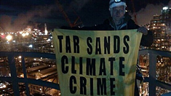

**Source 3**

Photograph: “TAR SANDS CLIMATE CRIME”

Photo ©Greenpeace Canada (<http://www.greenpeace.org/canada>)

(Greenpeace activist protesting at Shell Oil’s plant in Fort Saskatchewan, AB)

***CAUTION: you can discuss this answer from the point of view of the man with the sign OR the Oil refinery and the people who work there.***

|  |  |  |
| --- | --- | --- |
| **Question** | **Answer** | **Details from the source that support** |
| Who is the source about? |  |  |
| What is the source addressing? |  |  |
| When did it occur? |  |  |
| Where did it occur? |  |  |
| Why was the source created? |  |  |

After you have examined the source, you should be able to demonstrate both your understanding of the source and its link to ideology.

|  |  |  |
| --- | --- | --- |
| **Question** | **Answer** | **Details from the source that support** |
| What is the challenge to liberalism? (Refer to online reading Unit 4) |  |  |
| Is the resistance to liberalism in this source justified? |  |  |

## **Source Three Paragraph**

Some people embrace the values of liberalism while other people challenge the values of liberalism in favor of alternative thought.

**What does this source communicate to you about the challenges to liberalism?** **AND Is each group’s resistance to liberalism justified?**

Use the chart above to write a paragraph that is 4–7 sentences long.

* Who is the source about?
* How do you know?
* What is happening in the source? What details support this?
* When did this occur? How do you know?
* Where did this happen? What details prove that? Why was this source created? Any insight why? What is the challenge to liberalism? (Use the readings to discuss this) Is the resistance justified? Why or why not?

<Write your response here.>

# **Rubric and Marks**

ADL

|  |  |  |  |
| --- | --- | --- | --- |
| **Focus** | **Interpretation of Sources**  **8 marks** | **Defense of Position**  **8 marks** | **Communication**  **4 marks** |
| * Quality of the interpretation of each source * Quality of evidence drawn from the sources * Quality of evidence drawn from knowledge of social studies * Understanding of the assigned task | * Quality of argument(s) selected to support the position taken * Quality of evidence selected to support the position taken * Understanding of applicable social studies knowledge and the assigned task | * Organization and coherence * Contribution of stylistic choices to the creation of voice * Vocabulary, sentence construction, grammar, and mechanics |
| **Excellent**  **E** | Interpretations are insightful, comprehensive and address all sources. Evidence is specific and accurate and errors, if present, do not detract from the response. The student demonstrates a thorough and perceptive understanding of applicable social studies knowledge the assigned task. 8 marks | The defense of position is based on one or more convincing, logical arguments. Evidence is specific and accurate, and errors, if present, do not take away from the response. There is a confident and perceptive understanding of appropriate social knowledge and the assigned task. 8 marks | The writing is fluent and effectively organized. Voice is convincing and engaging. Vocabulary is precise. The writing shows a confident control of sentence construction, grammar, and mechanics. Errors, if present, are unimportant. 4 marks |
| **Proficient**  **Pf** | Interpretations are specific and accurate but may not address all sources. Evidence is relevant and appropriate, but may contain some minor factual errors. The student demonstrates a clear understanding of applicable social studies knowledge and the assigned task. 6 marks | The defense of position is based one or more sound arguments. Evidence is appropriate but may contain some minor factual errors. There is a clear understanding of appropriate social knowledge and the assigned task. 6 marks | The writing is straightforward and clearly organized. Voice is distinct. Vocabulary is specific. The writing shows effective control of sentence construction, grammar, and mechanics. Errors do not detract from communication. 3 marks |
| **Satisfactory**  **S** | Interpretations are valid but general and may contain minor conceptions. Interpretations may not address all sources. Evidence is relevant, but general, may be incompletely developed, and/or contain minor errors. The student demonstrates an acceptable understanding of applicable social studies knowledge and the assigned task. 4 marks | The defense of position is based one or more acceptable arguments. Evidence is relevant but general and/or incompletely developed. The evidence may contain errors. There is an acceptable understanding of appropriate social knowledge and the assigned task.4 marks | The writing is generally clear and functionally organized. Voice and vocabulary are adequate. The writing shows basic control of sentence construction, grammar, and mechanics. Errors do not seriously interfere with communication. 2 marks |
| **Limited**  **L** | Interpretations are overgeneralized and may contain substantial misconceptions. Evidence is superficial, may not always be relevant, and may contain significant errors. The student may demonstrate a confused, yet discernable, understanding of applicable social studies knowledge and the assigned task. 2 marks | The defense of position is based on oversimplified arguments and/or questionable logic. Evidence is superficial, may not always be relevant, and may contain large errors. There is a confused, yet visible, understanding of appropriate social knowledge and the assigned task.2 marks | The writing is uneven and incomplete but is somewhat organized. Voice is inappropriate and/or unconvincing. Vocabulary is imprecise and/or inappropriate. The writing shows uncertain control of sentence construction, grammar, and mechanics. Errors reduce communication. 1 mark |
| **Poor**  **P** | Interpretations are mistaken or irrelevant. Evidence, if present, is incomplete and/or marginally relevant and frequently contains significant errors. The student demonstrates minimal understanding of applicable social studies knowledge and the assigned task. 1 mark | The defense of position is hard to understand, and/or little to no attempt is made to defend it. Evidence, if present, is incomplete and/or barely appropriate with frequent large errors. There is minimal understanding of appropriate social knowledge and the assigned task. 1 mark | The writing is unclear and disorganized. Voice is unsuitable and/or ineffective. Vocabulary is ineffective and frequently incorrect. There writing shows lack of control of sentence construction, grammar, and mechanics. Errors hurt communication. .5 mark |
| **Insufficient**  **I** | Zero is assigned to a response that fails to meet the minimum requirements of the Poor category. | Zero is assigned to a response that fails to meet the minimum requirements of the Poor category. | Zero is assigned to a response that fails to meet the minimum requirements of the Poor category. |
| |  |  |  | | --- | --- | --- | | ***Source 1***  **Interpretation /8**  **Defense /8**  **Communication /4**  **TOTAL: /20** | ***Source 2***  **Interpretation /8**  **Defense /8**  **Communication /4**  **TOTAL: /20** | ***Source 3***  **Interpretation /8**  **Defense /8**  **Communication /4**  **TOTAL: /20** | | | | |
| **Areas of Strength** |  | | |
| **Areas to Improve** |  | | |
| **Totals** | **Total: /60**  Once your assignment is graded, always review the comments and the feedback file. You will be expected to use those comments and feedback in your next assignment. | | |

# **Student Exemplars**

**80-100%**

***Source 1***

In this source,what is this kind of source? two men are shown in conflict. The first image shows the slimmer less well dressed man, who represents the communists, with a boot on top of the overweight man’s, representing the capitalist, gut and a rifle in his hand. The healthy sized man who does not dress flashy represents the ideologies of communism. The overweight man who is dressed in an expensive, flashy suit represents the greed and excess demonstrated by capitalism ideologies. We are lead to presume that the communist has defeated the capitalist and this would symbolize the destruction of the capitalist system. Speculate when and where this was created using details from the source to prove it. The other image shows the capitalist man driving his heel into the communists head. This would have symbolized the current control by wealthy merchants over the less fortunate citizens. What does the caption suggest should happen? What is the challenge to liberalism here? This poster was designed to drive the citizens to become a “triumphant” communist supporters and “stomp out” the capitalist system. This was a justified means under the current economic system. Is it justified to suggest war, violence and death over differing ideologies? IS this extreme?

***Source 2***

Italy was under fascist rule at the time of this event. Provide a detail from the cartoon that tells you that. Ethiopia had liberal ties with other members of the League of Nations. When Italy invaded it was most likely because they wanted to gain more land and increase fascist control over other nations. The characters represent the separate nations. The man in the middle represents the nation of Italy, seen as imposing and larger than life. Who is it? How do you know? What detail from the source? The woman on the right is representing Ethiopia, seen as frail and meek. The two men on the left reading an instruction book represent the League of Nations. What was the challenge to liberalism? This however, is an unjustified attack on liberalism as the League of Nations had strict agreements in favor of Ethiopia (Abyssinia) on this matter. Was Mussolini an extremist?

***Source 3***

In this source, a member of greenpeace is shown holding a sign that protests the development of tar sands. Inferring that extracting oil from them is a crime against the climate. This violates the liberalist right to earn an income as a person sees fit. However, in regards to environmental concerns, this could be considered justified as climate change is a major problem in modern society. Liberal views this as unacceptable behaviour. I believe that protest should be allowed on the condition nobody is physically harmed. Protest draws the attention of others to a certain point of view. It expresses our right to free speech and should be respected if it is does not cause harm to others who may feel differently on the issue.

Is Greenpeace an extreme group? Is it okay to break and enter private property to protest?

Overall great use of terminology. Ensure you always give details from the sources to back up your statements. Consider the challenges to liberalism readings from the course when examining these sources.