**Social 30-2 Diploma Exam Preparation**

**Understanding the Social Studies 30–2 Diploma Examination**

**The Social 30-2 Diploma Examination** is a mandatory exam developed by Alberta Education. The diploma exam is weighted with your course mark in the following way:

* Your **school-awarded course mark** is 70% of your final mark in Social Studies 30–2.
* Your **Social Studies 30–2 Diploma Examination** **mark** is the other 30% of your final mark.

**The Social Studies 30–2** Diploma Examination has two parts written separately at different times:

* **Part A:** Written Response
* **Part B:** Multiple-Choice Questions

**Part A: Written Response**

* Part A requires students to complete **three** writing assignments.
* The written-response part of the examination is worth 50% of the total Social Studies 30–2 Diploma Examination mark.
* Part A is developed to be completed in 3 hours.

**Part B: Multiple Choice**

* Part B consists of 60 multiple-choice questions.
* The multiple choice part of the examination is worth 50% of the total Social Studies 30–2 Diploma Examination mark.
* Part B is developed to be completed in 3 hours.

### Part A: Written Response

**Part A: Written Response**, worth 50% of the total diploma examination mark, consists of three writing assignments:

* **Assignment 1:** Understanding and Evaluating Key Course Concepts (worth 10%)
* **Assignment 2:** Interpreting Sources and Defending a Position (worth 20%)
* **Assignment 3:** Exploring an Issue and Defending a Position (worth 20%)

**Assignment I: Understanding and Evaluating Key Course Concepts**

Assignment I requires students to demonstrate understanding and to apply the skill of evaluation to social studies knowledge and understanding.

For this assignment, students must

* identify a characteristic or characteristics among those provided that are the most important to one of the key concepts of the program of studies
* explain why the characteristic or characteristics chosen are the most important
* support their response using their understanding of social studies

Students are expected to develop a response in paragraph form that reflects the quality of thought and communication expected of students completing Social Studies 30–2.

Value: 10% of the total examination mark (Parts A and B combined)

Scoring: Scores contribute to the total examination mark in the following proportions:

* Explanations and Support 8%
* Communication 2%

|  |
| --- |
| **Part A Assignment I Example** |
| NOTE: This is an example of Assignment I and is not actually on the exam. The question and source are similar to these.  ASSIGNMENT I   * Value: 10% of the total examination mark   Mixed economies blend principles and practices of both free market and command economies. |

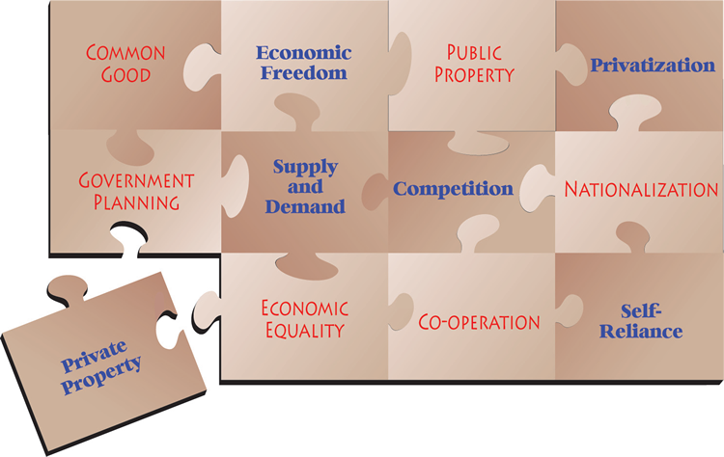

|  |  |
| --- | --- |
|  | **Which characteristic(s) of a free-market economy is (are) the most important to the Canadian economy?**  Write a response in which you   * identify the characteristic(s) of free market economies that is (are) the most important to the Canadian economy * explain why the characteristic(s) is (are) the most important * support your response using your understanding of social studies |

**Consider the Question.**

Do you understand the question? *Which of the values of a free-market economy is most important for Canada?* To answer this question, you need to

* review your knowledge about capitalist and communist ideologies
* analyze the capitalist and communist values shown in the diagram
* establish a position on which of the capitalist values is most important to Canada
* think of arguments and evidence to support your position

**Analyze the Ideological Values in the Source.**

Your response is based on your analysis of the source presented.  You must show that you understand the ideological values shown in the source.

1. **Review your understandings of ideological values:** Think about everything you have learned in this course:

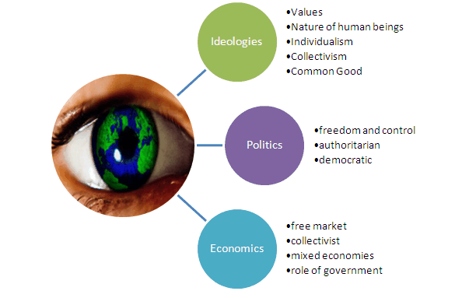

1. **Analyze the source:** Look closely at the words used and the message. What values and beliefs does it suggest regarding economic equality and freedom? Does it support individualism, collectivism, classical or modern liberalism, or another ideological perspective? What ideas does it suggest about the role of government in society?

**Establish a Position.**

Your position must be clear. You must argue for a particular ideological value presented in the source. No matter what position you take, you must support it.

**Support Your Position.**

After you have formed a position, think about how you will defend it.

* What are the main reasons you support the particular ideological value presented in the source?
* What information will help you defend your position?
* What specific examples can be used to support your position? Your response is evaluated on your use of argument and the evidence you present. Evidence can be theoretical, historical, contemporary, or current.

**Organize Your Ideas.**

Before you begin to write your response, organize your opinions, facts, and examples so that they make sense. Using your outline or graphic organizer as a guide, write the first draft of your response. Get your thoughts and information on paper while following your organizational structure. Do not worry about spelling and grammar just yet.

**Write the Response.**

Your response must include an opening paragraph in which you introduce the key elements of the concept being discussed and a strong thesis, two or three supporting paragraphs in which your arguments, evidence, and examples are presented, and a concluding paragraph.

**Revise the Response.**

As you read your first draft, ask the following questions:

* Did I analyze the source thoroughly?
* Did I establish a clear position?
* Do my arguments *make sense*?
* Does the evidence I present support my position?  Are they facts or opinions?
* Are my ideas organized logically?
* How are my spelling, grammar, and word usage?

|  |  |  |  |  |  |  |  |  |  |  |  |  |  |  |  |  |  |  |  |  |  |  |  |  |
| --- | --- | --- | --- | --- | --- | --- | --- | --- | --- | --- | --- | --- | --- | --- | --- | --- | --- | --- | --- | --- | --- | --- | --- | --- |
| **Social 30-2 Written Response Assignment I** **Scoring Categories and Criteria**   |  |  |  | | --- | --- | --- | | **Markers are reminded that students are working under examination conditions, have completed first draft compositions, and are responsible for three writing assignments.** | | | |  | **Explanations and Support (8 marks)**  When marking ***Explanations and Support***, markers should consider   * quality of explanations * selection and quality of support | **Communication (2 marks)**  When marking ***Communication***, markers should consider   * organization and coherence * vocabulary (specificity and accuracy) * sentence construction (clarity, completeness) * grammar and mechanics (consistency of tense, punctuation, spelling, capitalization)   Proportion of error to the length and complexity of the response must be applied when awarding a mark for ***Communication***. | | **Excellent**  **E** | Explanations are thorough and comprehensive revealing a perceptive understanding. Support is specific and accurate, and errors, if present, do not detract from the response. Mark=8 | The writing is fluent and effectively organized. Vocabulary is precise and effective. The writing demonstrates confident control of sentence construction, grammar, and mechanics. The occurrence of error is rare.   Mark=2 | | **Proficient**  **Pf** | Explanations are appropriate and purposeful revealing a clear understanding. Support is relevant and appropriate, but the explanation may contain some minor errors.  Mark=6.4 | The writing is clearly organized. Vocabulary is accurate and appropriate. The writing frequently demonstrates effective control of sentence construction, grammar, and mechanics. The occurrence of error is infrequent.  Mark=1.6 | | **Satisfactory**  **S** | Explanations are general and straightforward revealing an acceptable understanding. Support is relevant but general, may be incompletely developed, and/or contains errors.  Mark=4.8 | The writing is generally clear and functionally organized. Vocabulary is generally accurate, but not specific. The writing demonstrates basic control of sentence construction, grammar, and mechanics. Errors do not interfere seriously with communication.  Mark=1.2 | | **Limited**  **L** | Explanations are over-generalized and/or redundant revealing a confused,though discernable understanding. Support is superficial, may not always be relevant, and may contain significant errors.  Mark=3.2 | The writing is uneven and incomplete but is discernibly organized. Vocabulary is imprecise and/or inappropriate. The writing demonstrates faltering control of sentence construction, grammar, and mechanics. Errors hinder communication.  Mark=0.8 | | **Poor**  **P** | Explanations are tangential or minimal revealing a negligible understanding. Support, if present, is incomplete, may be marginally relevant, and contains significant and/or frequent errors. Mark=1.6 | The writing is unclear and disorganized. Vocabulary is ineffective and frequently incorrect. A lack of control of sentence construction, grammar, and mechanics is demonstrated. Errors impede communication.  Mark=0.4 | | **Zero**  **0** | Zero is assigned to a response that fails to meet the minimum requirements of the Poor category.  Zero may be assigned in one or more categories. | | |

[[Click here to go to www.texthelp.com](https://www.texthelp.com/)](https://www.texthelp.com)

**Assignment II: Interpreting Sources and Defending a Position**

Assignment II requires students to demonstrate the skills and processes of interpreting, evaluating, and synthesizing through the application of social studies knowledge and understanding. Students are required to interpret three sources to identify what each source communicates about either the role of government or the role of individuals. Considering the three sources, students must then explain and defend a position on what the role of either government or individuals should be.

For this assignment, students must

* interpret each source to identify the ideas presented in each source about the role of either government or individuals in society
* explain and defend a position on what the role of either government or individuals in society should be
* support their response by referring to the sources and their understanding of social studies

Students are expected to develop responses in paragraph form that reflect the quality of thought and communication expected of students completing Social Studies 30–2.

Value: 20% of the total examination mark (Parts A and B combined)

Scoring: Scores contribute to the total examination mark in the following proportions:

* Interpretation of Sources 8%
* Defence of Position 8%
* Communication 4%

### Part A Assignment II Example

|  |
| --- |
| Write a response in which you interpret each of the three sources and answer both questions. (Three sources will be given, each one either a photo, visual image, political cartoon, or text.) |

|  |
| --- |
| Source I |
| Source 2 |
| Source 3 |

**What do each of the three sources presented communicate about the role of government in society?**

**AND**

**Considering the sources presented, what do you think should be the role of government in society?**

Write a response in which you

* interpret each source to identify ideas presented in the source about the role of government in society
* explain and defend your position on what the role of government in society should be
* support your interpretations and position by referring to the sources and to your understanding of social studies

Reminders for Writing

* Remember that you must answer both questions.
* Organize your response.
* Proofread your response.

**Assignment II: Source Analysis:** You must do several things. You must write about each source, describing its ideological perspective, and explaining how it connects to liberalism. You must also explain how the three sources relate to each other. Your response should

* contain a clear interpretation of each source with an explanation of how each connects to the principles of liberalism
* demonstrate that you understand both the principles of liberalism **and** the ideological perspective reflected in the source
* identify and explain the relationship that exists among the sources
* present a response that is orderly, logical, and thorough
* use your understanding of social studies, including your knowledge of ideologies and the principles of liberalism

**Consider the Assignment**   
This assignment has three main parts. Describe each source, explain how it relates to liberalism, and explain how all three are related. There is no prescribed format for this assignment, but

* review the six principles of liberalism (rule of law, individual rights and freedoms, private property, economic freedom, self interests, competition)
* analyze how the perspective in the source is connected to liberalism (It might be helpful to identify the ideology or issue presented in the source.)

**Before you begin, review your understandings of liberalism.** In your mind and/or on your planning page, review

* the principles of liberalism
* the principles of collectivism
* the evolution of liberalism
* resistance to liberalism
* the viability of liberalism
* the rights, roles, and responsibilities of citizenship

**Interpret EACH source.** The interpretation of the source has two parts. Identify the ideological perspective

1. **Identify the perspective:** Consider the *context*, which provides clues to help you interpret the source. What are the circumstances surrounding the event or situation in the source? Draw on your knowledge of history and ideologies to understand the source. Use details from the source to help you understand the following:

* Where did this occur?
* When did it occur?
* Who or what are in the source? What are they doing?
* What feelings are conveyed ?
* Why was this source created?
* What is the main idea reflected in the source?
* Explain its connection to liberalism.

**Identify the links to liberalism:** How does each source relate to the principles of liberalism? Show that you understand the principles of liberalism and the perspectives presented by each source. Write about each source and the specific principles of liberalism separately, or discuss liberalism more holistically. Consider the following:

**What perspective is shown**?

* Does the author of the source represent an individual perspective, or is it of a particular nation, religion, race, gender, or class?
* Does the author support any of the values of liberalism? Which ones?
* Does the author reject any of the values of liberalism? Which ones?
* Does the author accept liberalism, or does he or she support another ideology such as socialism, fascism, communism, religious fundamentalism, or environmentalism?
* What details or techniques used in the source support your analysis?

**Analyze the Relationship**

The analysis of relationship has two parts:

1. **Identify the connection.**

|  |
| --- |
| Do the sources address the same principle of liberalism or different principles?  Do the sources all share the same ideological perspective, or do they represent different perspectives? |

**2. Explain the connections among the sources.** You may identify and explain the relationship(s) in one part of the response or embed your explanation in each paragraph.

|  |  |
| --- | --- |
| **What details from each source can be used to support your interpretation?** | |
| **Organize your Ideas.** Before you begin to write your response, organize your ideas so they make sense.  Using an outline or organizer as a guide, write the first rough draft of your response. Do not worry about spelling and grammar just yet. Get your thoughts and information on paper while you follow your organizational structure.  **Write your response.**  Your response must be in paragraph form. Your assignment can consist of one long paragraph, but to do justice to the sources, you should include four paragraphs:   * an introduction that explains the topic * a paragraph that explains each of the three sources * a paragraph that explains the relationship among the three sources * a paragraph that concludes your presentation   **Proofread and Revise your response.**  As you read your first draft, ask yourself the following questions:   1. Did I interpret **each** source thoroughly? 2. Did I establish a clear connection between the source and the principles of liberalism? 3. Does my explanation make sense? 4. Did I explain clearly how the sources are connected or related? 5. Are my statements facts or opinions? 6. Are my ideas organized logically? 7. How are my spelling, grammar, and word usage? | |

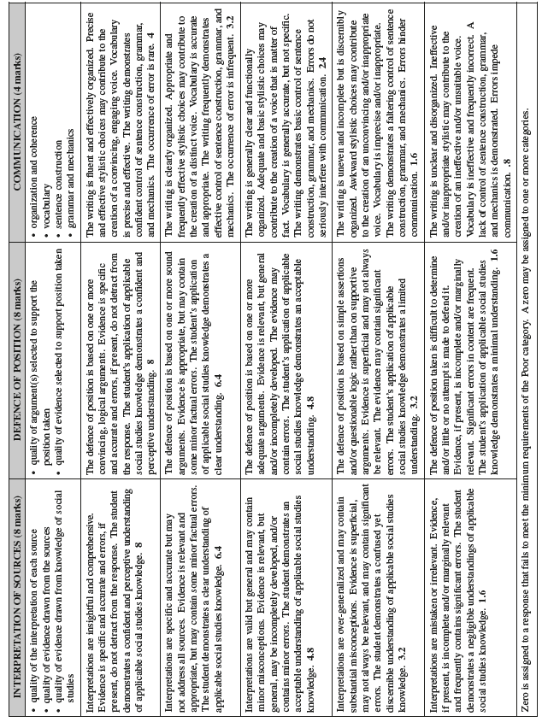

**Assignment III: Exploring an Issue and Defending a Position**

Assignment III requires students to demonstrate their skills and processes of analyzing, evaluating, and synthesizing through the application of social studies knowledge and understanding. Students must respond to an issues-focused question. Several brief responses from fictitious citizens are provided to serve as a prompt for students.

For this assignment, students must

* explore an issue that is posed to them
* analyze various points of view on the issue
* explain and defend their position on the issue
* support their response using their understanding of social studies

Students are expected to develop a response in paragraph form that reflects the quality of thought and communication expected of students completing Social Studies 30–2.

Value: 20% of the total examination mark (Parts A and B combined)

Scoring: Scores contribute to the total examination mark in the following proportions:

* Exploration and Analysis 8%
* Defence of Position 8%
* Communication 4%

### Part A Assignment III Example

|  |
| --- |
| Three citizens were sampled at randomly by a local newspaper to respond to the following question:  **How should we respond to extremist political organizations?** |

|  |
| --- |
| Citizen I  In recent years, many countries have seen first-hand the impact of extremists who are motivated by hatred of other ethnic or religious groups. Extremism, whether it is expressed violently or not, must never be tolerated. Extremist beliefs violate a fundamental principle of liberalism—that all citizens are equal. Citizens may have to sacrifice some of their rights to allow the government to have the power it needs to crush extremist groups. |
| Citizen II  Defining who is and who is not an extremist is a tough judgement call. Who would decide? We must tolerate extremist organizations no matter how much we disagree with their ideas. If an extremist organization uses violence, then police forces should act, and the guilty should be punished. Merely holding beliefs that are different from the rest of society is not a crime; acting on any beliefs in a way that causes harm to others is. |
| Citizen III  Extremist organizations must not only be tolerated, they must also have full rights of participation in our society even if their goals are to end liberal democracy. We cannot call ourselves a liberal democracy unless we allow all people to hold differing values and express those values no matter what we think of them. If our liberal democracy is not strong enough to survive threats from a few extremists, maybe liberalism is not a worthy ideology to believe in. |

**How should we respond to extremist political organizations?**

Write a response in which you

* explore the issue of how to respond to extremist political organizations
* analyze various points of view on the issue
* explain and defend your position on the question
* support your point of view using your understanding of social studies

**Consider the Question.**

Do you understand the question?  *Should we accept or reject the perspective(s) in the source, or should we take a position somewhere in the middle?* To answer this question, you need to

* review your knowledge about ideologies
* analyze the perspective(s) in the source
* establish a position
* think of arguments and evidence to support your position

**Analyze the Perspective(s) in the Source.**

Your entire Letter to the Editor is based on your analysis of the source presented.  You must show that you understand the ideological perspective(s) discussed in the source.

1. **Review your understandings of ideological perspectives:** Think about everything you have learned in this course:



1. **Analyze the source:** Look closely at the words used and the message. What view about the nature of human beings does it suggest? What values and beliefs does it suggest regarding equality and freedom? Does it support individualism, collectivism, classical or modern liberalism, or another ideological perspective? What ideas does it suggest about the role of government in society?

**Establish a Position.**

Your position must be clear. That does not mean you have to argue completely for or against the perspective(s) presented in the source, but you do have to say how much you think it should be embraced. No matter what position you take, you must support it in the body of your letter. Possible answers might include qualifiers such as

* “...to the full extent”
* “...to a great extent”
* “...to a certain extent”
* “...to the extent that…”
* “...to no extent”

**Support Your Position.**

After you have formed a position, think about how you will defend it.

* What are the main reasons you support or reject the ideological perspective(s) presented in the source?
* What information will help you defend your position?
* What specific examples can be used to support your position? Your letter is evaluated on your use of argument and the evidence you present. Evidence can be theoretical, historical, contemporary, or current.

**Organize Your Ideas.**

Before you begin to write your Letter to the Editor, organize your opinions, facts, and examples so that they make sense.  An outline or a graphic organizer will help order your thoughts. Using your organizer as a guide, write the first draft of your letter. Get your thoughts and information on paper while following your organizational structure. Do not worry about spelling and grammar just yet.

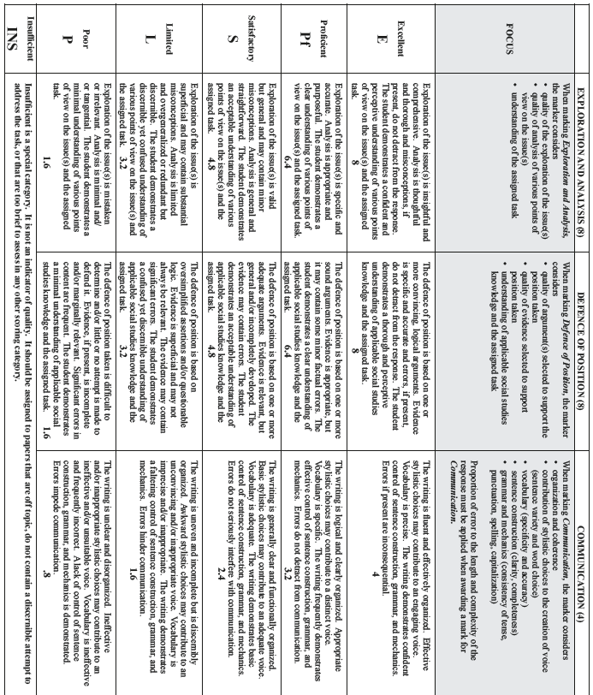

|  |
| --- |
| Part B Multiple Choice Questions |
| **The multiple-choice questions in the diploma exam** are based on generalizations, key understandings, concepts, and related facts from your Social 30-2 course. These questions require you to recall information and then go beyond simple recall to apply knowledge and thinking skills. You must demonstrate that you understand social studies concepts; that you understand historical, political, and economic relationships; and that you can interpret and evaluate social studies information and ideas.  General Tips for Multiple-Choice Questions   * When first reading a multiple-choice question, locate and note the key words to help clarify the meaning of the question. Without looking at the alternatives, try to formulate an answer of your own. Your answer may be close to the correct alternative. * Do not hesitate to answer each question even if you are unsure of the correct answer. A penalty is not given for guessing the answer. * If you are stuck on a question, mark the alternatives that you know are incorrect and choose from those remaining, using logical guessing strategy. Think of the questions as challenges, and cultivate a positive attitude about your ability to answer them. * If time permits, you may wish to scan quickly the written response and multiple-choice sections of the examination because a question in one section may be a clue to a question in another section. * Have a good reason for changing an answer. Do not change an answer on a hunch. Do not waste your time looking for patterns of As, Bs, Cs, and Ds in the multiple-choice answers—there are none. * If you cannot answer a question in a few minutes, leave it and go to the next one. If you have time left at the end of the exam, then come back to these questions. Time management while writing the exam is important because you have a specified amount of time to complete the exam.   Specific Tips for Multiple-Choice Questions   * Read the stem and think of an answer before you look at the options. * Read all options before making a choice. * If you are unsure of the answer, eliminate the obviously incorrect options, and test the remaining options for grammatical fit to the stem. * Scan for absolute qualifiers such as always or never because they often indicate a false option.  Options with often or sometimes are more likely true. * Do not guess. Eliminate as many alternatives as you can...then guess! NEVER leave the question blank. |

**Examples of Diploma Style Multiple-Choice Questions**

**Multiple-choice questions are of various types**, and each type requires you to apply your knowledge and understanding as well as to use your skills and processes differently.

**You should always read carefully each multiple-choice question and any source material.** You may wish to use a highlighter or pencil to circle key words and ideas, to cross out choices that you know are wrong, or to jot a brief summary of what you have read. Think carefully about what you are reading. For example, ask yourself what the quotation you have just read or the map you have just examined is really telling you.

**Examples of Multiple Choice Questions**

|  |  |
| --- | --- |
| Understanding and Analysis Questions  This type of question requires you to   * apply your knowledge and understanding * use your skills to address questions that deal with important events, ideas, and people * think critically as you analyze information presented to you | 1. In a free-market economy, consumers can expect consumer prices to be low when    1. goods are over-produced    2. inflation rate exceeds the rate of wage increase    3. the product is manufactured by only one or two companies    4. resources needed to manufacture the product are scarce   Correct answer: A |
| Evaluation and Synthesis Questions  This type of question requires you to   * apply your knowledge and understanding * use your skills to select the “most appropriate” answer or to determine relationships among sources or ideas   When answering these “most appropriate answer” questions, be sure to read all four alternatives (A,B,C,D) carefully before choosing the answer you think is best. | Use the following information to answer question 2.  Proposed Reforms  Proposal W: Nationalize fossil fuel production to regulate prices and reduce consumption.  Proposal X: Reduce corporate and personal taxation rates to stimulate economic expansion.  Proposal Y: Require persons receiving unemployment benefits to enroll in job skills enhancement programs to make themselves more employable.  Proposal Z: Lower the age at which citizens become eligible to receive government pension benefits to encourage early retirements.   1. In Canada, a person with right-wing ideological beliefs would most likely oppose which two of these proposed reforms?   A. Proposal W and Proposal X B. Proposal W and Proposal Z C. Proposal X and Proposal Y D. Proposal Y and Proposal Z  Correct answer: B |
| Evaluation and Synthesis Questions  This types of question requires you to   * use bold-faced word such as most, mainly, or primarily to ensure the answer fits the question * choose among choices that are all correct to some degree to find one that fits more strongly than the others | Use the following information to answer question 3.  https://d2l.adlc.ca/content/enforced/74492-SST3772-5cBl-17Jun13/Student%20Tutorials/Tutorial%20Images/part%20B%20MC%203%20question%20example.png?_&d2lSessionVal=qnSBbl2rQJvgqWAFiUL5CD2q5&ou=74492   1. Taken together, these headlines focus most directly on which of the following research questions?    1. Should citizens be required by law to vote in federal elections?    2. To what extent should governments be held accountable to the public?    3. To what extent should the news media be controlled by large corporations?    4. Should limits be placed on how long a person can serve as an elected representative?   Correct answer: B |

For some practice in writing the multiple choice part of the test, go to [Exambank](http://www.exambank.com) and enter the following username and password:

* Username: **phrd.adlc**
* Password: **online**