Assignment I

Value 10%

Suggested time 20-25 mins

This is an old diploma question

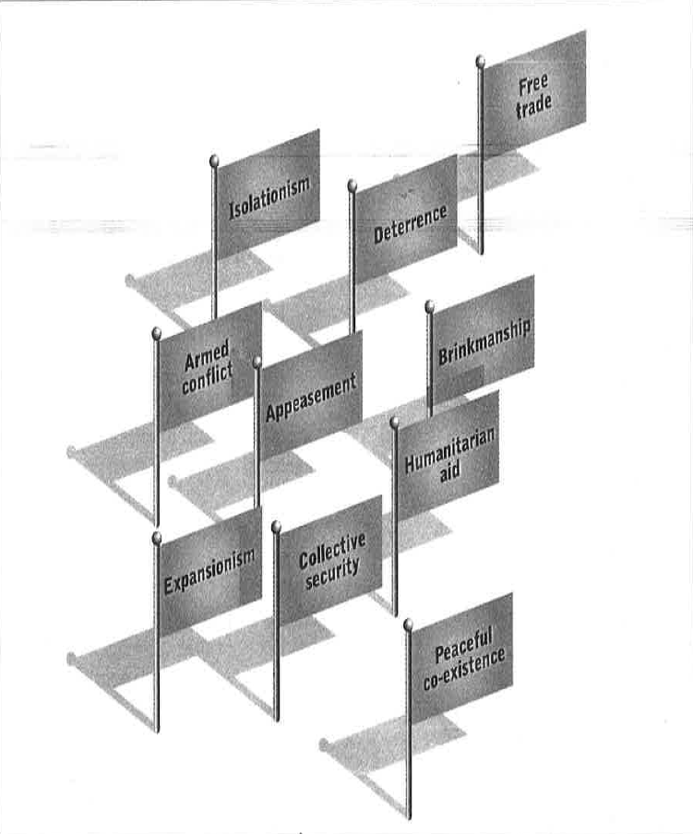

**Which foreign policy or policies had the most significant influence on internal relations after the Second World War?**

**Write a response in which you must**

* **identify** the policy or policies that played the most influential role in shaping international relations after the Second World War.
* **explain** why the method(s) is/are the most significant
* **support** your response using your understanding of social studies

**Reminder for writing**

* **Organize** your response
* **Proofread** your response

It’s very important to examine the question carefully. Make sure you answer it and not something misinterpreted. Like this question mentions WWII, but it is actually about the foreign policies of the Cold War. Questions that mention Classic Liberalism versus Modern LIberalism can be confused. Or collective versus individualism. Watch for keywords or terms and consider their meanings before picking the terms you will write about. Specific terms mean different things even though they sound similar.

Pick a maximum of three terms. Each term you choose requires a paragraph. Justify and prove the links between the terms and the question. Use examples and support from the course.

**Introduce** the time and place that the question and terms come from. 3-5 sentences.

**Terms One**- Expansionism- Russia and the US quickly vied for global domination. The foreign policy of expansionism was employed by both countries to gain ideological support and domination. etc. etc. List all the ways they employed expansionism with specific events if you can. 5-7 sentences

**Term two**- Reference support, examples and events to support your choice. 5-7 sentences

**Term three**- Reference support, examples and events to support your choice. 5-7 sentences

**Small closure** about the theme and major event. Maybe what was gained or learned globally from this event or policies.

|  |
| --- |
| **Introduce** -The larger theme and event.In this case three to five sentences about foreign policies. What are foreign policies and why do countries have them? Think about the general kinds of foreign policies a country can have. What happened after WWII? Was it peaceful or was there more global events? What were they? |

|  |
| --- |
| **Term One**- What is the term definition? Explain why it was chose. How does it fit into the event? Provide examples, terminology and explain the significance of your choice. |



|  |
| --- |
| **Term Two**- What is the term definition? Explain why it was chose. How does it fit into the event? Provide examples, terminology and explain the significance of your choice. |

|  |
| --- |
| **Term Three**- What is the term definition? Explain why it was chose. How does it fit into the event? Provide examples, terminology and explain the significance of your choice. |



|  |
| --- |
| **Conclude**- General statements about the terms chose in regards to the event or question. Debrief the conclusion of the event or ideology in the question. Make a comment about society lessons gained from events or ideology or policies. |