Social Studies 20-2 – Unit 1 – **Assignment 1.5.9** – My Identity and Nation

**Student Name:**

Total: /15 /15

Many factors have influenced the person you are today. Your parents, your community, your heritage, your customs and beliefs, your friends, your role models, your nationality, and your interests have all played a role to shape your unique identity. These factors often tie you to a larger group through collective identities, where you may share similar values and beliefs with others within a nation and/or in the same country.

**What you will do for this assignment:**

**Step 1:** Review and choose the main factors that influence your identity. Using the puzzle image below, review the factors that could influence your identity.

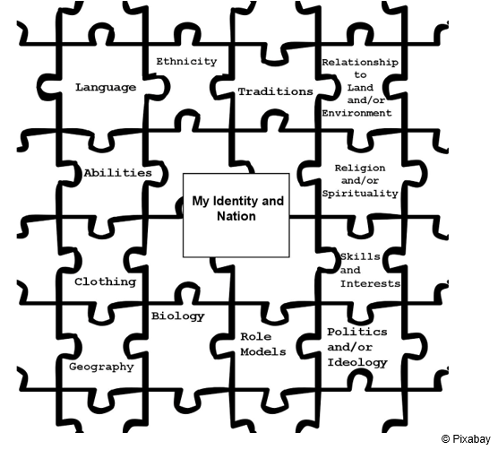

Step 2: Plan your response using the chart provided. *An example has also been provided for you.*

/5 marks

|  |  |  |
| --- | --- | --- |
| **Guiding Questions** | ***Example Reponses*** | **Your Responses** |
| What factors have you chosen that influence your identity? Choose at least three factors to discuss. | * *Skills and interests* * *Traditions* * *Role models* * *Abilities* |  |
| What examples should you include that demonstrate each factor’s influence on your identity? | *I want to include:*  *-travel/history and its impact on my perspective*  *-where my parents came from/traditions*  *-sports* |  |
| In point form, how (or in what ways) do these factors influence your identity? | *-Canadian and British/English identity*  *-how history leads me to travel*  *-sports for relaxing* |  |
| To which nation or nation-state do you feel a strong sense of belonging (a collective identity to your “nation”)? | *I’m from Hanna, Alberta, which is a very small town. I would identify myself as belonging to the nation-state of Canada. Especially since my dad is an orphan (and my mom has a British background but isn’t really invested in it with a group of British people) I don’t believe I have a “nation” within Canada according to the definition.* |  |

Step 3: Write a response in paragraph form that discusses the factors that influence your unique identity. An example student response has been included for you to see (not to copy it):

/10 marks

Sample response: *My name is Kelly Smith and I live in Hanna, Alberta. My mother was born in Durham, England and my dad was born in Saskatchewan. His father was an orphan so we really don’t where that part of the family line goes to. I probably inherited the connection to my Canadian identity through my father because it was the only focus he had for his identity. My mother’s English background makes me interested in British history. Most of the cultural traditions in our household are a mixture of British and our own inventions which makes for interesting contradictions sometimes. This mixture makes my Canadian identity clear to me because I see myself as Canadian before anything else (especially since Hanna is a small town). History is also passion for me which has led me to travel. I have travelled in Europe, Middle East, South American and United States as well as around Canada. These experiences have left me with a true appreciation of the diversity of people and the background for cultural growth. I enjoy sports especially baseball, hockey, and football. For leisure I like to gold as much as I can and get out into the mountains to fly fish.*

Your response here:

|  |
| --- |
|  |

Your teacher will grade your response according to the following scoring criteria (rubric).

|  |  |  |
| --- | --- | --- |
| **Scoring Criteria: 1.5.9 Response** | **Explanations and Support ( /8 marks)** | **Communication**  **( /2 marks)** |
| **Excellent**  **E** | ▪ Explanations are thorough and comprehensive revealing a perceptive understanding.  ▪ Support is specific and accurate and errors, if present do not detract from the response.  **8** | ▪ The writing is fluent and effectively organized.  ▪ Vocabulary is precise and effective.  ▪The writing demonstrates confident control of sentence construction, grammar and mechanics.  ▪ The occurrence of error is rare.  **2** |
| **Proficient**  **PF** | ▪ Explanations are appropriate and purposeful revealing a clear understanding.  ▪ Support is relevant and appropriate, but may contain some minor errors.  **6.4** | ▪ Vocabulary is accurate and appropriate.  ▪ The writing frequently demonstrates effective control of sentence construction, grammar, and mechanics.  ▪The occurrence of error is infrequent.  **1.6** |
| **Satisfactory**  **S** | ▪ Explanations are general and straightforward, revealing an acceptable understanding.  ▪ Support is relevant but general, may be incompletely developed, and/or contains minor errors.  **4.8** | ▪ The writing is generally clear and functionally organized.  ▪ Vocabulary is generally accurate, but not specific.  ▪ The writing demonstrates basic control of sentence construction, grammar, and mechanics. Errors do not seriously interfere with communication.  **1.2** |
| **Limited**  **L** | ▪ Explanations are overgeneralized and/or redundant revealing a confused, though discernible, understanding.  ▪ Support is superficial, may not always be relevant, and may contain significant errors  **3** | ▪ The writing is uneven and incomplete but is discernibly organized.  ▪ Vocabulary is imprecise and/or inappropriate.  ▪ The writing demonstrates a faltering control of sentence construction, grammar and mechanics.  ▪ Errors hinder communication.  **1** |
| **Poor**  **P** | ▪ Explanations are tangential or minimal revealing a negligible understanding.  ▪ Support, if present, is incomplete, may be marginally relevant, and contains significant and /or frequent errors**.**  **1.6** | ▪ The writing is unclear and disorganized.  ▪ Vocabulary is ineffective and frequently incorrect.  ▪ A lack of control of sentence construction, grammar, and mechanics is demonstrated.  ▪ Errors impede communication  **.4** |
| **Insufficient**  **INS** | Insufficient is a special category. **It is not an indicator of quality.** It is assigned to responses that are:  -off-topic  -do not contain a discernible attempt to address the task  -or that are too brief to assess in any scoring category | Attempt will be sent back to student for a redo. |

|  |  |
| --- | --- |
| Teacher Comments: |  |

|  |  |
| --- | --- |
| Step 1: Planning Chart | /5 |
| Step 2: Written Response | /10 |
| Total grade for Assignment 1.5.9 Total: | /15 |
| % |  |

Teacher/Date:

**Social Studies 20-2 Outcomes**

* Evaluate personal assumptions and opinions.
* Communicate effectively.
* Explore a range of expressions of nationalism.
* Appreciate why people seek to promote their identity through nationalism.