2.4 Notebook Organizer, Textbook pages 42 to 50
Using the organizer below and content from the pages in the Understanding Nationalism textbook, complete the various parts of this organizer as you work through this section of the course.
Before the Revolution
 | Political Factors | Economic Factors | Social Factors | Historical Factors | Geographic Factors
The King
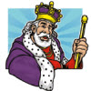
The First Estate
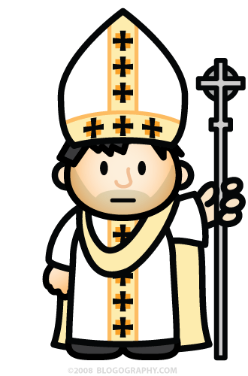
The Second Estate
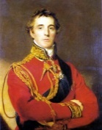
The Third Estate
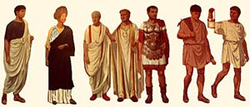

Reflect on your notes and respond. On page 44 of the Understanding Nationalism textbook, there is an editorial cartoon depicting conditions in pre-revolution France (Fig. 2-6). Does Canada have any of the three external factors discussed in the reading? Draw your own cartoon or symbol to represent your thoughts.


  Self-Reflection | Reflect on your notes and respond. On page 44 of the textbook, Fig. 2-6 is an editorial cartoon depicting conditions in pre-revolution France. Does Canada have any of the three external factors discussed in the reading? Draw your own cartoon or symbol to represent your thoughts.

Republic
Revolution
I do not share power with anyone other than God “The State is Me”
Louis XIV

