Social Studies 20-2 – Unit 2 – **Assignment 2.4.4** – Critical Viewing: Source Analysis

**Student Name:**

Nationalism: the feelings people have in identifying with their nation

These feelings generally include loyalty for and pride in their nation’s culture. This may also include a belief in the political and territorial independence of the nation, which likely has its own government and land. A person who promotes his or her country’s nationalism is said to be a “nationalist.”

|  |
| --- |
| **TASK:**  **Step 1:** Using the *How to Read a Picture* tutorial steps, analyze the two sources by referring to events in the **French Revolution**.   * “A faut esperer q’eu se jeu las finira bentot” - creator unknown (Title translates to: “You should hope the game is over soon”) * “The Oath of the Tennis Court” by Jacques Louis David   **Step 2:** Use your analysis to explain the development of **nationalism** in France by including references to the sources, the events of the French Revolution, and factors that shape nationalism. |

**Step 1:** Use the *How to Read a Picture* tutorial steps to analyze two sources from the French Revolution. You may use point form to analyze each source. When analyzing the sources, **remember to consider the feudal system, absolute monarchy, and the events leading to the Oath of the Tennis Court**.

/10 marks

|  |  |
| --- | --- |
| **Source 1**  *“A faut esperer q’eu se jeu la finira bentot” (Translation: You should hope the game is over soon)”* |  |
| Describe the source using point form. |  |
| Why is the **title** of the source important? Explain by using events in the French Revolution. |  |
| What **Estates** are represented in the source? How do you know? (Include and explain details from each source). |  |
| What are the Estates **doing** in this source? Indicate the obvious and be specific. |  |
| What do you believe is the main message to the viewer? |  |

|  |  |
| --- | --- |
| **Source 2**  *“The Oath of the Tennis Court” (Painter: Jacque Louis David)* |  |
| Describe the source using point form. |  |
| Why is the **title** of the source important? Explain by using events in the French Revolution. |  |
| What **Estates** are represented in the source? How do you know? (Include and explain details from each source). |  |
| What are the Estates **doing** in this source? Indicate the obvious and be specific. |  |
| What do you believe is the main message to the viewer? |  |

**Step 2:** Using the factors that shape nationalism diagram (below) and the events of the French Revolution, explain what the two sources communicate about the development of nationalism in France.

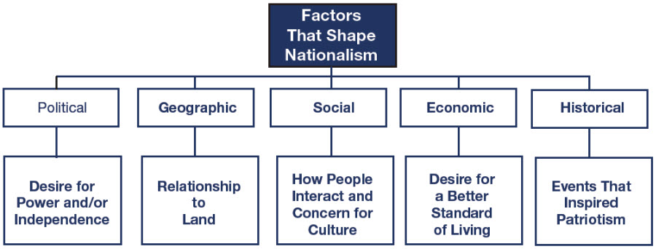

Your written response must include the following:

1. interpret each source to identify what the sources tell you about the development of nationalism in France,
2. identify and discuss key factors (from the diagram above that shaped nationalism in the French Revolution,
3. include details from both sources to support your discussion, and
4. correctly use and apply the terms **nationalism, constitution, Estate** (as in the First/Second/Third Estates), **Old Regime (Ancien Regime)**, and **egalitarianism**.

**20 marks**

Your response here:

|  |
| --- |
|  |

Your teacher will grade your response according to the following scoring criteria (rubric).

|  |  |  |  |
| --- | --- | --- | --- |
| **Scoring Criteria: Source Analysis** | **Interpretation of Sources**  (8 marks)   * quality of the interpretation quality of evidence from sources * quality of evidence from knowledge of social studies * understanding of the assigned task | **Defense of Position**  (8 marks)   * quality of argument(s) to support position * quality of evidence to support position * understanding of applicable social studies knowledge and the assigned task | **Communication**  (4 marks)   * organization/coherence * stylistic choices to create voice * vocabulary * sentence construction * grammar/mechanics |
| **Excellent**  **E** | * Interpretations are insightful and comprehensive, and address all sources. * Evidence is specific and accurate and errors, if present, do not detract from the response. * The student demonstrates a thorough and perceptive understanding of applicable social studies knowledge and the assigned task.   **8** | * The defense of position is based on one or more convincing, logical arguments. * Evidence is specific and accurate and errors, if present, do not detract from the response. * The student demonstrates a thorough and perceptive understanding of applicable social studies knowledge and the assigned task.   **8** | * The writing is fluent and purposefully organized. * Effective stylistic choices may contribute to the creation of an engaging voice. * Vocabulary is precise. * The writing demonstrates confident control of sentence construction, grammar, and mechanics. * Errors, if present, are inconsequential.   **4** |
| **Proficient**  **Pf** | * Interpretations are specific and accurate but may not address all sources. * Evidence is relevant and appropriate but may contain some minor factual errors. * The student demonstrates a clear understanding of applicable social studies knowledge and the assigned task.   **6.4** | * The defense of position is based on one or more sound arguments. * Evidence is appropriate, but may contain some minor factual errors. * The student demonstrates a clear understanding of applicable social studies knowledge and the assigned task.   **6.4** | * The writing is logical and clearly organized. * Appropriate stylistic choices may contribute to the creation of a distinct voice. * Vocabulary is specific. * The writing frequently demonstrates effective control of sentence construction, grammar, and mechanics. * Errors do not detract from communication.   **3.2** |
| **Satisfactory**  **S** | * Interpretations are valid but general and may contain minor misconceptions. * Interpretations may not address all sources. * Evidence is relevant, but general, may be incompletely developed, and/or contains minor errors. * The student demonstrates an acceptable understanding of applicable social studies knowledge and the assigned task.   **4.8** | * The defense of position is based on one or more adequate arguments. * Evidence is relevant, but general and/or incompletely developed. * The evidence may contain errors. * The student demonstrates an acceptable understanding of applicable social studies knowledge and the assigned task.   **4.8** | * The writing is generally clear and functionally organized. * Basic stylistic choices may contribute to the creation of a voice that is adequate. * Vocabulary is adequate. * The writing demonstrates basic control of sentence construction, grammar, and mechanics. * Errors do not seriously interfere with communication.   **2.4** |
| **Limited**  **L** | * Interpretations are overgeneralized and may contain substantial misconceptions. * Evidence is superficial, may not always be relevant, and may contain significant errors. * The student may demonstrate a confused, yet discernible, understanding of applicable social studies knowledge and the assigned task.   **3.2** | * The defense of position is based on oversimplified assertions and/or questionable logic. * Evidence is superficial and may not always be relevant. * The evidence may contain significant errors. * The student demonstrates a confused, yet discernible, understanding of applicable social studies knowledge and the assigned task.   **3.2** | * The writing is uneven and incomplete but is discernibly organized. * Awkward stylistic choices may contribute to the creation of an unconvincing and/or inappropriate voice. * Vocabulary is imprecise and/or inappropriate. * The writing demonstrates faltering control of sentence construction, grammar, and mechanics. * Errors hinder communication.   **1.6** |
| **Poor**  **P** | * Interpretations are mistaken or irrelevant. * Evidence, if present, is incomplete and/or marginally relevant and frequently contains significant errors. * Application of social studies knowledge is negligible.   **1.6** | * The defense of position taken is difficult to determine and/or little or no attempt is made to defend it. * Evidence, if present, is incomplete and/or marginally relevant. * Significant errors in content are frequent. * The student demonstrates a minimal understanding of applicable social studies knowledge and the assigned task.   **1.6** | * The writing is unclear and disorganized. * Ineffective and/or inappropriate stylistic choices may contribute to the creation of an ineffective and/or unsuitable voice. * Vocabulary is ineffective and frequently incorrect. * A lack of control of sentence construction, grammar, and mechanics is demonstrated. * Errors impede communication.   **0.8** |
| **Insufficient**  **INS** | Insufficient is a special category. It is not an indicator of quality. It is assigned to responses that are:  -off topic  -do not contain a discernible attempt to address the task  -or that are too brief to assess in any scoring category | Attempt will be sent back to student for a redo. |  |

Teacher Comments:

|  |  |
| --- | --- |
| Step 1: Source Analysis | /10 |
| Step 2: Written Response | /20 |
| Total grade for Assignment 2.4.4 Total: | /30 |
| % |  |

Teacher/Date:

**Social Studies 20-2 Outcomes:**

* Determine relationships among multiple sources of information
* Understand the difference between historical facts and historical interpretations
* Use a variety of visual sources to present informed positions on issues
* Analyze the impacts of various forms of media
* Communicate effectively