**Student Name:**



**Social Studies 20-2**

**Unit 2, Assignment 2.4.4**

**Critical Viewing: Source Analysis Assignment**

**/30**

In this assignment, you will

* connect the events of the French Revolution to © Flickr/Chris Isherwood

two sources,

* use the *How to Read a Picture* tutorial to analyze two sources, and
* describe the development of nationalism in France using the factors

that shape nationalism and your understanding of the French Revolution.

**Nationalism**: the feelings people have in identifying with their nation   
These feelings generally include loyalty for and pride in their nation's culture. This may also include a belief in the political and territorial independence of the nation, which likely has its own government and land. A person who promotes his or her country's nationalism is said to be a "nationalist."

**TASK**:

**Step 1:** Using the *How to Read a Picture* tutorial steps, analyze the two sources by referring to events in the French Revolution.

* “*A faut esperer q'eu se jeu la finira bentot*” –creator unknown

(Title translates to: “*You should hope the game is over soon*”)

* “The Oath of the Tennis Court” by Jacques Louis David

**Step 2: Use your analysis to explain** the development of **nationalism** in France by including references to the sources, the events of the French Revolution, and factors that shape nationalism.

**/10 Step 1:** Use the *How to Read a Picture* tutorial steps below to analyze two visuals from the French Revolution. You may use point form to analyze each source. When analyzing the sources, remember to consider the feudal system, absolute monarchy, and the events leading to the Oath of the Tennis Court.

|  |  |  |
| --- | --- | --- |
|  | **Source 1**  “A faut esperer q'eu se jeu la finira bentot” (*You should hope the game is over soon*) | **Source 2**  “The Oath of the Tennis Court”-Jacques Louis David |
| **How to Read a Picture Tutorial** | (A copy of this image can also be found on page 44 in the *Understanding Nationalism* textbook.) |  |
| Describe the sources using point form. |  |  |
| Why is the **title** of the source important?  Explain by using events in the French Revolution. |  |  |
| What **Estates** are represented in the source? How do you know (include and explain details from each source). |  |  |
| What are the **Estates** doing in each source? |  |  |
| What do you believe is the main message to the viewer? |  |  |
| Metaphors and Symbols | 1. facial expressions on each person 2. importance of the order of each person (Who comes first? Second? Last?) 3. importance of each person’s clothing (What does each item represent?) 4. sword (man in red) 5. axe (man on bottom) | 1. the central figure with his hand raised     b. the other people in the painting who have their hands raised    c. the group of three people in the foreground (*Which groups in French society do they symbolize?*)    d. the beam of light just around and above the central person’s head (*What could the light represent?*)    e. the curtains blowing in the window |

**/20 Step 2:** Using the factors that shape nationalism diagram (below) and the events of the French Revolution, explain what the two sources communicate about **the development of nationalism in France.**

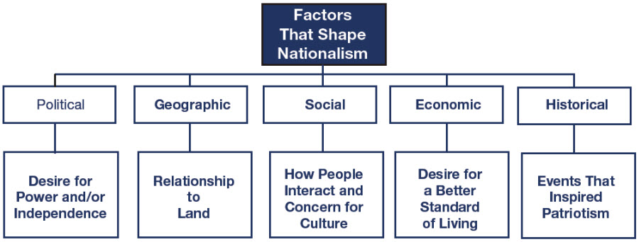

In your response, you **must**

1. **interpret each** source to **identify** whatthe sources tell you about the development of nationalism in France,
2. **identify and discuss key factors** (from the diagram above) **that shaped nationalism** in the French Revolution,
3. **include details** **from both sources** to support your discussion, and
4. correctly use and apply the terms **nationalism**, **constitution**, **Estate** (as in the First/Second/Third Estates), **Old Regime (Ancien Régime)**, and **egalitarianism**.

**Remember to review the Student Example: Step 2-2.4.4. in order to clarify the expectations for Step 2.**

**Your response here:**

The 2.4.4 Critical Viewing: Source Analysis Assignment will be marked using the rubric below.

|  |  |  |  |
| --- | --- | --- | --- |
| **Scoring Criteria: Source Analysis** | **Interpretation of Sources**  (8 marks)   * quality of the interpretation quality of evidence from sources * quality of evidence from knowledge of social studies * understanding of the assigned task | **Defence of Position**  (8 marks)   * quality of argument(s) to support position * quality of evidence to support position * understanding of applicable social studies knowledge and the assigned task | **Communication**  (4 marks)   * organization/coherence * stylistic choices to create voice * vocabulary * sentence construction * grammar/mechanics |
| **Excellent**  **E** | * Interpretations are insightful and comprehensive, and address all sources. * Evidence is specific and accurate and errors, if present, do not detract from the response. * The student demonstrates a thorough and perceptive understanding of applicable social studies knowledge and the assigned task.   **8** | * The defence of position is based on one or more convincing, logical arguments. * Evidence is specific and accurate and errors, if present, do not detract from the response. * The student demonstrates a thorough and perceptive understanding of applicable social studies knowledge and the assigned task.   **8** | * The writing is fluent and purposefully organized. * Effective stylistic choices may contribute to the creation of an engaging voice. * Vocabulary is precise.. * The writing demonstrates confident control of sentence construction, grammar, and mechanics. * Errors, if present, are inconsequential.   **4** |
| **Proficient**  **Pf** | * Interpretations are specific and accurate but may not address all sources. * Evidence is relevant and appropriate but may contain some minor factual errors. * The student demonstrates a clear understanding of applicable social studies knowledge and the assigned task.   **6.4** | * The defence of position is based on one or more sound arguments. * Evidence is appropriate, but may contain some minor factual errors. * The student demonstrates a clear understanding of applicable social studies knowledge and the assigned task.   **6.4** | * The writing is logical and clearly organized. * Appropriate stylistic choices may contribute to the creation of a distinct voice. * Vocabulary is specific. * The writing frequently demonstrates effective control of sentence construction, grammar, and mechanics. * Errors do not detract from communication.   **3.2** |
| **Satisfactory**  **S** | * Interpretations are valid but general and may contain minor misconceptions. * Interpretations may not address all sources. * Evidence is relevant, but general, may be incompletely developed, and/or contains minor errors. * The student demonstrates an acceptable understanding of applicable social studies knowledge and the assigned task.   **4.8** | * The defence of position is based on one or more adequate arguments. * Evidence is relevant, but general and/or incompletely developed. * The evidence may contain errors. * The student demonstrates an acceptable understanding of applicable social studies knowledge and the assigned task.   **4.8** | * The writing is generally clear and functionally organized. * Basic stylistic choices may contribute to the creation of a voice that is adequate. * Vocabulary is adequate. * The writing demonstrates basic control of sentence construction, grammar, and mechanics. * Errors do not seriously interfere with communication.   **2.4** |
| **Limited**  **L** | * Interpretations are overgeneralized and may contain substantial misconceptions. * Evidence is superficial, may not always be relevant, and may contain significant errors. * The student may demonstrate a confused, yet discernible, understanding of applicable social studies knowledge and the assigned task.   **3.2** | * The defence of position is based on oversimplified assertions and/or questionable logic. * Evidence is superficial and may not always be relevant. * The evidence may contain significant errors. * The student demonstrates a confused, yet discernible, understanding of applicable social studies knowledge and the assigned task.   **3.2** | * The writing is uneven and incomplete but is discernibly organized. * Awkward stylistic choices may contribute to the creation of an unconvincing and/or inappropriate voice. * Vocabulary is imprecise and/or inappropriate. * The writing demonstrates faltering control of sentence construction, grammar, and mechanics. * Errors hinder communication.   **1.6** |
| **Poor**  **P** | * Interpretations are mistaken or irrelevant. * Evidence, if present, is incomplete and/or marginally relevant and frequently contains significant errors. * Application of social studies knowledge is negligible.   **1.6** | * The defence of position taken is difficult to determine and/or little or no attempt is made to defend it. * Evidence, if present, is incomplete and/or marginally relevant. * Significant errors in content are frequent. * The student demonstrates a minimal understanding of applicable social studies knowledge and the assigned task.   **1.6** | * The writing is unclear and disorganized. * Ineffective and/or inappropriate stylistic choices may contribute to the creation of an ineffective and/or unsuitable voice. * Vocabulary is ineffective and frequently incorrect. * A lack of control of sentence construction, grammar, and mechanics is demonstrated. * Errors impede communication.   **0.8** |
| **Zero**  **Z** | Zero is assigned to a response that fails to meet the minimum requirements of the Poor category. | | |
| **Teacher Comments** |  | | |
| **2.4.4 Assignment Grade** | **Step 1: /10 + Step 2: /20 = /30** | | |

|  |  |  |  |
| --- | --- | --- | --- |
|  |  |  |  |

**Social 20-2 Outcomes**

* Determine relationships among multiple sources of information
* Understand the difference between historical facts and historical interpretations
* Use a variety of visual sources to present informed positions on issues
* Analyze the impacts of various forms of media
* Communicate effectively