2.7 Notebook Organizer, Textbook pages 43, 48 to 51

Using the organizer below, explain the significance of the major symbols during the French Revolution and respond to the question at the bottom of the page.

2.7.1 Bastille Day |  | 2.7.5 Victory over Austria and Prussia at Valmy, 1792
2.7.2 The Tricolour | 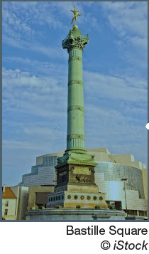 | 2.7.6 Slogan of French Nationalism
2.7.3 The Phrygian Cap |  | 2.7.7 La Marseillaise
2.7.4 Declaration of Rights of Man and the Citizen | 2.7.9 Women as a Symbol | 2.7.8 France’s Flag

  Self-Reflection | Research the following events.  - Vimy Ridge  - 1972 Hockey Summit Series (Canada vs. Russia)  - The Tragically Hip’s Final Concert  - Quebec Referendum  The storming of the Bastille is an event that drew the collective consciousness of France’s citizens, both in the French Revolution, and even into today. Using the events above, how did these events define Canada’s national identity?

