**4.4 Notebook Organizer, Textbook pages 136 to 140, 142**

Use the organizer to take notes using pages from the *Understanding Nationalism* textbook and content pages 4.4.1, 4.4.2, and 4.4.3, and answer the Reflect section below.

|  |
| --- |
|  |

Take point-form notes in the chart below. For each nation, take notes that show characteristics of ultranationalism. You may wish to review content page 4.3 for the characteristics of ultranationalism.

|  |  |  |  |
| --- | --- | --- | --- |
|  | **Treaty of Versailles** | **Economic Factors: The Great Depression** | **Political Factors: Leaders and Political Beliefs** |
| **Italy** |  |  |  |
| **Germany** |  |  |  |
| **Japan** |  |  |  |

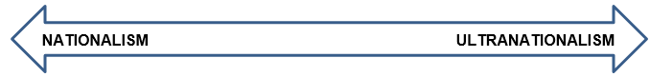

|  |
| --- |
| Review the factors that led Italy, Germany, and Japan to ultranationalism and World War II, and answer the following question.  In your perspective, which nation do you believe was most justified in their pursuit of national self-interests? Why? |