**8.4.3 Notebook Organizer, Textbook pages 224 to 226**

Reflect on your reading and fill the information to form your initial understanding of what impacts and shapes a nation’s foreign policy.

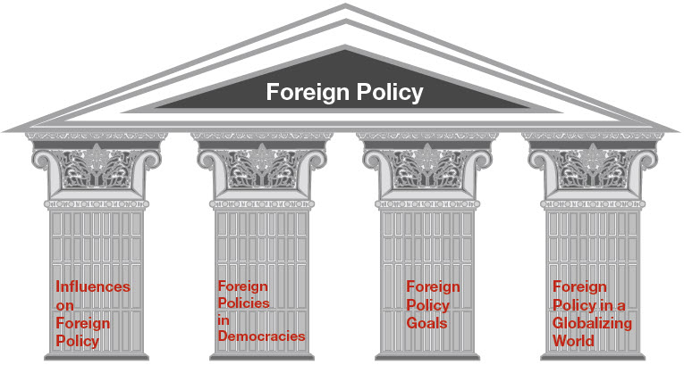

Influences on Foreign Policy

Foreign Policies in Democracies

Foreign Policy Goals

Foreign Policy in a Globalizing World