**Sample Outline-Source Analysis**

Feel free to use the sample outline below to plan out your Source Analysis written response. Remember that this is a rough outline, and you can respond in point form.

The final draft of your Source Analysis written response should be in paragraphs and edited for errors prior to being submitted.

**Outline for the Source Analysis**

* 1. Review and rephrase the central question: usually the question will look like "What does each of the sources on page # and # communicate about the role of _______________ in society?"

*Ex.* 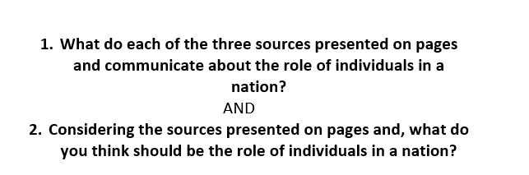

**PLAN:**

What is the central question? Write it here:

Rewrite the central question in your own words:

* 1. Look at all the provided sources, and make a general statement about the sources.
     + What is **each source** saying about the central question, and what is the source’s **position** on the central question? Paraphrase the central message in each source, and list main details from each source you plan to use.
     + Analyze the sources by demonstrating an understanding of the **position the sources take on the central question**. For example, is the message in the source FOR or AGAINST the question? What main details can you pick that supports the position in each source?

**PLAN:**

Source 1:

Main Message and Position:

Main Details:

Source 2:

Main Message and Position:

Main Details:

Source 3:

Main Message and Position:

Main Details:

* 1. State your thesis or position on the central question-what do **YOU** believe is the role of...?. List the main arguments you will use to support your position.

**PLAN:**

My position on the central question is:

Supporting Reasons/Arguments:

**\*Remember, this is a rough outline for the Source Analysis. Review the expectations and exemplars for the Source Analysis written response within your course.**