**Sample Outline-Speakers’ Perspectives**

Feel free to use the sample outline below to plan out your Speakers’ Perspectives written response. Remember that this is a rough outline, and you can respond in point form.

The final draft of your Speakers’ Perspectives written response should be in paragraphs and edited for errors prior to being submitted.

**Outline for the Speakers’ Perspectives Written Response**

* 1. Review and rephrase the central issue/topic question: usually the question will look like "Should….” or “ Is it in _________’s interest to….”

***Is it in Canada’s national interest to play a significant role in NATO led military missions around the world?***

Write a response in which you

* + - * **explore** the issue of Canada’s involvement in NATO led military missions
      * **analyze** various points of view on the issue
      * **explain** and **defend** your position on the question
      * **support** your point of view by using your understanding of Social Studies

*Ex.*



**PLAN:**

What is the central issue/topic question? Write it here:

Explain why the central issue/topic question is generally important to consider:

* 1. Review all 3 speakers’ perspectives, and make a general statement about each of the perspectives.

*Ex. 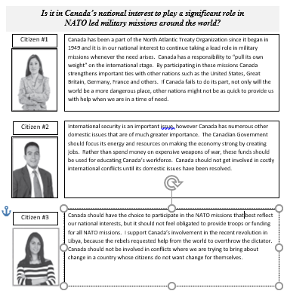*

* + - What is **each speaker** saying about the central issue/topic question; do they agree, disagree, partially agree/disagree? Reference specific words or sentences the speaker uses that supports their position.
    - Do you agree/disagree/partially agree/disagree with the speaker’s perspective? Explain why, and support with evidence from Social Studies.

**PLAN**:

Speaker 1:

Main Position:

Details to Support:

Your Position:

Evidence to Support:

Speaker 2:

Main Position:

Details to Support:

Your Position:

Evidence to Support:

Speaker 3:

Main Position:

Details to Support:

Your Position:

Evidence to Support:

* 1. Explain your position on the central issue/topic question, and list the main arguments you will use to support your position.

**PLAN:**

My position on the central issue/topic question is:

Supporting Reasons/Arguments:

**\*Remember, this is a rough outline for the Speakers’ Perspectives written response. Review the expectations and exemplars for the Speakers’ Perspectives written response within your course.**