43  Marks Total | ASSIGNMENT 1  Part One: Momentum and Newton’s Second Law  Part One of this assignment is worth 22 marks. The value of each question is noted in parentheses in the left margin. Note: The answer areas will expand to fit the length of your response.

1. | Identify and explain if one of the objects in each of these pairs has a greater value for the magnitude of its momentum than the other. (No calculations should be required.)
(1) | - a 900.0-kg truck travelling at 60 km/h, or a 500.0-kg car travelling at 60 km/h
Answer:
(1) | - a 15.0-kg object travelling to the right at 5.0 m/s, or a 15.0-kg object travelling to the left at 5.0 m/s
Answer:
(1) | - a 900-kg truck at rest, or a 500-kg car at rest
Answer:
(1) | - a 900-kg truck at rest, or a mosquito flying at 2 m/s
Answer:
(3) 2. | The momentum of a 75-g dart is 9.00 kg∙m/s east. What is the velocity of the dart? As with all problems involving vectors, remember to include the direction in your answer.
Answer:
3. | A 425-g softball is travelling at 18.6 m/s [214º].
(2) | - What is the momentum of the softball?
Answer:

(1) | - Which of the four vectors below accurately shows the direction of the softball using the polar coordinates method as described on page 78 of the Pearson text?
 | 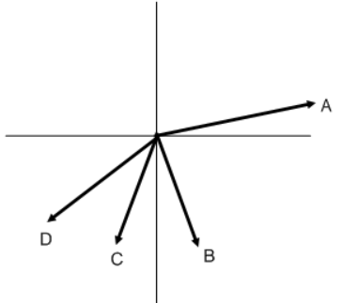
Answer:
(3) 4. | What is the mass of a boat if it travels at a velocity of 57.0 km/h [E] and has a momentum of 2.15 x 10⁶ kg∙m/s [E]?
Answer:
(2) 5. | Use the concepts of momentum and Newton’s second law to explain why a motorcycle can accelerate at a greater rate than a large truck.  To earn full marks for this question you should:  - Identify which vehicle has the larger momentum and use the equation for momentum to explain why this affects its ability to accelerate.  - Identify which vehicle can accelerate faster and use Newton’s second law to explain why.
Answer:
(5) 6. | In video games, high-speed crashes are common. Consider a motorcycle and a scooter racing against each other down a mountain road. Neither driver will yield. Eventually each vehicle strikes a metal barrier. The concepts of momentum and net force can be used to make each simulated crash realistic.  In a paragraph, explain how you would use the concept of momentum and net force to make each simulated crash realistic. In general, how could you use momentum and Newton's laws of motion to predict the amount that each section of the barrier changes shape?  Your answer should address the following questions:  - Compare the masses and speeds of each vehicle. (1 mark)  - Define momentum and compare the momentum values for each vehicle. (1 mark)  - Use the concept of impulse to explain the two variables that are required to change the momentum of each vehicle. (1 mark)  - Describe how this is reflected in the change of shape of the barrier. (1 mark)  - Use the concept of Newton’s first law to explain what happens to each driver when they strike the barrier. (1 mark)
Answer:

STOP!
When you have completed all of the questions in Part One, save your work to your desktop. You will return to this assignment to complete Part Two after you have completed the remainder of the content in the changing momentum section.

Part Two: Changing Momentum

Part Two of this assignment is worth 21 marks. The value of each question is noted in the left margin in parenthesis. Note: The answer areas will expand to fit the length of your response.

(3) 1. | An arrow gains a momentum of 94.3 kg•m/s [W] in 0.400 s. Determine the magnitude and direction of the average unbalanced force that acted on the arrow.
Answer:
- 2. | An artillery shell is accelerated from rest and gains a momentum of 2.00 x 10³ kg•m/s [E]. If the average net force acting on the shell was 8.50 x 10³ N [E], calculate the time interval that this net force acted on the shell.
Answer:
3.  (3) | A high school football player hits and pushes a tackling dummy during practice. The following graph shows the amount of force that acts on the player.  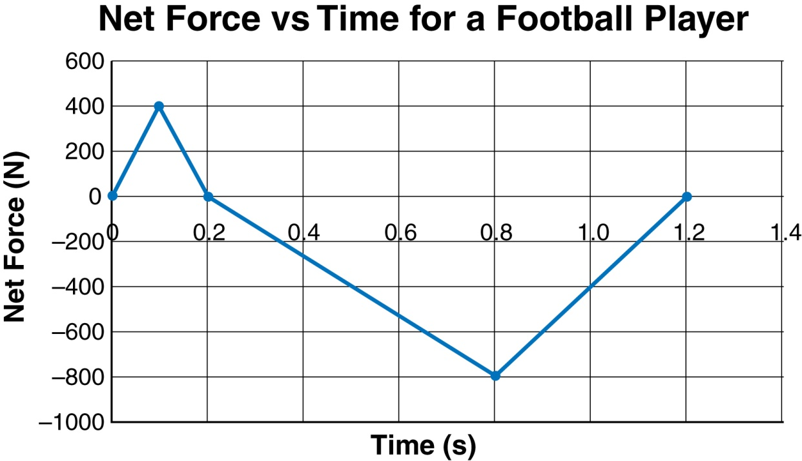  - What is the impulse that acts on the football player?
Answer:
(3) | - If the 60 kg player is running forward at 7.0 m/s when she makes contact with the dummy, what is the player’s velocity at the end of the 1.20 s impact?
Answer:
(1) | - From 0.0 s to 0.1 s, what is happening to the acceleration of the player?  The player is accelerating at  A. an increasing rate in the forward direction  B. a decreasing rate in the forward direction  C. a decreasing rate in the backward direction  D. an increasing rate in the backward direction
Answer:
(1) | - From 0.1 s to 0.2 s, what is happening to the acceleration of the player?  The player is accelerating at  A. an increasing rate in the forward direction  B. a decreasing rate in the forward direction  C. an increasing rate in the backward direction  D. a decreasing rate in the backward direction
Answer:
(1) | - During which time interval is the net force positive? Is the velocity increasing or decreasing when the force is positive?
Answer:
(1) | - Identify and explain at which point in time the magnitude of the acceleration is the greatest.
Answer:
(3) 4. | The following illustration shows two ways of providing impulse to change the momentum of a vehicle. In the top illustration, the vehicle collides with a massive concrete barrier. In the bottom illustration, the vehicle collides with water-filled barrels.  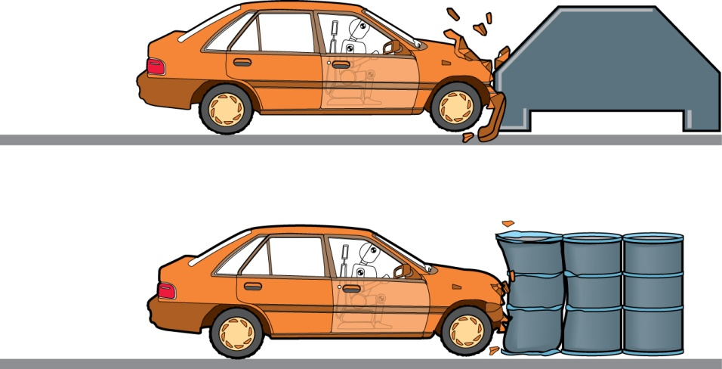  Explain which type of crash barrier would likely produce less damage to the vehicle and less injury to the occupants.
Answer:
(2) 5. | On the basis of the contents of this lesson, explain the necessity of bicycle helmets to someone who does not believe they are necessary. Give two reasons.
Answer:

When you have completed all of the questions in this assignment,
submit your work to your teacher.

