18  Marks Total | ASSIGNMENT 3  Unit A Assessment – The Conservation of Momentum  This assignment is worth 18 marks. The value of each question is noted in the left margin in parenthesis. Note: The answer areas will expand to fit the length of your response. Important: Complete this assignment after you have reviewed your marked Assignment 2.

(2) 1. | Review the case file data below and answer the questions that follow.  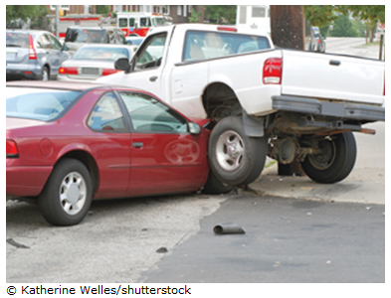  Kathy and Bill collided at an intersection. The police learned the mass of the truck is 3200 kg and the mass of the car is 2800 kg. Based on the length of the skid marks at the scene and the mass of the vehicles, police estimate that the combined mass was moving at 7.0 m/s just after impact. From this point, the two vehicles slid and came to rest at the corner of the intersection.  Using the principle of conservation of momentum, the police determined that Bill’s truck was travelling at 2.3 m/s before the collision and Kathy’s car was travelling at 15 m/s before the collision.  The two momentum vectors before the collision are represented by the horizontal and vertical lines below. The momentum after the collision is the slanted line. Adding the two momentum vectors before the collision equals the momentum after the collision, according to the law of conservation of momentum  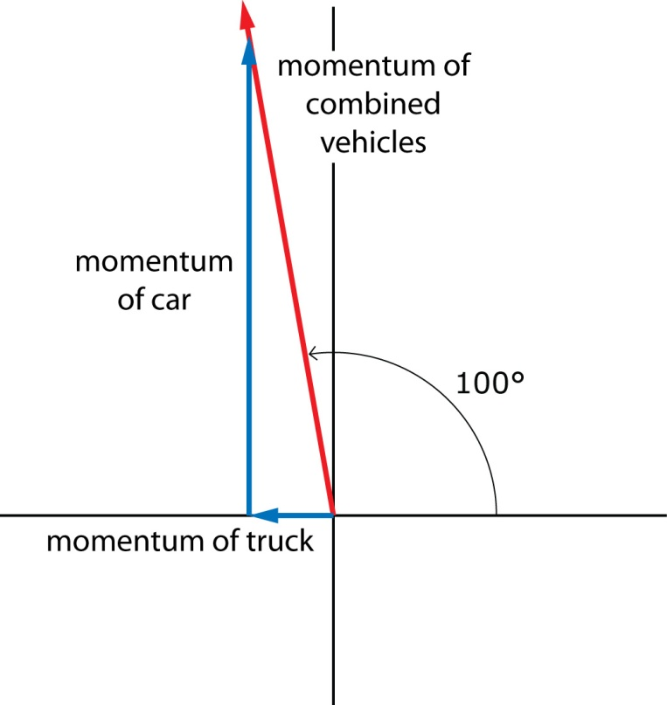  While the photo suggests a much more complex collision than the given diagram, assume that the diagram shows exactly what happened.  Determine the magnitude of the momentum just after the collision.
Answer:
(6) 2. | What is the kinetic energy of the vehicles before and after the collision? Find the individual kinetic energies before and after and then find the sum of the energies before and after.
Answer:
(2) 3. | Using the vector diagram above and your calculated value for the momentum of the combined vehicles, verify the police’s calculations and determine the momentum and velocity of Bill’s truck just before the collision.
Answer:
(2) 4. | Using the vector diagram above and your calculated value for the momentum of the combined vehicles, verify the police’s calculations and determine the momentum and velocity of Kathy’s car just before the collision.
Answer:
(2) 5. | Is the total magnitude of the momentum before the collision the same as the total magnitude of the momentum just after the collision? Explain why or why not.
Answer:
(2) 6. | Is kinetic energy conserved, and if the kinetic energy was not conserved, what does this tell us about the type of collision?
Answer:
(2) 7. | Does your analysis prove, beyond a reasonable doubt, that Kathy was, in fact, travelling at the speed limit of 50 km/h just prior to the accident? What assumptions did you make in your solution to determine your conclusion?
Answer:

When you have completed all of the questions in this assignment,
submit your work to your teacher.

