44  Marks Total | ASSIGNMENT 4  Part One: Electrostatics  Part One of this assignment is worth 25 marks. The value of each question is noted in parentheses in the left margin. Note: The answer areas will expand to fit the length of your response.

1. | Complete each of the following statements by responding with the missing word(s).
(1) | - A charged glass rod is brought close to an insulated metal rod. The rod is momentarily grounded and then the ground is removed. This method of charging is called charging by __________.
Answer:
(1) | - At the end of the procedure the sign of the charges on the metal rod and the glass rod are __________.
Answer:
(1) | - A balloon is rubbed on a carpet. This method of charging is called charging by __________.
Answer:
(1) | - At the end of the procedure the sign of the charges on balloon and carpet are __________.
Answer:
(1) | - A charged ebonite rod is touched to an uncharged pith ball. This method of charging is called charging by__________.
Answer:
(1) | - At the end of the procedure the charges on ebonite rod and pith ball are __________.
Answer:
(2) 2. | A child’s balloon is rubbed on her hair to charge it and then is placed in contact with a neutral ceiling. The balloon does not fall but remains in contact with the ceiling. Explain how the charged balloon is electrostatically attracted to the neutral ceiling.
Answer:
3. | Complete each of the following statements by responding with the missing word(s).
(1) | - When water molecules in a churning cloud formation collide with each other the result is __________.
Answer:
(1) | - The top of the cloud becomes positive and the bottom negative because __________.
Answer:
(1) | - A conducting plasma is formed due to __________.
Answer:
(1) | - The separation of charge at Earth’s surface is cause by __________.
Answer:
(1) | - A streamer is formed when air molecules near Earth’s surface __________.
Answer:
(1) | - A lightning strike occurs when __________.
Answer:

4.  (2) | The diagram below shows the apparatus used in an electrostatics experiment. 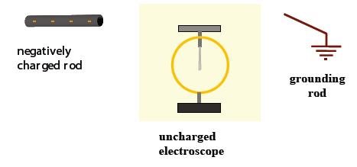  - Describe or draw what is observed when a negatively charged rod is placed beside the top of the electroscope and why the observed effect occurs.
Answer:
(2) | - While the rod is held close to the top plate of the electroscope as in part a, the grounding rod makes contact with the plate. Describe what happens to the leaves and why.
Answer:
(2) | - Following from b above, the ground is removed and the rod is withdrawn. A net charge will be left on the electroscope. Identify the sign of the charge and explain why this charge is left on the electroscope. You may answer with any combination of words and diagrams.
Answer:
(5) 5. | You and your friend have an ebonite rod, a swatch of fur, an electroscope, and a sphere of unknown charge. Describe an experimental procedure that you could use to determine the charge on the sphere. The test must be done without changing the charge on the sphere. The diagram below shows a possible apparatus used in the experiment.  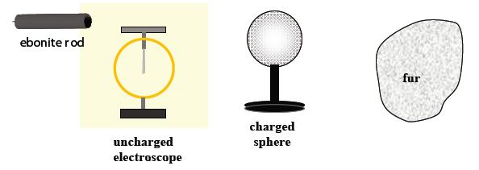
Answer:

STOP!
When you have completed all of the questions in Part One, save your work to your desktop. You will return to this assignment to complete Part Two after you have completed the remainder of the content.

Part Two: Investigating Coulomb’s Law
Part Two of this assignment is worth 19 marks. The value of each question is noted in the left margin in parenthesis. Note: The answer areas will expand to fit the length of your response.

1. | While investigating Coulomb’s Law, physics students devised an experiment to better understand the relationship between the force of electrostatic repulsion acting on two charged objects and the distance of their separation. Results of the experiment are shown in the table below.  Separation Distance (r) (cm) Magnitude of Force of Repulsion ؀ │F│ (N)  1.00 360.0  2.00 89.9  3.00 40.0  4.00 27.5  5.00 14.4
(3) | - Draw a graph of the results shown in the table.
Answer: | Note: You may use the template below. If you have any question or would like to use a different template, please contact your teacher.  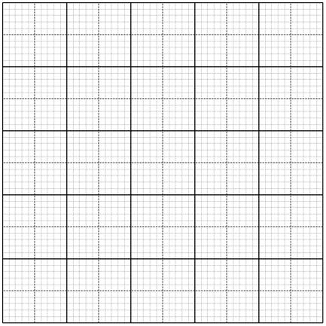  Horizontal Text  0.00  0.00  0.00  0.00  0  Vertical text  Horizontal Text  0.00  0.00  0.00  0.00  0  0.00  0.00  0.00

(1) | - What does the shape of the graph indicate regarding the relationship between the electrostatic force and the separation distance between the two charges?
Answer:
(3)  Answer:  (3) | - Complete the third column in the table below with an expression using r which can then be used with F to plot a linear graph (i.e., straighten the graph).  Separation Distance (r) (cm) Magnitude of Force of Repulsion ؀ │F│ (N) Add title here  1.00 360.0  2.00 89.9  3.00 40.0  4.00 27.5  5.00 14.4  - Draw a graph of the data in the revised table above.
Answer: | Note: You may use the template below. If you have any question or would like to use a different template, please contact your teacher.  Horizontal Text  0.00  0.00  0.00  0.00  0  Vertical text  Horizontal Text  0.00  0.00  0.00  0.00  0  0.00  0.00  0.00
2.  (2) | A student is investigating Coulomb’s law. The student measures a force of +2.00×10⁻³ N between the two charged spheres.  - Explain how you can tell from the sign of the measured force whether the charges are alike or if they are oppositely charged.
Answer:
(2) | - Describe two methods the student could use to increase the force to 64 times its current value. Your answer should include numerical values for clarity.
Answer:
(2) | - The student touches one of the spheres with a neutral sphere of equal size and then removes the neutral sphere. The student then moves one of the spheres so the distance is three times the original distance. What is the ratio of the original force to the new force?
Answer:
(1) 3. | Briefly describe Coulomb’s torsion balance experiment.
Answer:
(2) 4. | What two relationships are investigated in Coulomb’s torsion balance experiment?
Answer:

When you have completed all of the questions in this assignment,
submit your work to your teacher.

