61  Marks Total | ASSIGNMENT 5  Part One: Applying Coulomb’s Law  Part One of this assignment is worth 17 marks. The value of each question is noted in parentheses in the left margin. Note: The answer areas will expand to fit the length of your response.

(3) 1. |  | What is the distance between two charges of - 5.00 C each if the force of electrostatic repulsion acting on them is 4.00 x 10³ N?
Answer:
2.  (4) |  | Three charges are placed in a line as shown below.  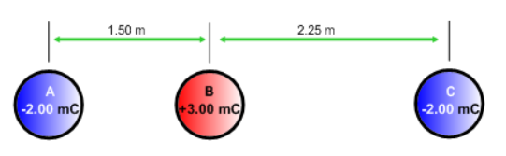  - What is the net electrostatic force on charge A?
Answer:
(4) |  | - What is the net electrostatic force on charge B?
Answer:
(6) 3. |  | As shown below, an equilateral triangle with sides of 0.150 m has three charges of -2.50 microcoulombs each, situated on the vertices of the triangle. Calculate the net electrostatic force on each charge. What assumption did you have to make to complete the calculation? Reminder: Your answer must include magnitude and direction.  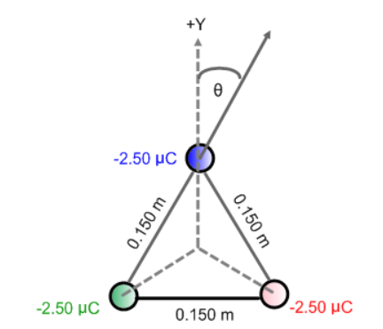
Answer:

STOP!
When you have completed all of the questions in Part One, save your work to your desktop. You will return to this assignment to complete Part Two after you have completed the remainder of the content in the changing momentum section.

Part Two: Electric Fields

Part Two of this assignment is worth 21 marks. The value of each question is noted in the left margin in parenthesis. Note: The answer areas will expand to fit the length of your response.

(4) 1. | Calculate and illustrate the electric field strength at a distance of 8.25 m from a +6.50 μC charged particle. Use the simulation to verify your field diagram. Show the direction of the field at location P in the diagram below or indicate it in your written answer.
 | 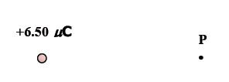
Answer:
- 2. | A particle has a charge of -5.00 μC. At a point near this particle, the electric field strength is 7.20 × 10⁷ N/C. Determine the distance from this point to the charged particle.
Answer:
- 3. | Point P is collinear with a +2.80 μC charged particle and a -8.50 μC charged particle as shown in the diagram below. Point P is 10 cm to the left of the positive charge and 20 cm to the left of the negative charge. What is the electric field at point P?  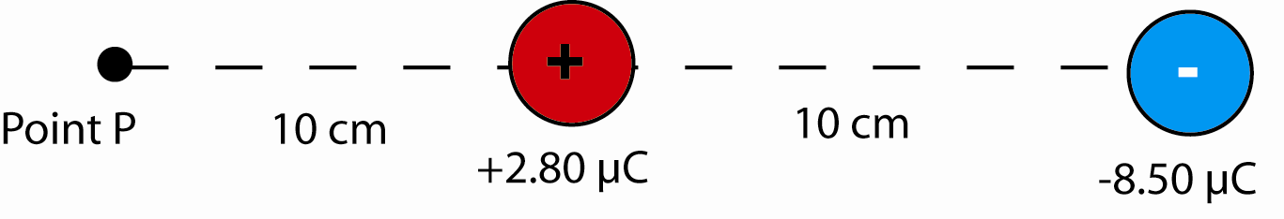
Answer:
(6) 4. | The diagram below shows two charged spheres arranged to the left of a point in space labelled P. Use the information on the diagram to calculate the magnitude and direction of the net electric field at point P.  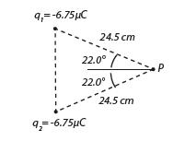
Answer:
5. | After reading about St. Elmo’s fire, (refer to pages 555 – 558 of your physics text), answer the following questions.
(1) | - Compare the charge distribution on a flat surface compared to a curved surface and explain why these distributions occur.
Answer:
(1) | - A metallic conductor has a fixed charge on it. How could you increase the electric field intensity on its surface without adding extra charge?
Answer:
(1) | - Under what conditions is a hot ionizing gas called a plasma formed?
Answer:
(1) | - Why can’t St Elmo’s fire be observed in the interior of a conductor?
Answer:

STOP!
When you have completed all of the questions in Part Two, save your work to your desktop. You will return to this assignment to complete Part Three after you have completed the remainder of the content in the changing momentum section.

Part Three: Electric Potential Energy

Part Two of this assignment is worth 23 marks. The value of each question is noted in the left margin in parenthesis. Note: The answer areas will expand to fit the length of your response.

(2) 1. | Describe the motion of a test charge in a uniform electric field.
Answer:
(2) 2. | Describe the motion of a test charge in a non-uniform electric field.
Answer:
(2) 3. | By considering the electric forces acting and Newton’s second law, explain the type of motion occurring in a uniform electric field.
Answer:
(2) 4. | By considering the electric forces acting and Newton’s second law, explain the type of motion occurring in a non-uniform electric field.
Answer:
(3) 5. | In which direction must a test charge be moved within an electric field if potential energy is to be stored in the system? Explain. (Consider both positive and negative charges.)
Answer:
(5) 6. | A student wanted to determine if the electric potential varied inversely as the square of the distance in a non-uniform field. Data collected was organized in the table below. Analyze the data and determine if the electric potential varies inversely as the square of the distance in a non-uniform field.  Distance of Test Charge from Source Charge (m) Electric Potential (x 10⁴ V)  100 27.0  200 13.5  300 8.99  400 6.74  500 5.39  600 4.49
Answer:
7.  (2) | Explain why the equation 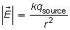cannot be applied in the following situations.  - Situation one.  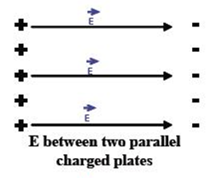
Answer:
(2) | - Situation two.  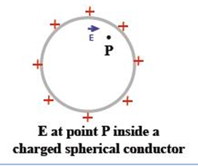
Answer:
(3) 8. | Determine the maximum speed an alpha particle could obtain if it moves from rest through a potential difference of 8.40 kV. Remember to show all work.
Answer:

When you have completed all of the questions in this assignment, submit your work to your teacher.

