25  Marks Total | ASSIGNMENT 6  The Motion of Charges in Uniform Electric Fields  This assignment is worth 25 marks. The value of each question is noted in parentheses in the left margin. Note: The answer areas will expand to fit the length of your response.

1. | From your reading about electric fields, you know that the direction of an electric field is defined as the direction a small positive charge (test charge) would move when placed in the field. With this in mind, answer the following two questions.
(1) | - State what will happen when a positive particle has an initial velocity opposite to the direction of the electric field.
Answer:
(1) | - State what will happen when a positive particle has an initial velocity in the same direction as the electric field.
Answer:
(2) 2. | Use Newton’s second law to explain the motion you described in question one.
Answer:
(2) 3. | Describe the motion of a positive particle when the direction of its initial velocity is perpendicular to the direction of the electric field.
Answer:

(2) 4. | Use Newton’s first and second laws to explain the motion you described in question three.
Answer:
(2) 5. | Describe the motion of a negatively charged particle when the direction of its initial velocity is perpendicular to the direction of the electric field.  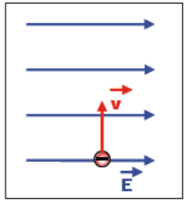
Answer:
(2) 6. | Refer to Newton’s first and second laws to explain the motion you described in question five.
Answer:
(1) 7. | Explain the circumstances that enable a particle to move un-deflected with uniform motion through an electric field if it is given an initial velocity perpendicular to the electric field. Assume the electric field is the only field present.
Answer:
8.  (2) | The diagrams that follow show the initial position and the velocity vector of charged particles within a uniform electric field.  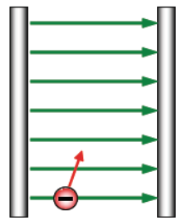  - On the diagram above, sketch a free-body diagram showing the net force that acts on the particle as well as the path of the particle OR describe the path in words in the answer area below.
Answer:
(2) | 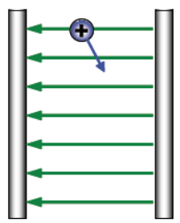  - On the diagram above, sketch a free-body diagram showing the net force that acts on the particle as well as the path of the particle OR describe the path in words in the answer area below.
Answer:
(8) 9. | The following diagram shows a proton entering the region between two oppositely charged plates. The plates are 45.0 mm long and 17.5 mm apart. A potential difference of 0.208 V generates an electric field between the plates. The proton is given an initial velocity of 1.35 x 10⁴ m/s, in the positive x direction. Use this information to determine the y-component of the displacement of the proton when it leaves the region between the plates. (This displacement is how far the proton has moved above or below the x-axis the instant it leaves the region between the plates.)  Begin your solution by showing or describing the path of the proton resulting from the forces acting on the proton in the diagram.  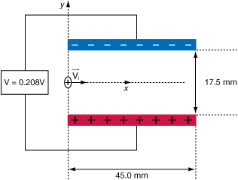
Answer:

When you have completed all of the questions in this assignment,
submit your work to your teacher.

