18  Marks Total | ASSIGNMENT 7  Magnetic Fields  This assignment is worth 18 marks. The value of each question is noted in parentheses in the left margin. Note: The answer areas will expand to fit the length of your response.

1. | Using the diagrams below, indicate the direction of the magnetic field associated with the wire when the current is flowing in the direction indicated. (Electron current flows from negative to positive). You may respond with clockwise (CW) or counterclockwise (CCW) from a given direction such as left or right, top or bottom.
(1) | - Diagram a  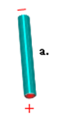
Answer:
(1) | - Diagram b  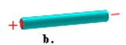
Answer:
(1) | - Diagram c  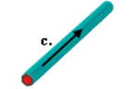
Answer:
(1) | - Diagram d  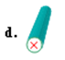
Answer:
(1) | - Diagram e  
Answer:
2.  (1) | Using the diagrams below, indicate the direction of electron flow if the associated magnetic field is in the direction indicated.  - Diagram 1  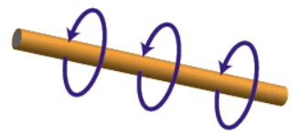
Answer:
(1) | - Diagram 2  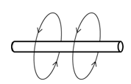
Answer:
(1) | - Diagram 3  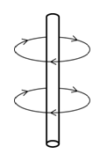
Answer:
3. | The diagrams below show end views of two wires and the magnetic fields surrounding them. Indicate the direction of electron current flow by stating whether a dot or an “x” should be placed in each circle.
(1) | - Diagram a  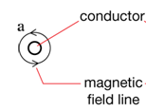
Answer:

(1) | - Diagram b
 | 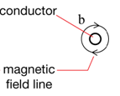
Answer:
4.  (1) | Given the diagrams below, indicate the path of the current (e- flow) that produces magnetic poles as indicated.  - Diagram 1  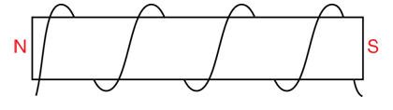
Answer:
(1) | - Diagram 2  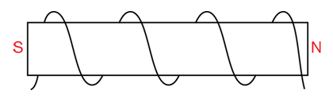
Answer:
(1) | - Diagram 3  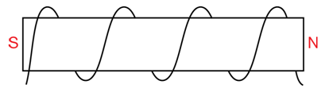
Answer:

5.  (1) | Given the diagrams below, indicate the position of the north pole due to the current (e-flow) through the solenoid.  - Diagram a  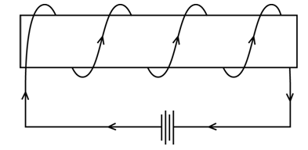
Answer:
(1) | - Diagram b  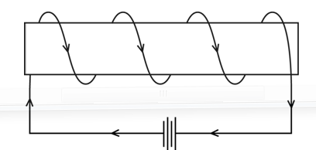
Answer:
(1) | - Diagram c  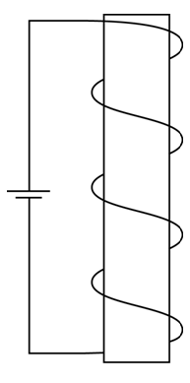
Answer:
(1) | - Diagram d  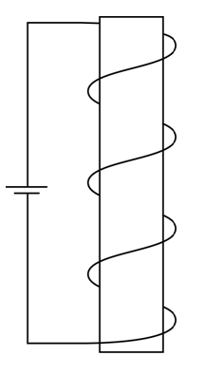
Answer:
(1) | - Diagram e  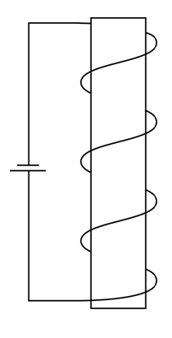
Answer:

When you have completed all of the questions in this assignment,
submit your work to your teacher.

