42  Marks Total | ASSIGNMENT 8  Part One: Moving Charges in Magnetic Fields  Part One of this assignment is worth 16 marks. The value of each question is noted in parentheses in the left margin. Note: The answer areas will expand to fit the length of your response.

1. | State the direction of the magnetic force on the moving charge in each diagram below. You may wish to verify your answers using the online simulation.
(1) | - positive charge  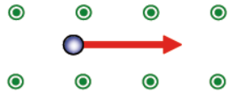
Answer:
(1) | - positive charge  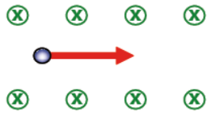
Answer:
(1) | - negative charge  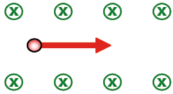
Answer:
(1) |   - negative charge  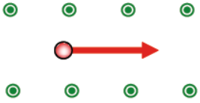
Answer:
(3) 2. | An electron experiences a downward magnetic force of 7.20 × 10⁻¹⁴ N when it is travelling at 3.00 × 10⁵ m/s south through a magnetic field. Calculate the magnitude of the magnetic field and determine its direction using the left-hand rule. Explain all finger directions and the palm direction.
Answer:
(3) 3. | A charged particle is travelling west through a downward magnetic field and it experiences a magnetic force directed to the north. Using the appropriate hand rule, determine if the charge is negative or positive. Explain all finger directions and the palm direction.
Answer:
(2) 4. | Calculate the magnitude and the direction of the magnetic force acting on an alpha particle that is travelling upwards at a speed of 3.00 x 10⁵ m/s through a 0.525 T west magnetic field. Explain all finger directions and the palm direction.
Answer:
(4) 5. | An electron (m = 9.11 × 10⁻³¹ kg) enters a downward magnetic field of 5.00 × 10⁻¹ T with a velocity of 6.50 × 10⁶ m/s West. Calculate the radius of the circular path it will follow once it is travelling within the magnetic field.
Answer:

STOP!
When you have completed all of the questions in Part One, save your work to your desktop. You will return to this assignment to complete Part Two after you have completed the remainder of the content in the next section.

Part Two: Electromagnetic Induction

Part Two of this assignment is worth 26 marks. The value of each question is noted in the left margin in parenthesis. Note: The answer areas will expand to fit the length of your response.

1.  (2) | A compact fluorescent light bulb draws a current of 0.10 A for one hour.  - How much charge flows through the bulb in one hour?
Answer:
(1) | - How many electrons flow through the light bulb in the hour? Remember the charge of one electron is the elementary charge on your physics data sheet.
Answer:
(2) 2. | A motor uses a coil of wire in a magnetic field to generate force. The motor draws a current of 9.50 A through the coil of wire and has a magnetic field of 1.75 T. If the motor is designed to generate 800 N, how long is the wire in the coil assuming that all of the wire creates force?
Answer:
3. | The diagram below shows electrons flowing through a loop of wire within a magnetic field.
(1) | - Draw or insert an arrow on the diagram below to indicate the direction of the magnetic force.
Answer: | 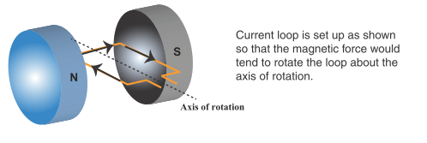
(1) | - Draw an arrow on the diagram below to indicate the direction of the magnetic force after the loop has rotated one half turn.
Answer: | 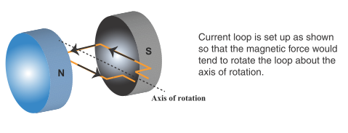
(1) | c. Describe the resulting motion of the loop.
Answer:
4. | In the diagrams below, a magnet is either dropped down or pulled up through a cylinder encircled by a coil conductor. Depending on what is asked for in questions a through e, (the “?”), indicate whether the magnetic pole is north or south and/or whether the motion of the magnet is up or down. Remember that current is e- flow.
(1) | - Determine the magnetic poles of the cylinder.  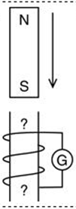
Answer:
(1) | - Determine the magnetic poles of the cylinder.  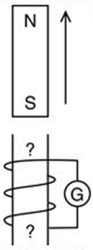
Answer:
(1) | - Determine if the magnet is pulled up through the cylinder or pushed down through the cylinder.  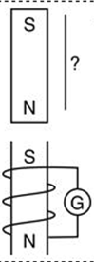
Answer:
(2) | - Determine the magnetic poles of the cylinder and the magnet.  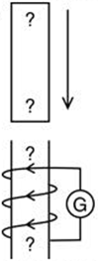
Answer:
(1) | - Determine if the magnet is pulled up through the cylinder or pushed down through the cylinder and determine the magnetic poles of the cylinder.  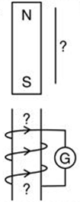
Answer:
(1) | - Determine the magnetic poles of the magnet.  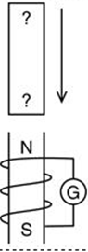
Answer:
5.  (3) | Give three different ways the strength of the magnetic force created in a solenoid can be  increased.
Answer:
(2) 6. | Explain why the generator effect would occur in the same way if the wire was moved rather than the magnet.
Answer:
(2) 7. | Would two parallel wires carrying a current in opposite directions repel or attract one another? Explain your answer.  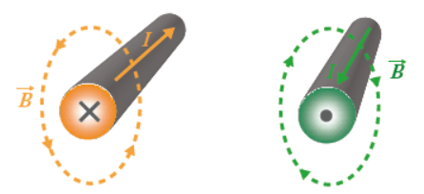
Answer:
(4) 8. | A 0.120 m long copper wire has a mass of 9.02 g and is carrying a current of 5.10 A perpendicular to a uniform magnetic field. The apparatus is placed in a strong magnetic field and the wire is found to levitate. Calculate the magnetic field strength. Remember to show all work.
Answer:

When you have completed all of the questions in this assignment,
submit your work to your teacher

