55  Marks Total | ASSIGNMENT 11  Part One: Reflection  Part One of this assignment is worth 23 marks. The value of each question is noted in parentheses in the left margin. Note: The answer areas will expand to fit the length of your response.

(1) 1. | The law of reflection is one of the most basic of all laws in optics; it relates the angle of incidence to the angle of reflection. State the law of reflection.
Answer:
2. | Open the Lenses simulation (see course content for link)  - change “lens” to “mirror” at the top of the screen by clicking on the word  - decrease the number of rays by clicking on the “ray 2 and 3” boxes  - click and drag the candle to move it around and match the images below  For example, determine if the images are  - real or virtual  - erect or inverted  - larger, smaller, the same size, or not formed  - on the same side of the mirror as the objects or on the opposite side
(2) | - An object is placed at F in front of a converging or concave mirror. List the image characteristics below. (Note the focal length is positive for converging mirrors in the simulation.)  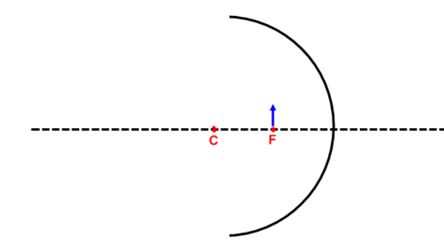
Answer:
(2) | - An object is placed between F and the surface of a converging of concave mirror. List the image characteristics below. (Note the focal length is positive for converging mirrors in the simulation.)  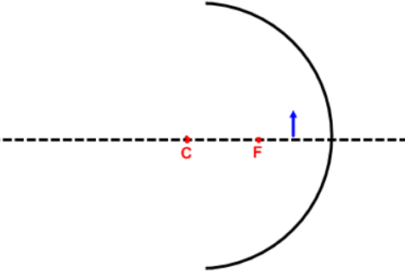
Answer:
(2) | - An object is placed very far away from a diverging or convex mirror (far left on the simulation). List the image characteristics below. (Note the focal length is negative for diverging mirrors in the simulation.)  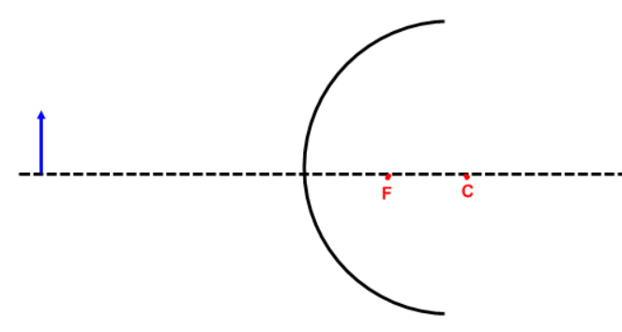
Answer:
(2) 3. | If an object is extremely far from a mirror (approaching infinity), 1/d_{o} becomes zero. In this situation, where will the image form in relation to the focal length of the mirror? (Hint: use the mirror equation.)
Answer:

(2) 4. | If 1/f approaches zero for a flat mirror, where will the image form in relation to the object? (Hint: use the mirror equation.)
Answer:
(3) 5. | A converging mirror has a focal length of 20 cm. An object is placed 30 cm in front of the mirror. Showing your calculations, determine where the image appears.
Answer:
(3) 6. | A diverging mirror has a focal length of 0.12 m. The image formed is located 0.070 m from the mirror. Showing your calculations, determine where the object is located.
Answer:
(3) 7. | A student places a 5.0 cm tall object 15 cm away from a converging mirror. The image is 12 cm from the mirror. Showing your calculations, determine the height and orientation of the image.
Answer:
(3) 8. | A 1.5 cm tall object is placed 12 cm away from a converging mirror. The image is magnified to four times its original height and is inverted. Showing your calculations, determine the mirror’s focal length.
Answer:

STOP!
When you have completed all of the questions in Part One, save your work to your desktop. You will return to this assignment to complete Part Two after you have completed the remainder of the content in the next section.

Part Two: Refraction

Part Two of this assignment is worth 32 marks. The value of each question is noted in the left margin in parenthesis. Note: The answer areas will expand to fit the length of your response.

(1) 1. | When light travels from a low-index medium (fast) to a high-index medium (slower), does the ray bend toward or away from the normal?
Answer:
- 2. | When light travels from a high-index (slower) medium into a low-index (fast) medium, does the light ray bend toward or away from the normal?
Answer:
(4) 3. | Using the diagram below, complete the table that follows. If you wish, you may refer to the online diagrams, printing your own page and using your own protractor. Note that the lines on the diagram below are separated from each other by 10º.  Water Refractions  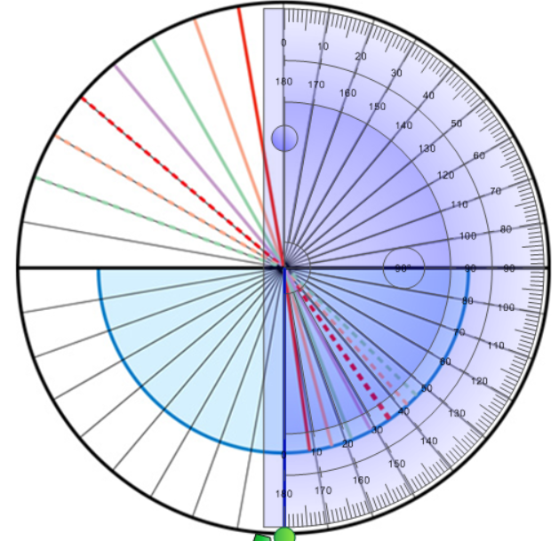
Answer: | Water  θ ₁ θ ₂ sin θ ₁ sin  θ ₂  10  30  50  70
(4) 4. | Using the diagram below, complete the table that follows. If you wish, you may refer to the online diagrams, printing your own page and using your own protractor. Note that the lines on the diagram below are separated from each other by 10º.  Ethanol Refractions  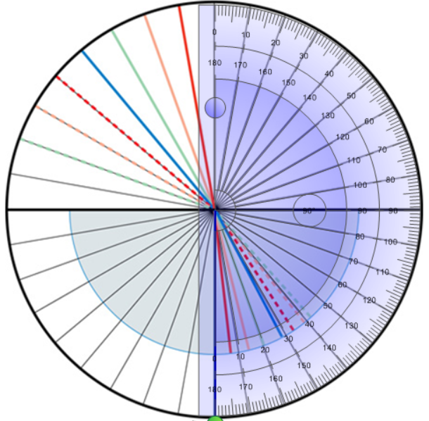
Answer: | Ethanol  θ _{incidence} θ _{refraction} sin θ _{incidence} sin  θ _{refraction}  10  30  50  70
5.  (6) | Using the data from the tables in questions 4 and 5, complete the two items that follow.  - Plot a graph of the sine angle of incidence vs the sine angle of refraction for water and ethanol. (You will have two separate lines.)
Answer: | Horizontal Text  0.00  0.00  0.00  0.00  0  Vertical text  Horizontal Text  0.00  0.00  0.00  0.00  0
(2) | - Calculate the slope of each line on the graph above.
Answer:
(2) | - Calculate the percent error for each index of refraction using 1.33 as the absolute index of refraction for water and 1.37 as the absolute index of refraction for ethanol.
Answer:
(1) | - Which material (water or ethanol) is more effective in changing the direction of light when light enters it?
Answer:
(5) 6. | Consider white light entering an equilateral prism at a 50° angle with respect to the normal of one of its faces. The index of refraction for blue light is 1.66 and 1.62 for red light. The two rays will emerge from the prism at different angles. The path for red light is shown below. Calculate all angles and determine the angular separation between the blue and red rays as they leave the prism. You may use the Prism simulation to verify your answer.
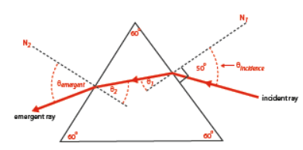

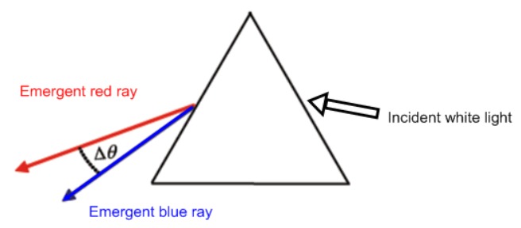
Answer:
(3) 7. | A critical angle may occur if a wave travels from a substance having a high refractive index to a substance with a low refractive index. If the critical angle for a given liquid-air system is 49.5º, what is the refractive index of the liquid? Show all work.
Answer:
(3) 8. | What is the critical angle for a diamond – water system? Show all work.
Answer:

When you have completed all of the questions in this assignment,
submit your work to your teacher.

