45  Marks Total | ASSIGNMENT 12  Part One: Optical Systems Refraction  Part One of this assignment is worth 26 marks. The value of each question is noted in parentheses in the left margin. Note: The answer areas will expand to fit the length of your response.

1. | Open the Lenses simulation from the course content. Click and hold the object arrow and move it to various locations on the principal axis. Using the simulation as a guide, draw rough diagrams of the images formed then record the characteristics of the images formed in each case below. For example, determine if the images are  - real or virtual  - erect or inverted  - larger, smaller, the same size, or not formed  - on the same side of the mirror as the objects or on the opposite side
(2) | - An object is placed at C in front of a converging lens. List the image characteristics below. (Note the focal length is positive for converging lenses in the simulation.)  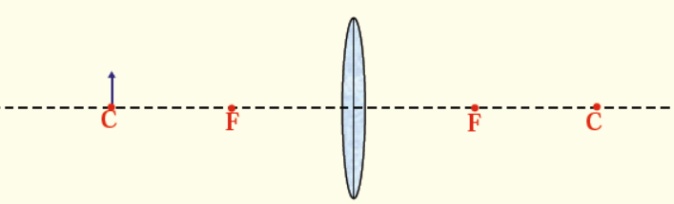
Answer:

(2) | - An object is placed at F in front of a converging lens. List the image characteristics below. (Note the focal length is positive for converging lenses in the simulation.)  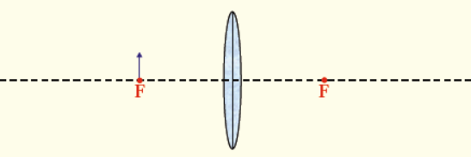
Answer:
(2) | - An object is placed between C and F in front of a diverging lens. List the image characteristics below. (Note the focal length is negative for diverging lenses in the simulation.)  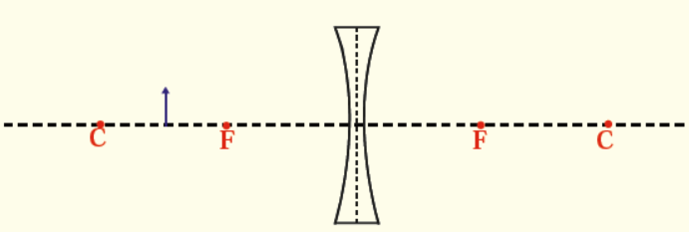
Answer:
2.  (2) | A lens with a focal length of 5.0 cm is placed 12 cm away from an 8.0 cm tall object.  - How far from the lens is the image?
Answer:
(1) | - How tall is the image?
Answer:
(3) | - Describe the image characteristics: real/virtual, inverted/erect, larger/smaller than object.
Answer:
3. | A scientist uses a lens with a 17 cm focal length to focus light and create a holograph. The lens is 30 cm from the 25 cm tall image.
(2) | - How far from the lens is the object?
Answer:
(1) | - What is the height of the object?
Answer:
(3) | - Describe the image characteristics: real/virtual, inverted/erect, larger/smaller than object.
Answer:
4.  (2) | A student is given the challenge of determining the focal length of the lens in an LCD projector. The projector creates an image 600 cm tall 12 m from the lens. The object is 12 cm tall.  - What is the distance from the lens to the object?
Answer:
(2) | b. What is the focal length of the lens?
Answer:
5.  (2) | A 15 cm tall object is 30 cm away from a concave lens that has a focal length of 5.0 cm.  - What is the image’s distance from the lens? Show all work.
Answer:
(1) | b. What is the size of the image? Show all work.
Answer:
(1) | c. What is the magnification of the image? Show all work.
Answer:

STOP!
When you have completed all of the questions in Part One, save your work to your desktop. You will return to this assignment to complete Part Two after you have completed the remainder of the content in the next section.

Part Two: Diffraction and Interference

Part Two of this assignment is worth 19 marks. The value of each question is noted in the left margin in parenthesis. Note: The answer areas will expand to fit the length of your response.

1.  (1) | Using the formula λ = xd/nL, describe how the following changes affect the “x” distance in an interference pattern.  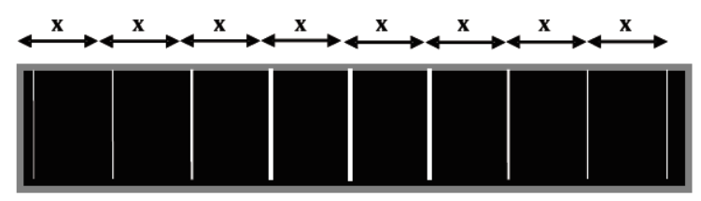  - decreasing the wavelength
Answer:
 | - decreasing the “d” distance
Answer:
(1) | - increasing the length to the screen
Answer:
(1) | - Based on your answer for part 1a above, which light diffracts more, blue or red?
Answer:
(3) 2. | To confirm the wavelength of a new laser, a scientist prepares a diffraction grating with a distance of 5.00 ×10⁻⁶ m between slits and places it in front of the laser which is 1.50 m in front of a screen. The scientist measures the distance from the central maxima to the second bright fringe, which is 0.330 m. What is the wavelength of the laser?
Answer:
3.  (2) | As part of a laser light show, a technician is adjusting a diffraction grating. A green laser with a wavelength of 532 nm is shone on a diffraction grating with 2700 lines/cm. The screen is 35.0 m from the diffraction grating.  - What is the distance between the slits of the diffraction grating?
Answer:
(3) | - How far from the central maximum is the bright fringe?
Answer:
(3) 4. | A student is looking at a monochromatic light source and is looking for the third bright fringe. The light has a wavelength of 625 nm and has passed through a diffraction grating with a slit separation of 2.80×10⁻⁶ m. At what angle should the student look for the third bright fringe?
Answer:
(2) 5. | Explain how the polarization of light is used as evidence to support the transverse wave nature of light.
Answer:
6.  (1) | Use the terms refraction and diffraction to fill in the blanks for the two statements that follow.  - Blue light is affected more by ______________.
Answer:
(1) | - Red light is affected more by ______________.
Answer:

When you have completed all of the questions in this assignment, submit your work.

