58  Marks Total | ASSIGNMENT 13  Part One: Blackbody Radiation and the Quantum  Part One of this assignment is worth 27 marks. The value of each question is noted in parentheses in the left margin. Note: The answer areas will expand to fit the length of your response.

(3) 1. | Describe the pattern of intensity vs wavelength observed in blackbody experiments and explain why these observations were in conflict with the prediction of classical physics.
Answer:
(2) 2. | What is the frequency of a 13.0 eV photon?
Answer:
(2) 3. | What is the wavelength of a 4.30 x 10⁻¹⁹ J photon?
Answer:
(4) 4. | How many photons with a wavelength of 532 nm are released each second by a 5.0 mW laser?
Answer:
(2) 5. | When welders are working on pipelines they wear filters that block UV light. Why is this safety precaution necessary?
Answer:
(3) 6. | A person lives near a 50 kW radio tower. Why is it safe to live near a high power radio tower but dangerous to be exposed to an x-ray machine that uses 7.5 kW?
Answer:

(2) 7. | Why did the introduction of the photon effectively end classical physics?
Answer:
(2) 8. | How did Einstein’s explanation of the photon contradict the classical explanation of light?
Answer:
(1) 9. | Provide an example of an experiment that Einstein’s theory could not explain.
Answer:
10.  (1) | Using the concepts of quantum and photons, explain the difference between a 100 W and a 40 W light bulb if they both produce only green light. Answer the following questions in your explanation.  - Why does the 100 W bulb appear brighter than a 40 W bulb?
Answer:
(1) | - Why would you expect the 100 W bulb to feel hotter than the 40 W bulb?
Answer:
(3) | - If 10% of the energy consumed by each bulb produces green light of 500 nm, how many green coloured photons does each bulb produce each second?
Answer:
(1) | - How does your answer to 10c support your explanation of brightness?
Answer:

STOP!
When you have completed all of the questions in Part One, save your work to your desktop. You will return to this assignment to complete Part Two after you have completed the remainder of the content in the next section.

Part Two: The Photoelectric Effect

Part Two of this assignment is worth 31 marks. The value of each question is noted in the left margin in parenthesis. Note: The answer areas will expand to fit the length of your response.

1.  (3) | While conducting research into the design of a light sensor, scientists measured the kinetic energy of photoelectrons that had been ejected from an unknown metal surface. The metal was exposed to various frequencies of EMR and the stopping voltage was measured to obtain the kinetic energy of the photoelectrons. The following data was obtained.  Incident EMR frequency x 10¹⁴ Hz Kinetic energy of photoelectrons (eV)  6.0 0.38  7.0 0.80  8.0 1.20  9.0 1.63  10.0 2.04  - Using the data above, plot a kinetic energy vs. frequency graph and use it to answer questions b – e.
Answer: | 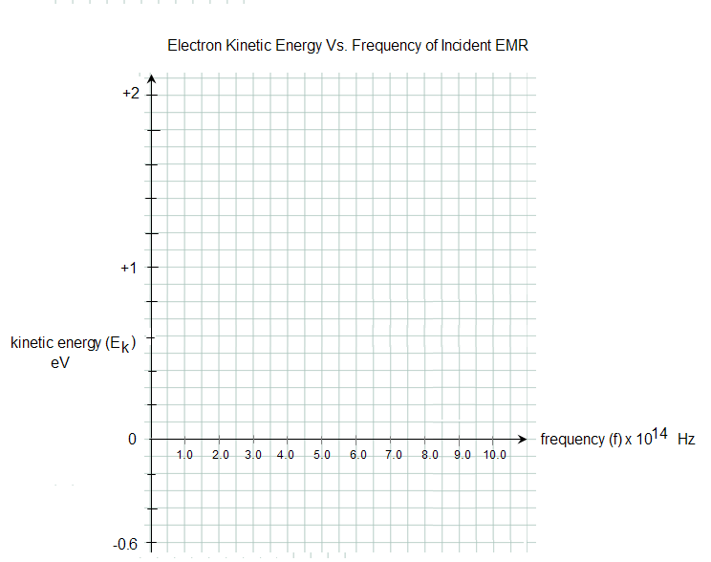
(2) | - According to your graph, what is the threshold frequency of the unknown metal? Label the threshold frequency on your graph.
Answer:
(2) | - Determine the work function of the unknown metal.
Answer:
(1) | - Using the tables below, identify the unknown metal.  Element Aluminum Beryllium Cadmium Calcium Carbon Cesium Copper  Work Function (eV) 4.08 5.00 4.07 2.90 4.81 2.10 4.70  Element Magnesium Mercury Potassium Selenium Sodium Zinc  Work Function (eV) 3.68 4.50 2.30 5.11 2.28 4.33
Answer:
(3) | - Explain how to find Planck’s constant from your graph then, using your graph, determine the experimental value for Planck’s constant in eVs.
Answer:
(2) 2. | What is the energy of a photon that has a wavelength of 460 nm?
Answer:
(2) 3. | A photoelectric surface has a work function of 2.00 eV. What is the threshold frequency of this surface?
Answer:
(3) 4. | A photon of frequency 8.2 x 10¹⁵ Hz is incident upon a photoelectric apparatus containing a metal whose threshold frequency is 3.6 x 10¹⁵ Hz. What is the stopping voltage?
Answer:
(3) 5. | Electrons are ejected from a photoelectric cell with a maximum kinetic energy of 1.20 eV. If the incident light has a wavelength of 410 nm, what is the work function of the cell?
Answer:
(4) 6. | Light with a wavelength of 425 nm falls on a photoelectric surface that has a work function of 2.00 eV. What is the maximum speed of any emitted photoelectrons?
Answer:
(6) 7. | Explain the photoelectric effect in terms of energy. In your explanation, start with the energy of the incident EMR photons and finish with the energy of the stopping voltage. Be sure to include the following terms in your answer: threshold frequency, light intensity, photoelectron current, work function, photoelectron kinetic energy and stopping voltage.
Answer:

When you have completed all of the questions in this assignment, submit your work.

